SAP : WHAT—HOW--WHY
What is SAP : SYSTEM APPLICATION PRODUCT IN DATA PRODUCTION
1972 Germany company SAP AG DEVELOPED
2025 Version and services
FIORI
ECC ECC 6.0
S4 HANA
SAP CLOUD
ERP: ENTERPRISE RESOURCE PLANNING
MODULE : 25+
SAP Around 180 Countries in operation like using

IT is a integration of all function modules into one common software
Example:
Raw Material
Developed Product
Sell Market
Money Buying

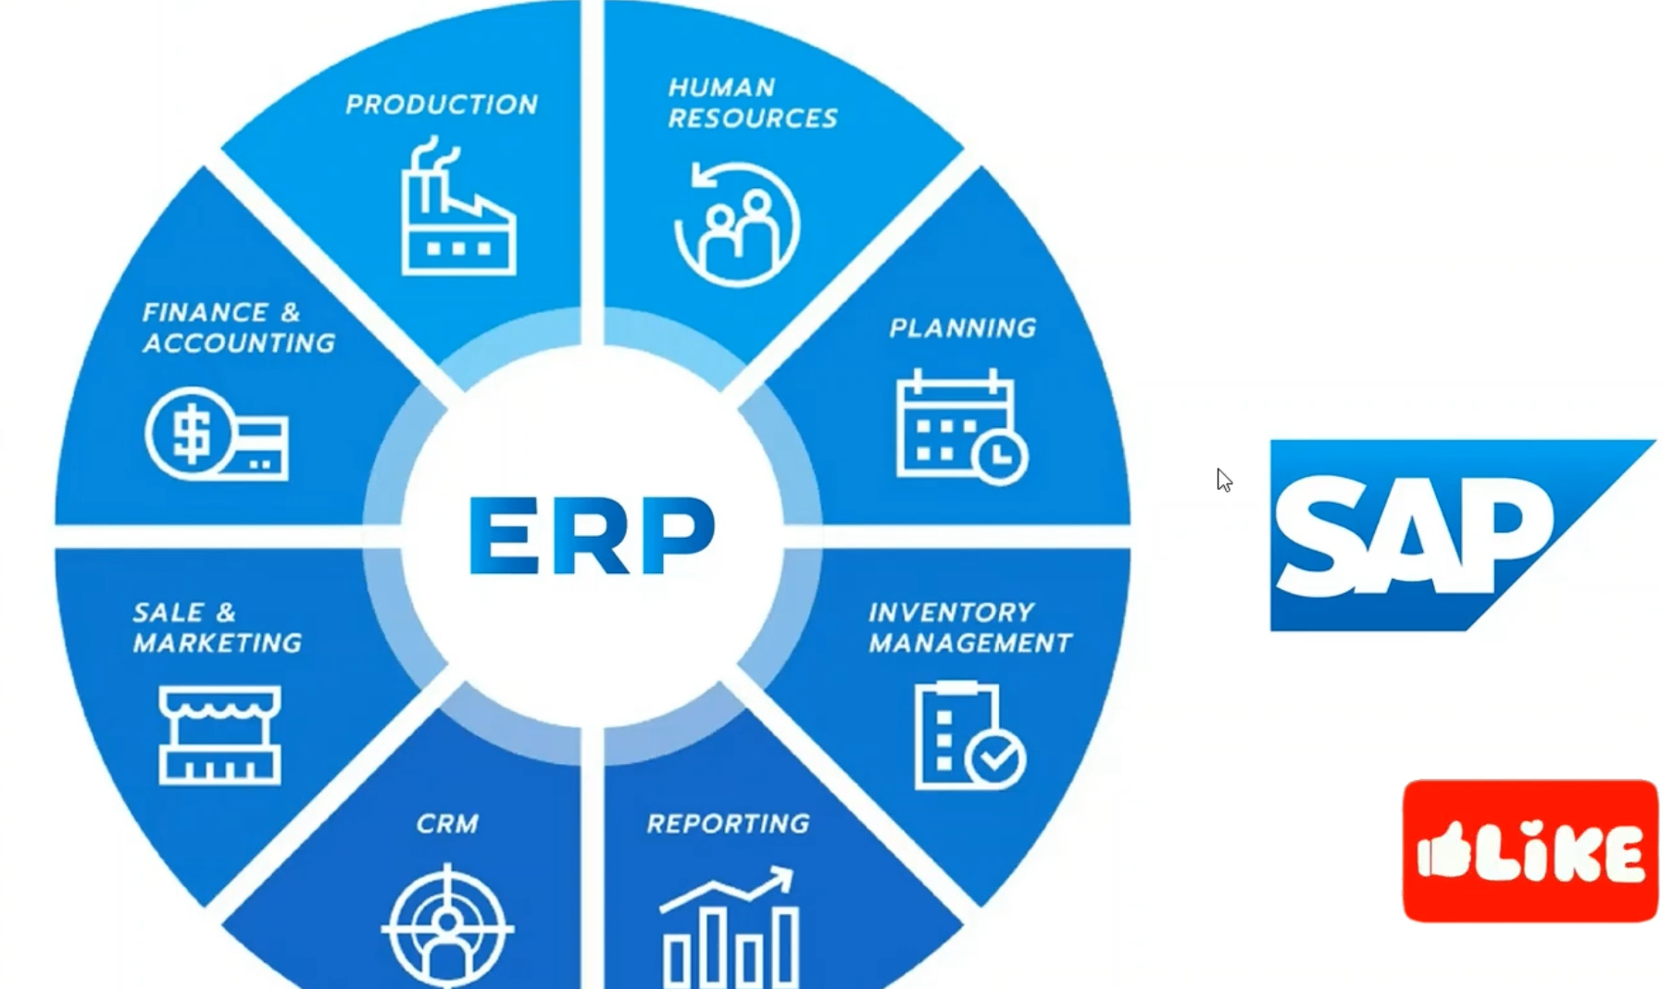
ex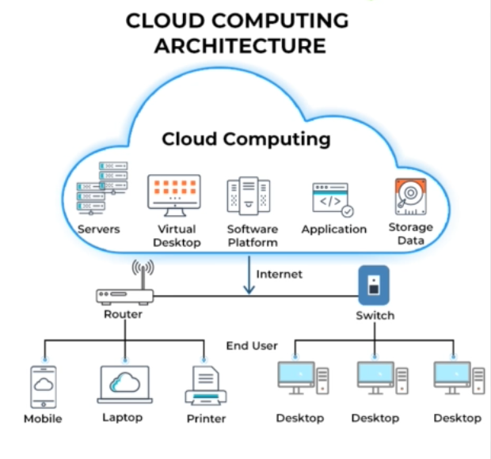

Clouds :
Microsoft
AWS
Google Cloud

Ram
Size

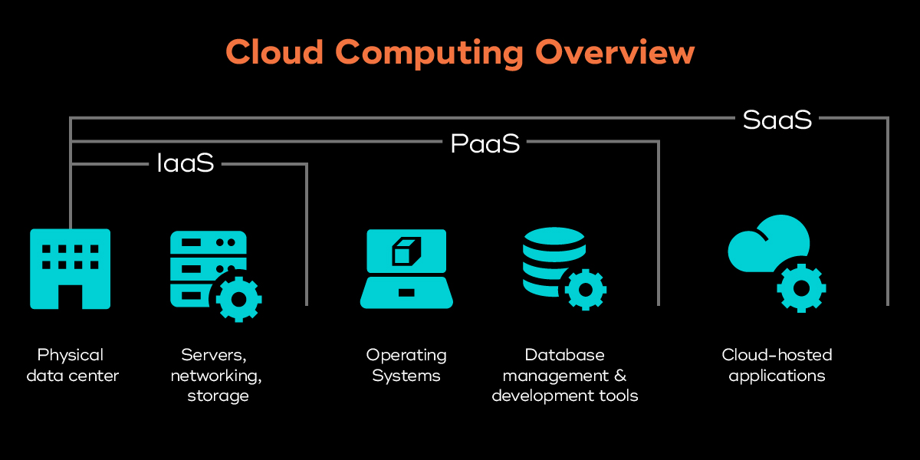
IAAS--Infrastructure as a Service—Providing a space or ram
PAAS : Platform as a service—We can Develop an application - CPI come into this service

SAAS : Software as a Service—Application can be installed , Can be customized and access to client usuage
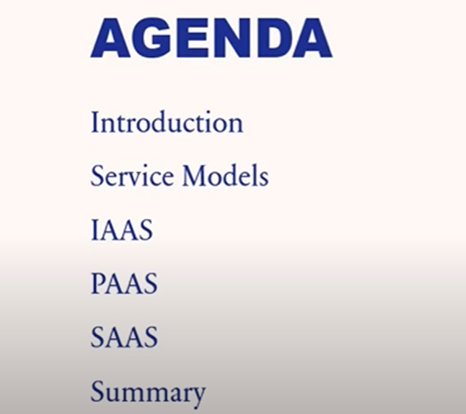
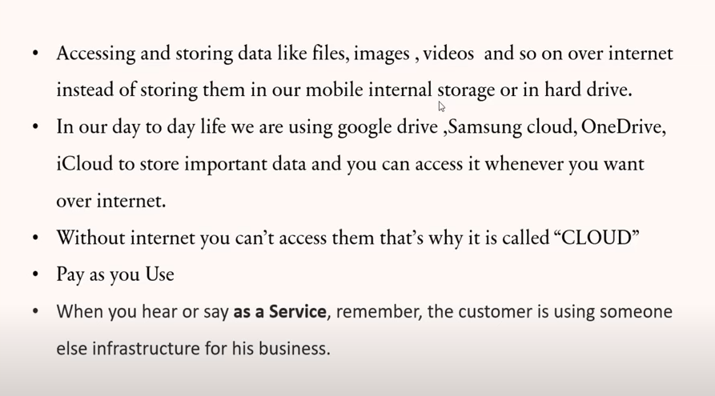



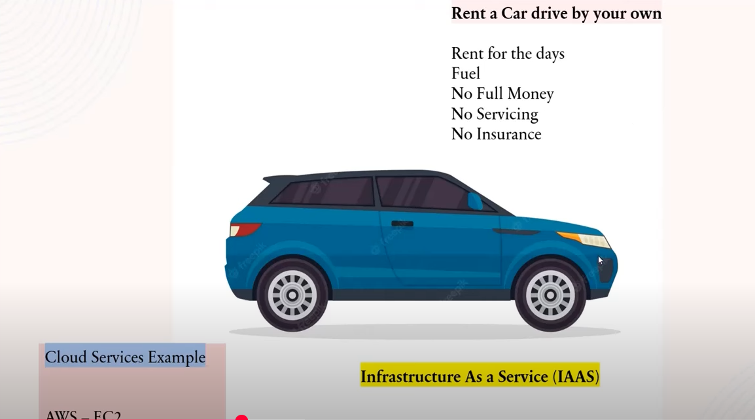



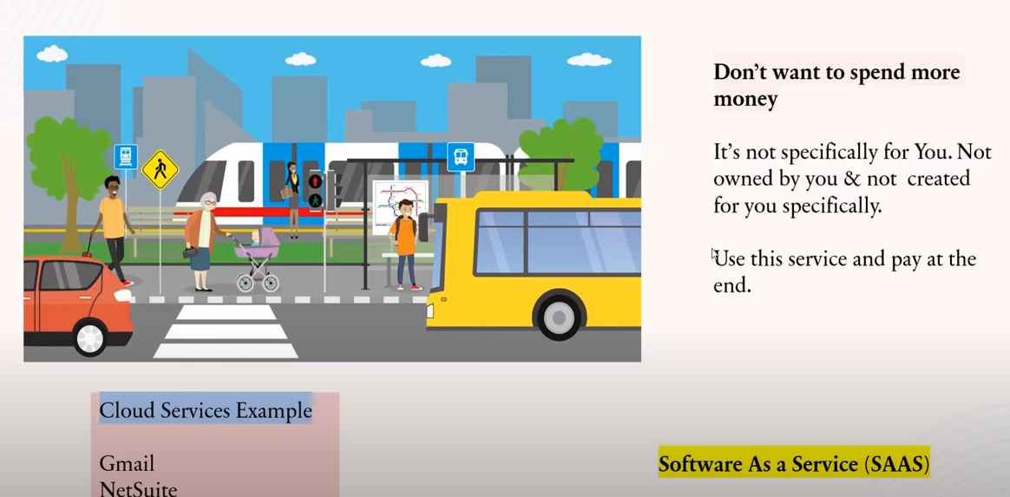
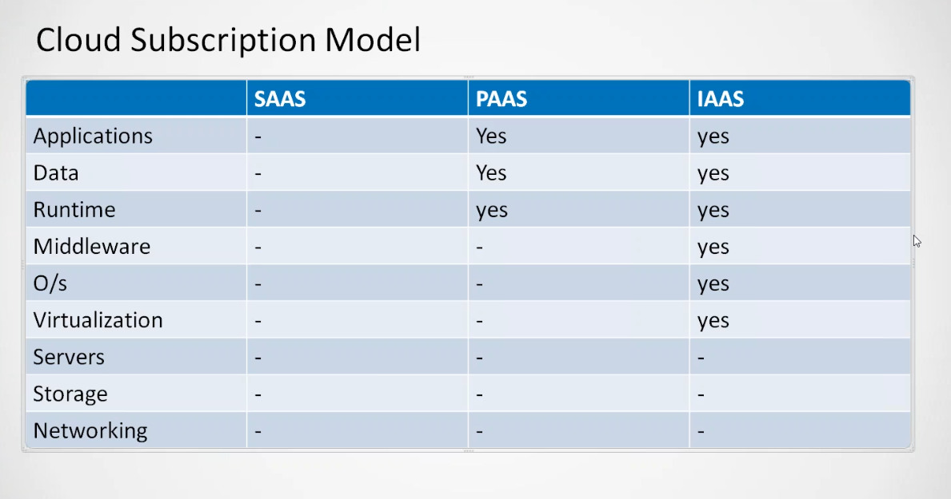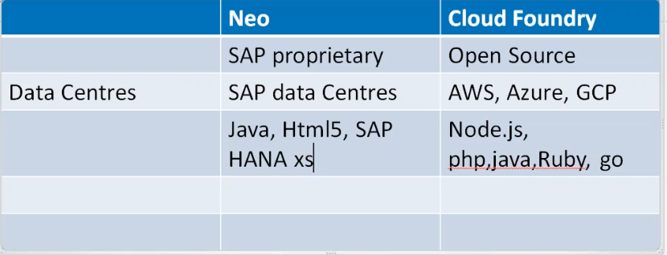

Account Creation:
Click on link in below for account creation in sap
https://www.sap.com/india/index.html?geotargering_redirect=true
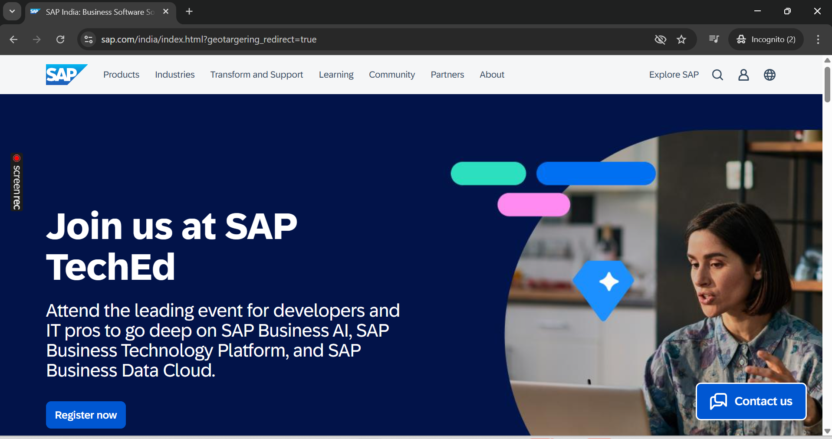
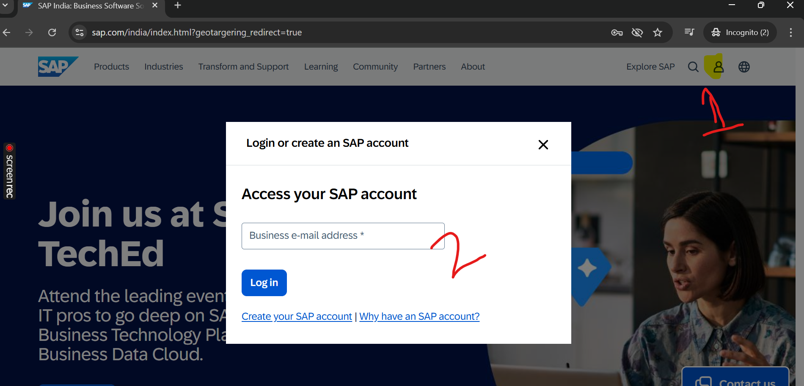

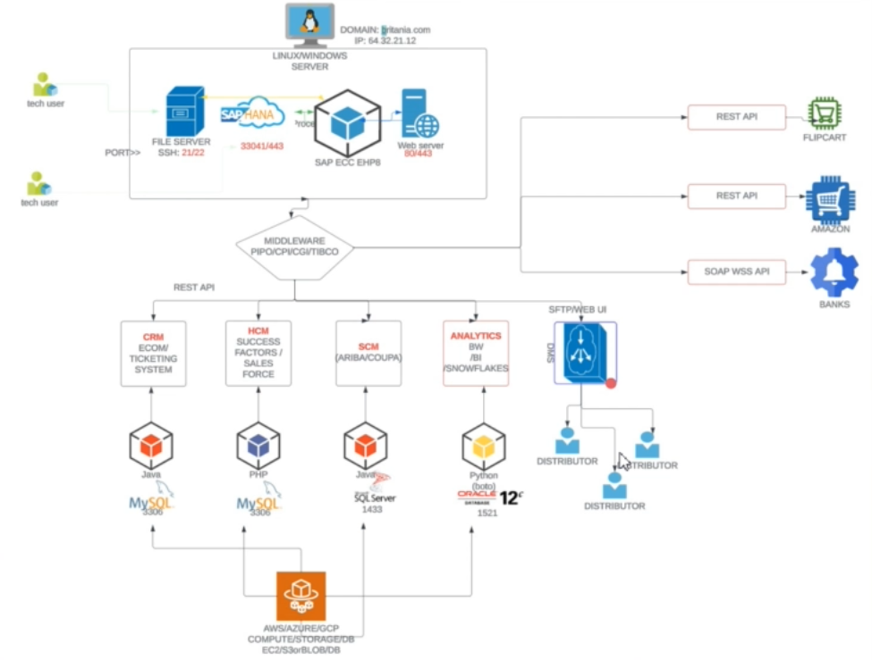

Linux or Windows:
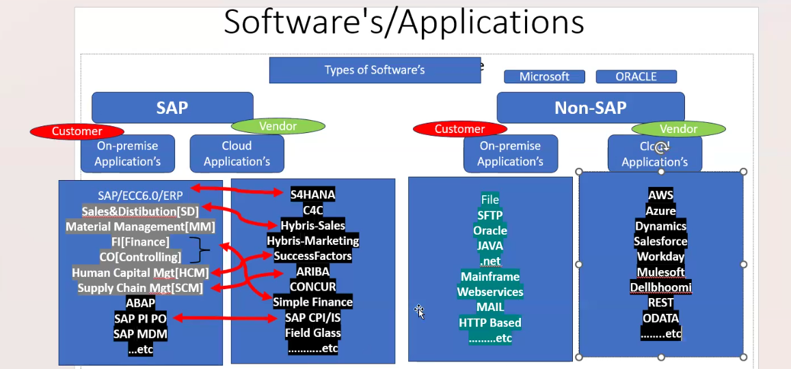
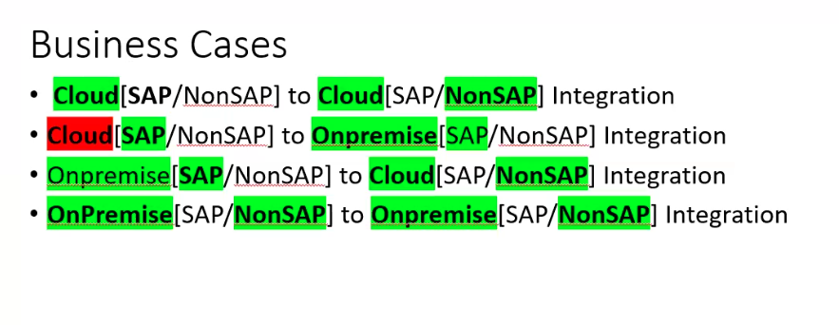
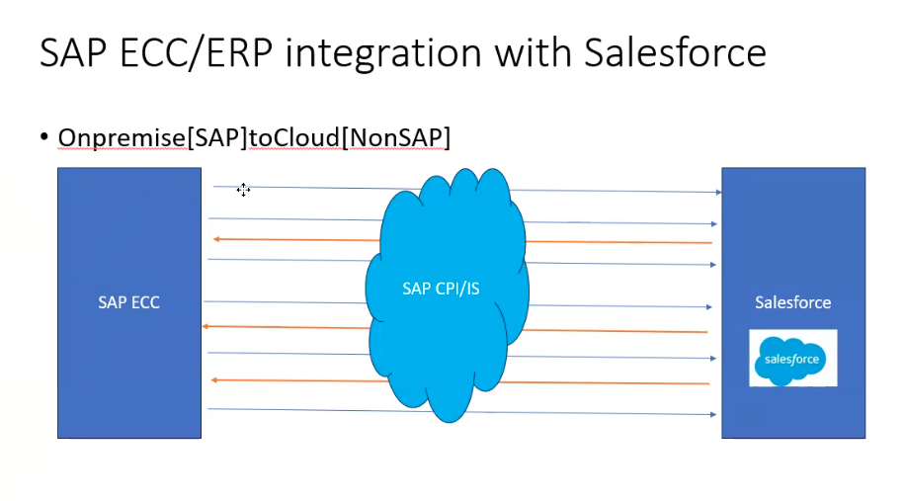
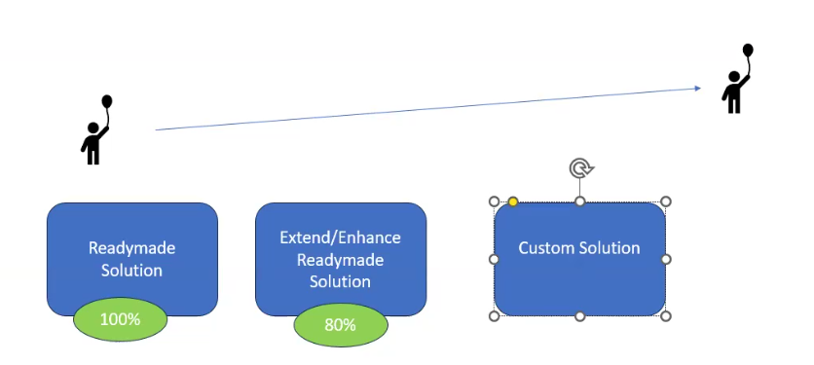
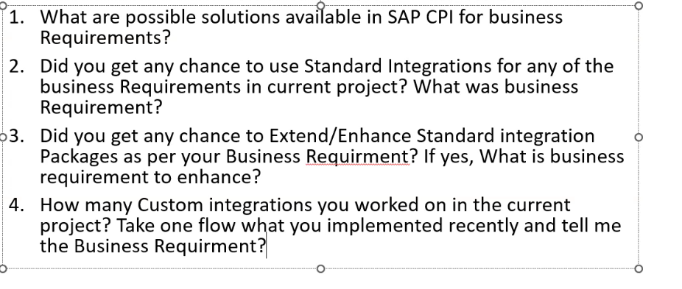
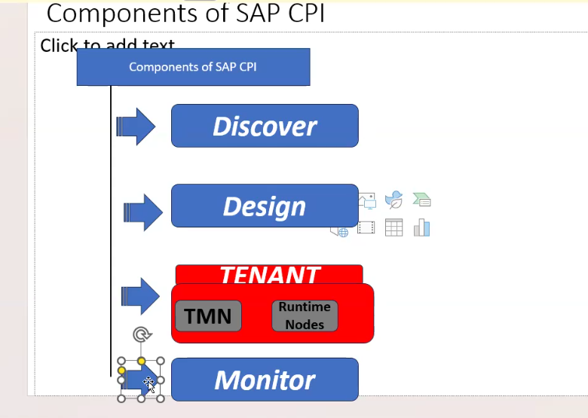

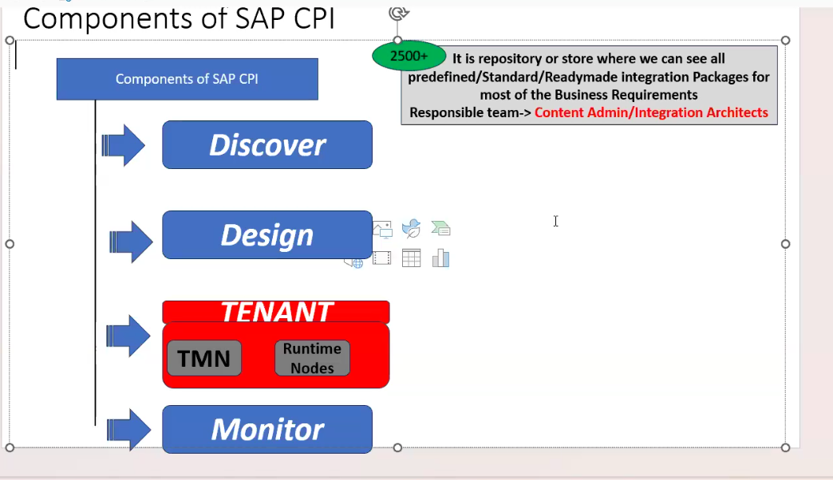
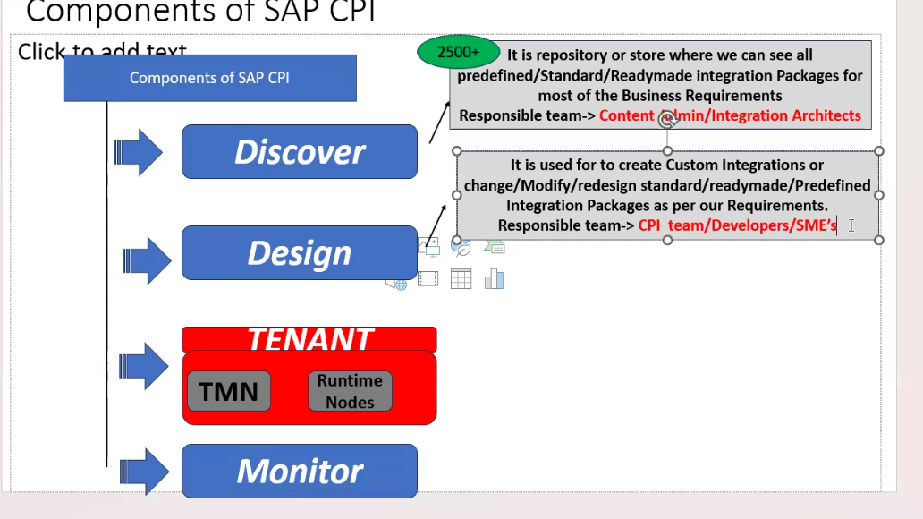

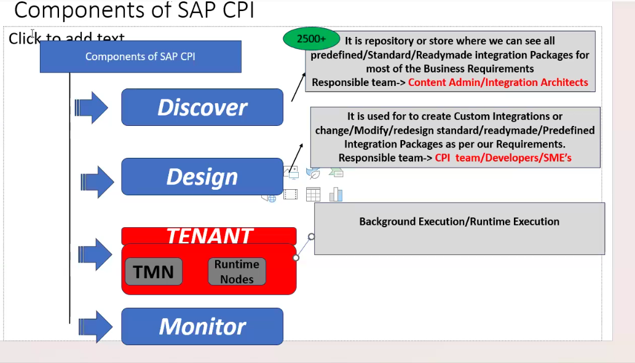
TMN-Supervisor node or administrate node.
It will monitor run time node. If any node is failed it will assign new node
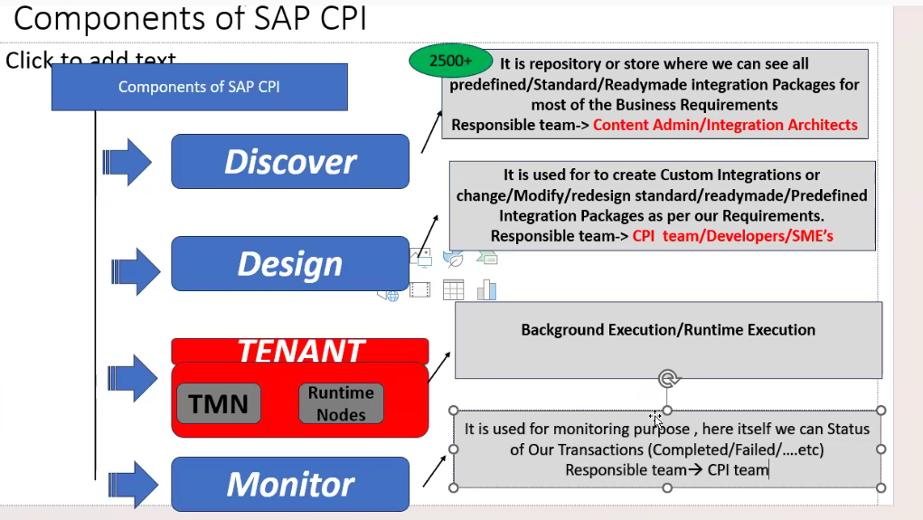

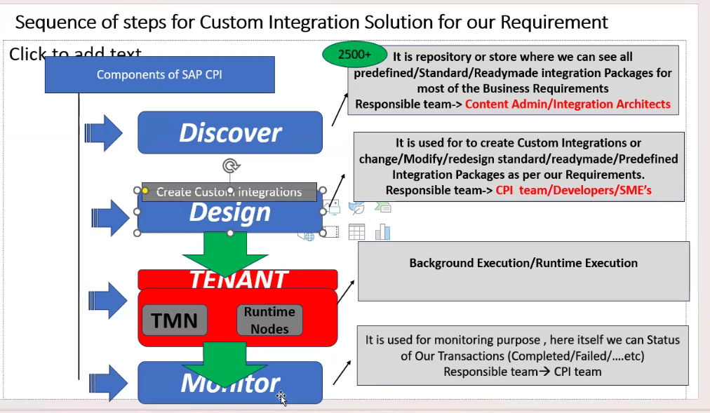
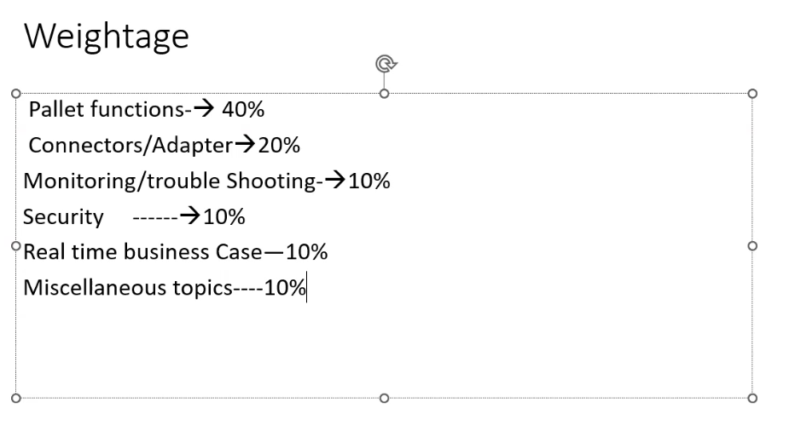

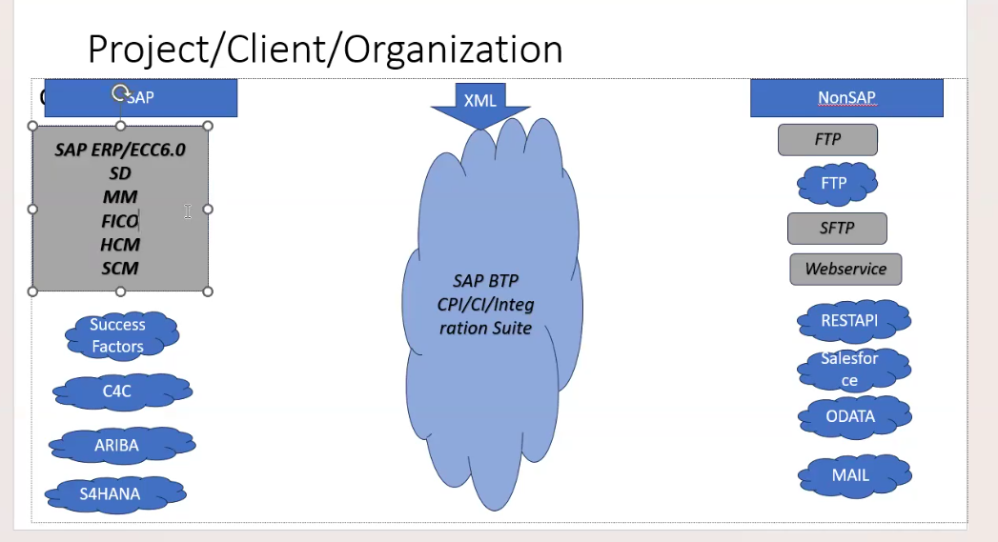

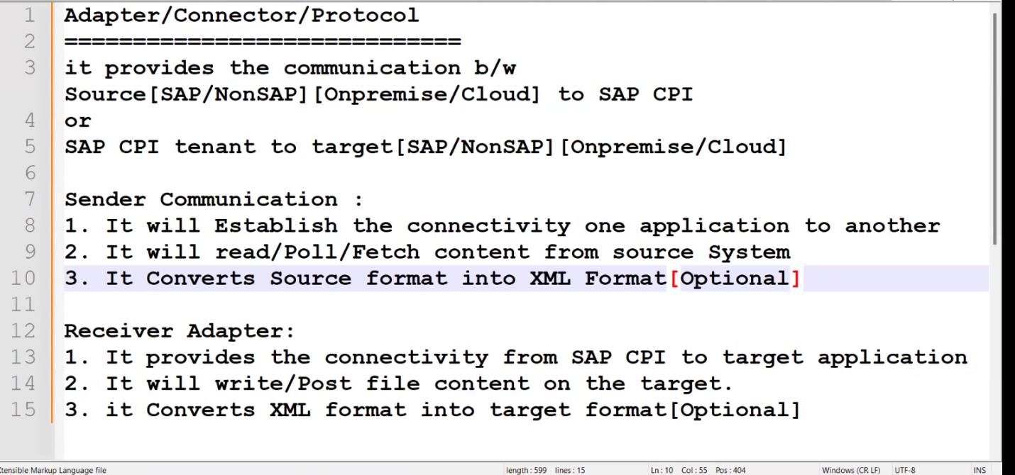

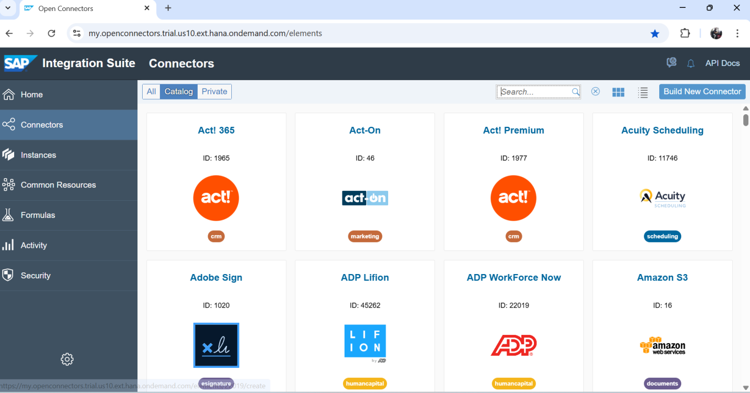

Stripe
BambooHr

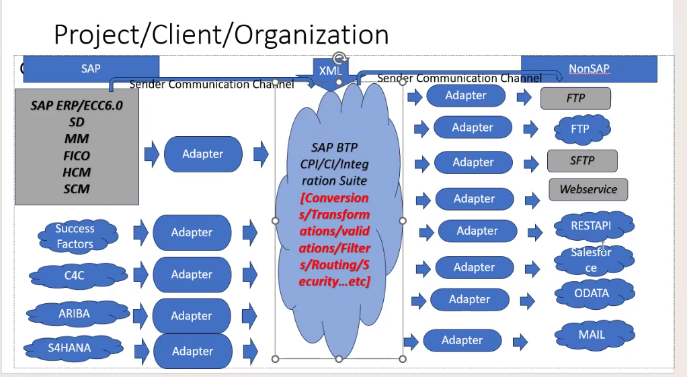
Root
Intermediate
Peer

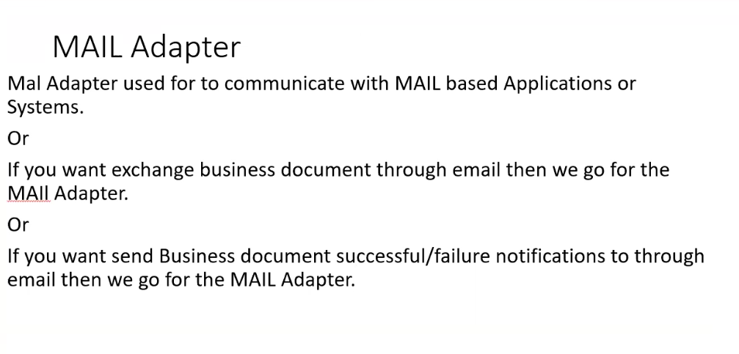
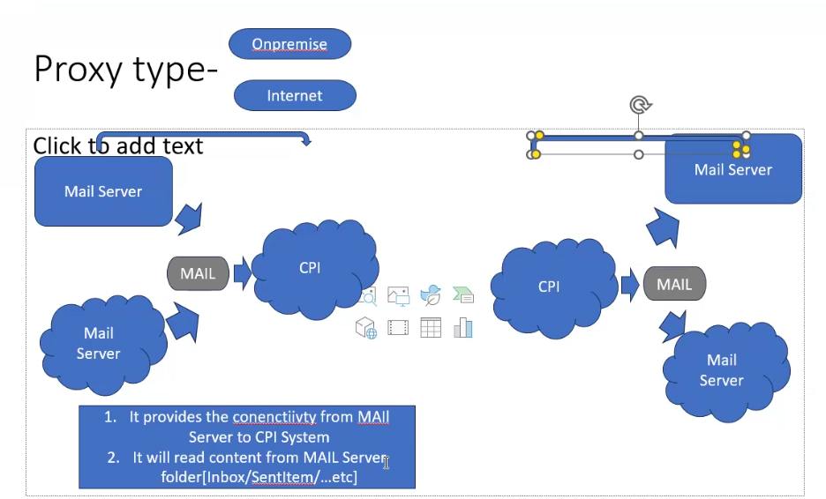
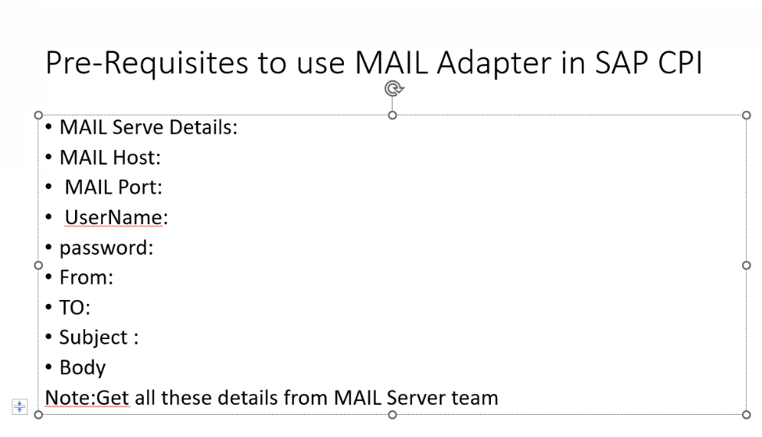

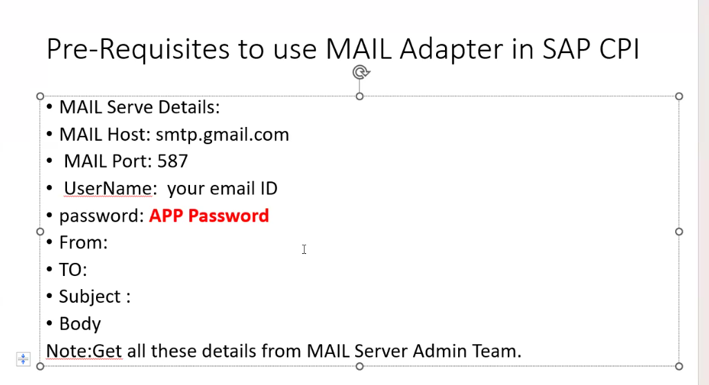

7th Class
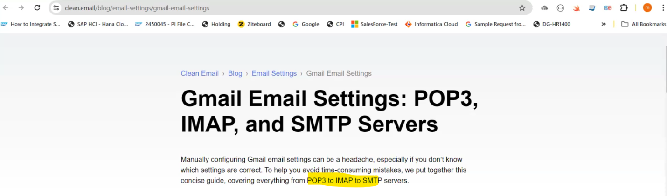

https://www.hesk.com/knowledgebase/index.php?article=72

8Th Class:
ADAPTORS
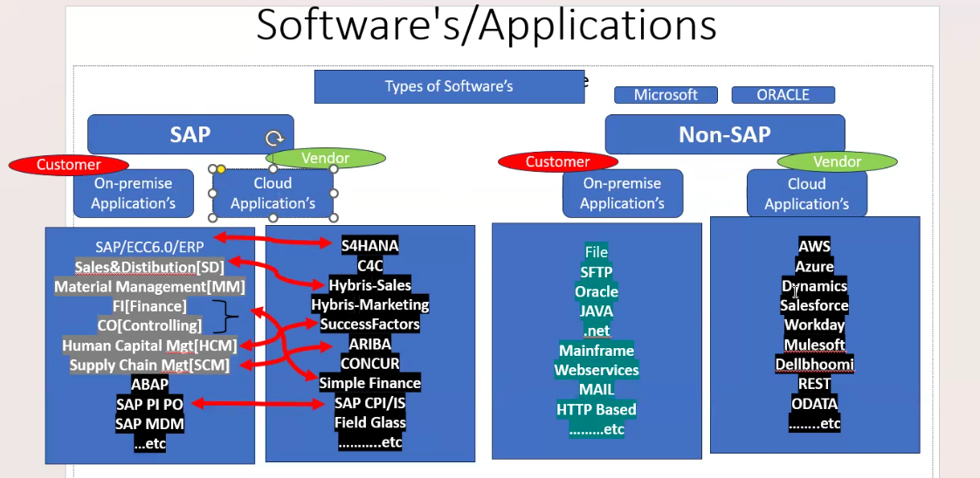

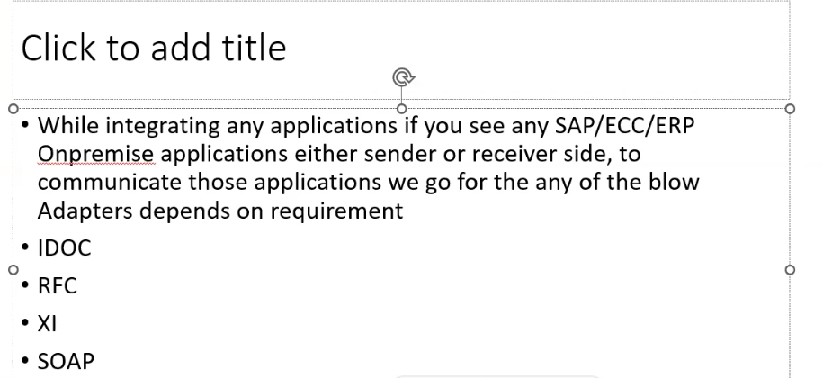

SOAP : SIMPLE OBJECT ACCESS PROTOCOL
IDOC: INTERMEDIATE DOCUMENT
RFC:REMOTE FUNCTION
XI: EXHANGE INFRACTURE

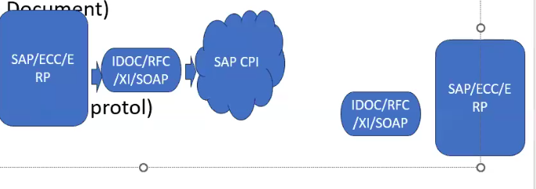
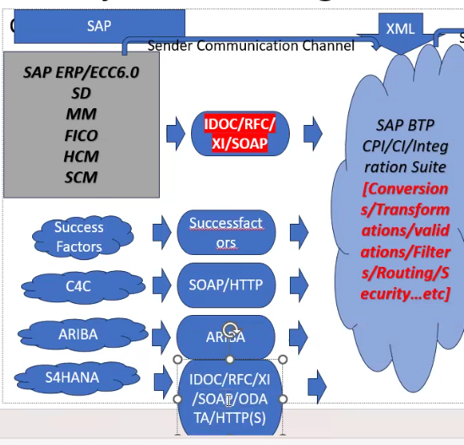

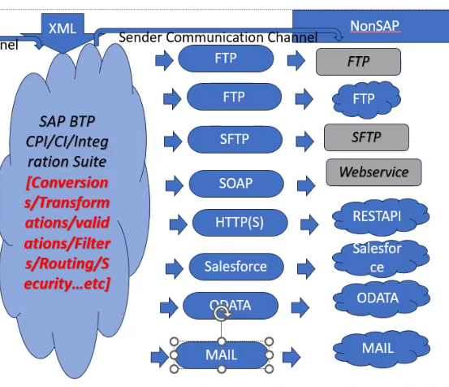

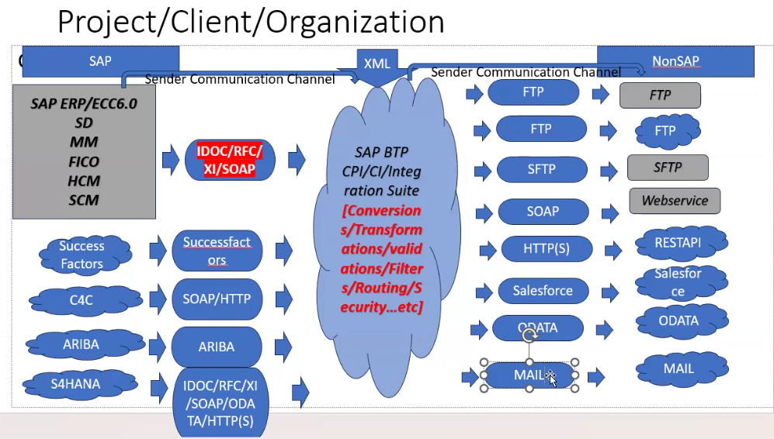

EVENT MESH : JMS
ARIBA: ARIBA
AS2: EDI
AZURE STORAGE: AZURE BASED APPLICATIONS
FTP:
HTTPS : REST BASED
IDOC: SAP
JMS : JAVA MESSAGING SERVICE QUEUE BASED
KAFKA : TAX BASED
MAIL : MAIL BASED APPLICATION
MICRO SOFT SHARE POINT : MICROSOFT
ODATA : ODATA APPLICATIONS
PROCESSDIRECT : TO CONNECT IN INTER FLOW IN CPI
SOAP: WEB SERIVE APPLIACTIONS
XI : SAP
SUCCESFATORS : SUCCESSFACTORS

S4 HANA: ON PREMISE/CLOUD (PUBLIC CLOUD AND PRIVATE CLOUD)
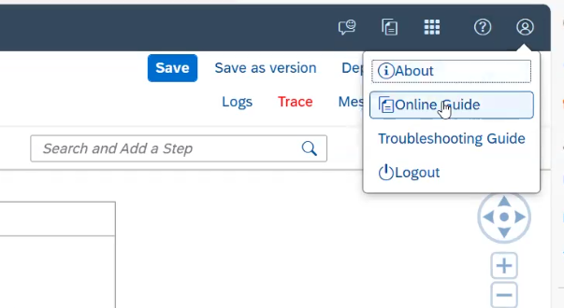
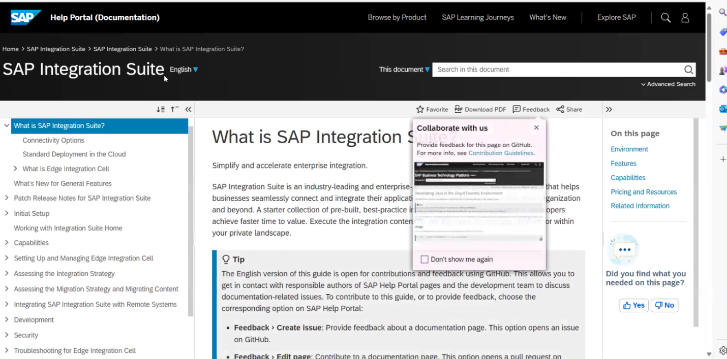
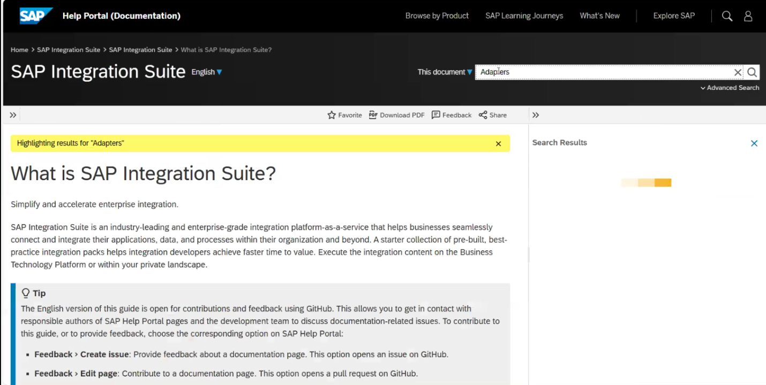
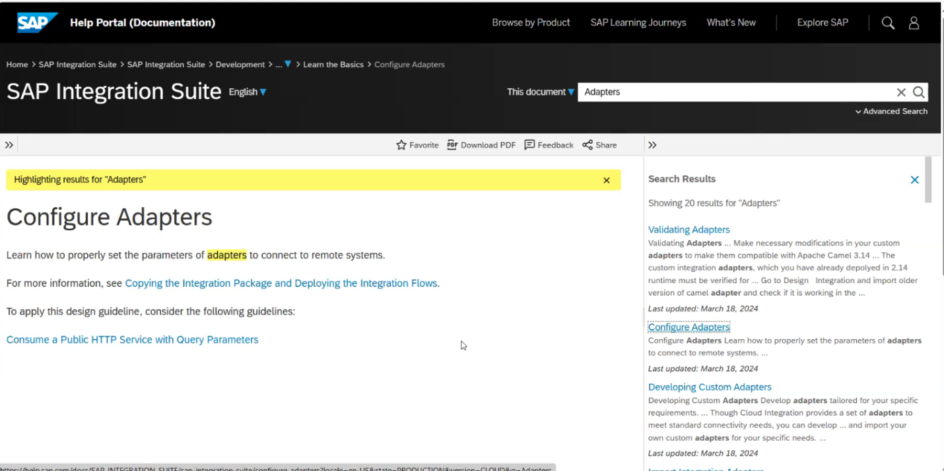
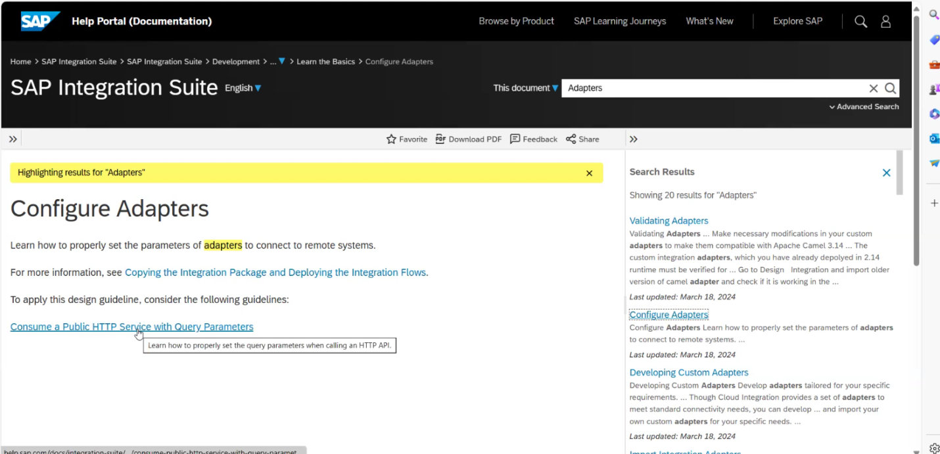

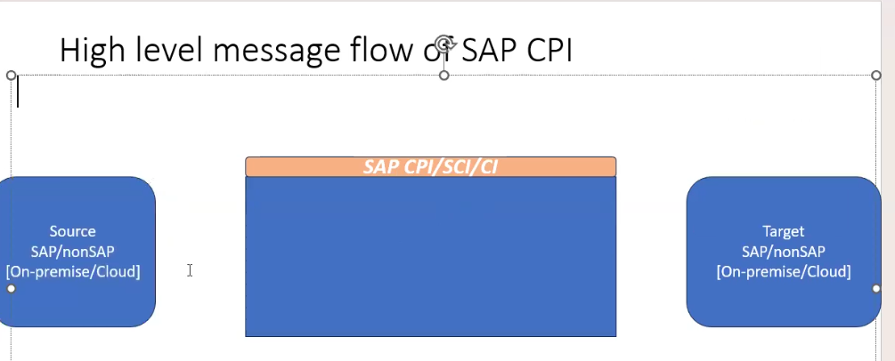

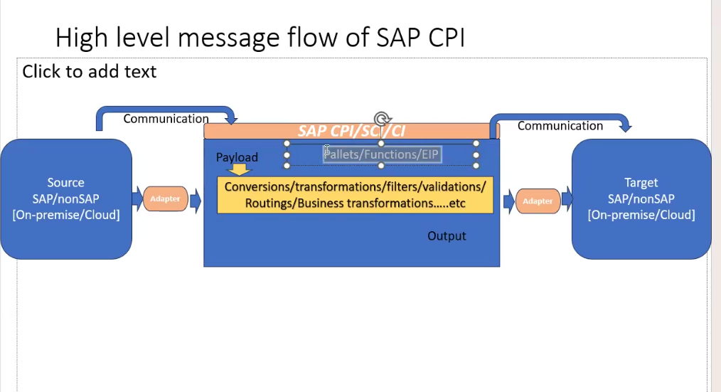
EIP = Enterprise integration pattern

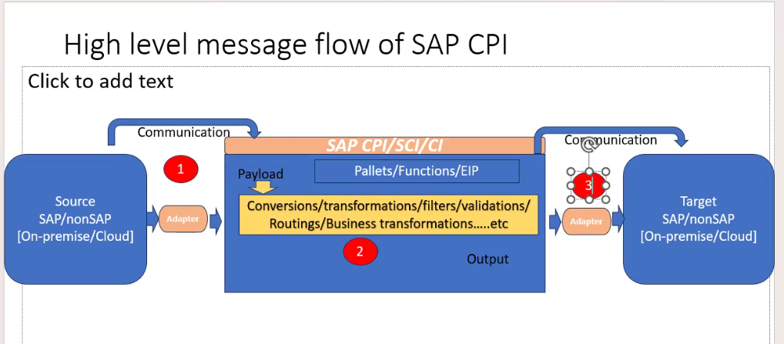
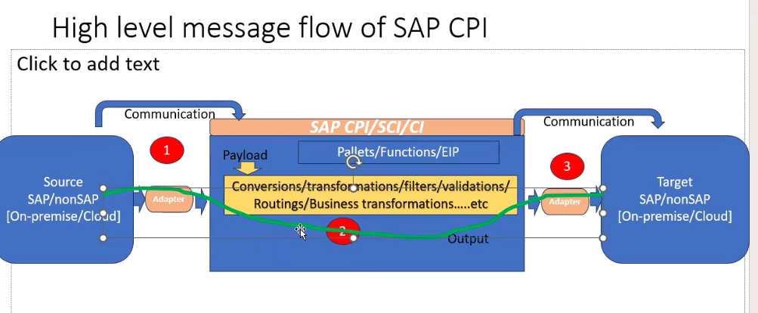

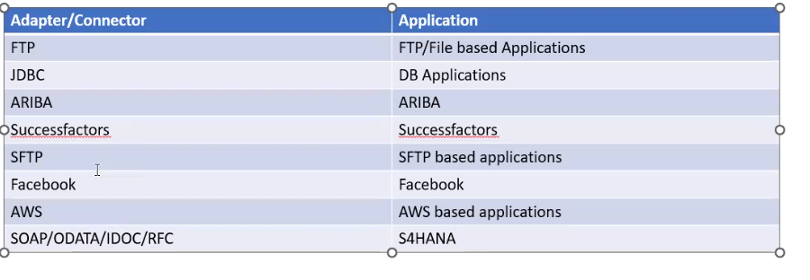
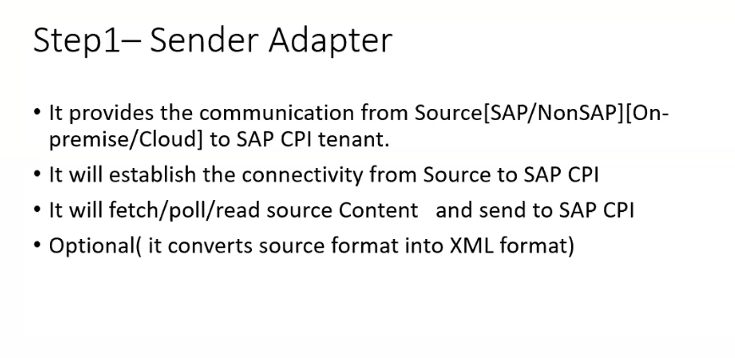
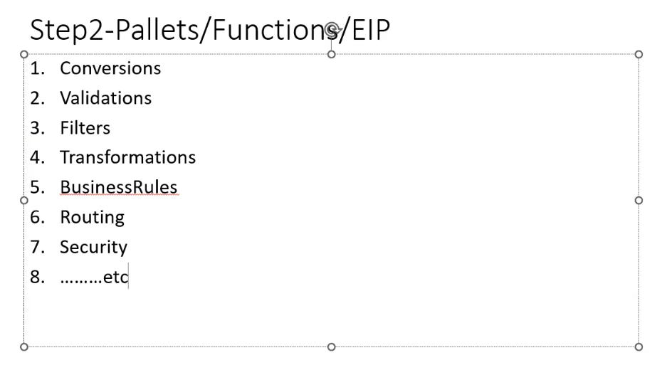
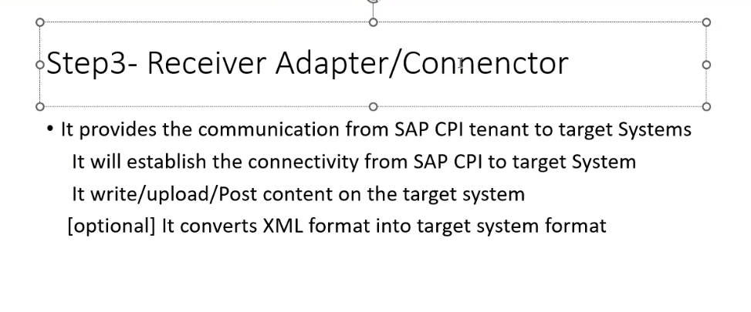

Task 1 : Need a write all pallets - 2 times

9th class:
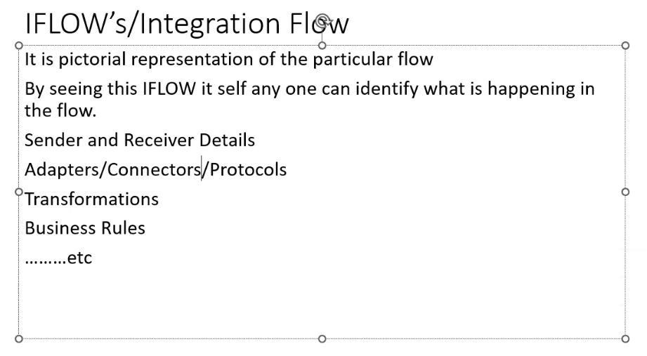

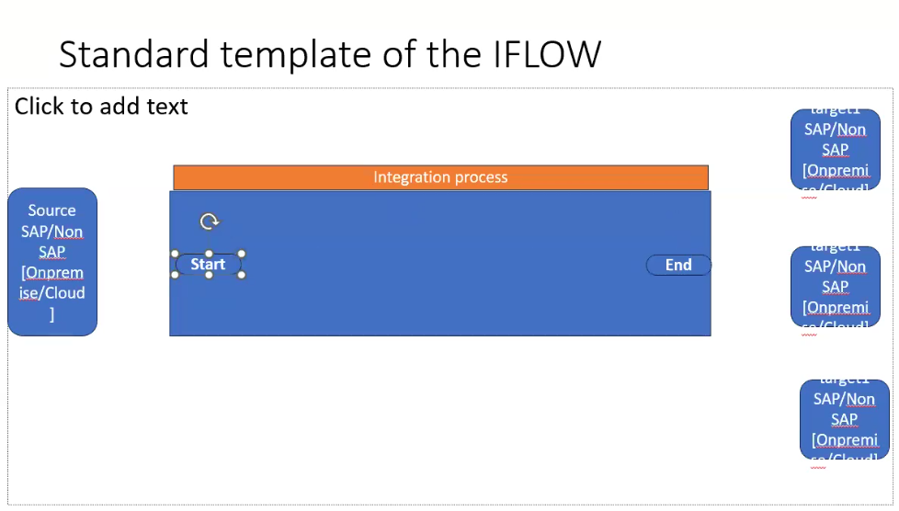
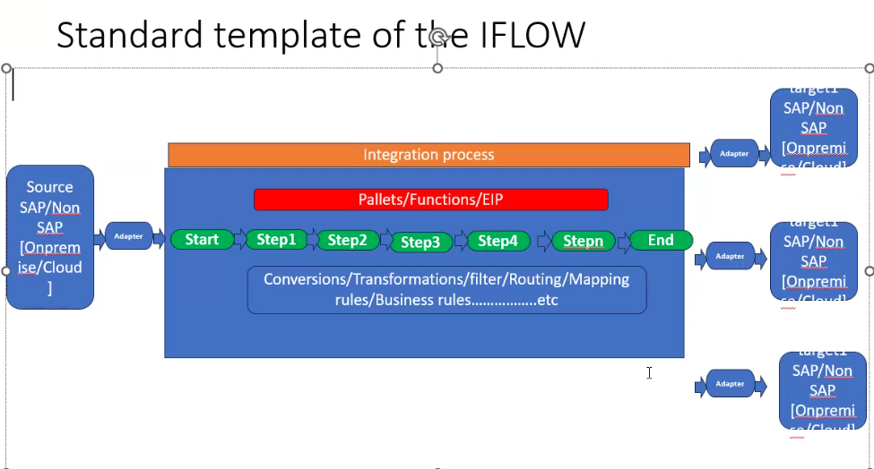
FTP Adaptor
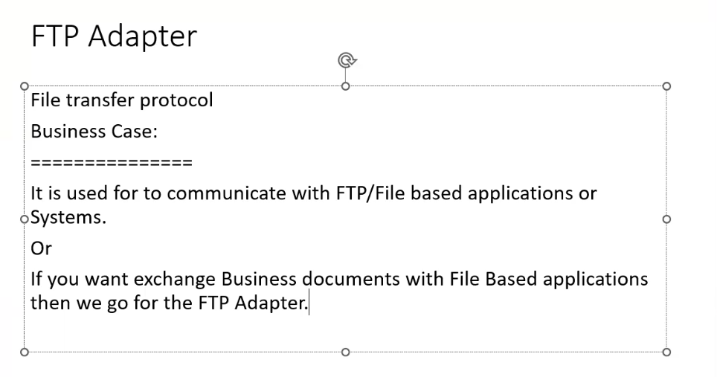
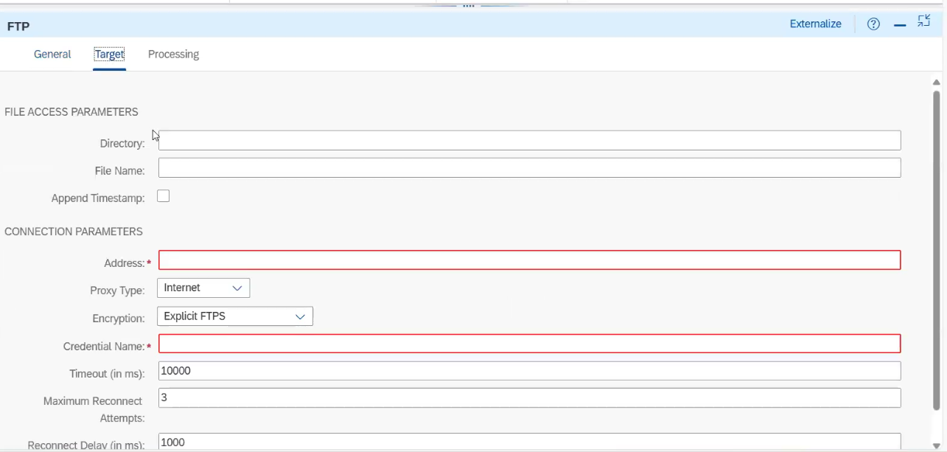
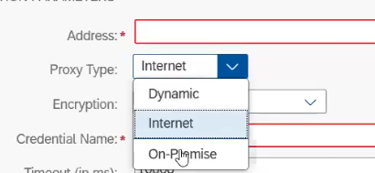

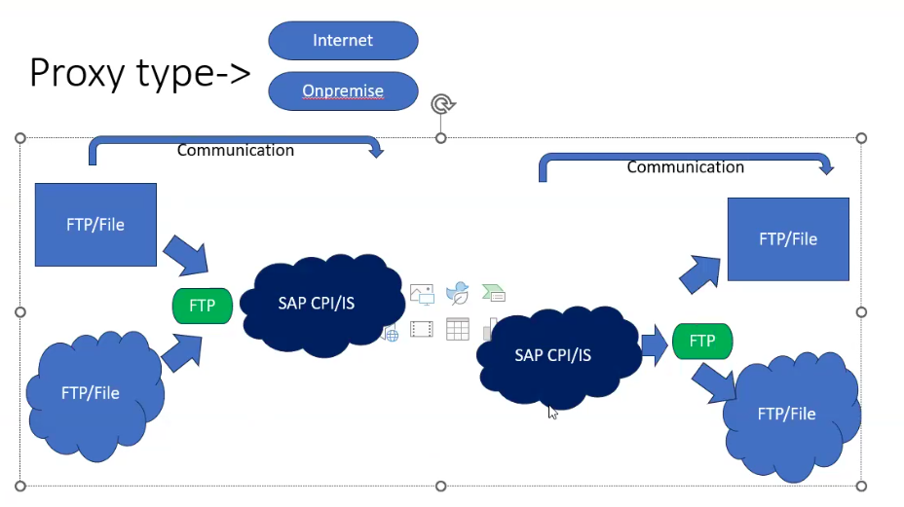

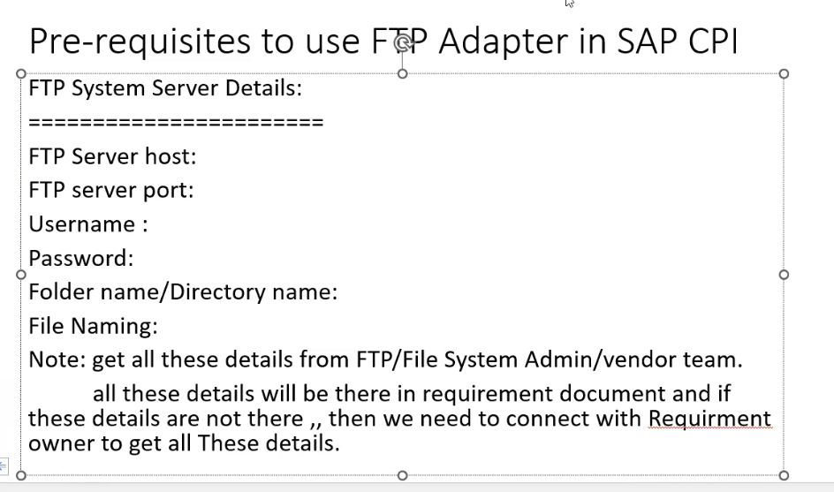

Demo server :
Dlptest.com/ftp-test/

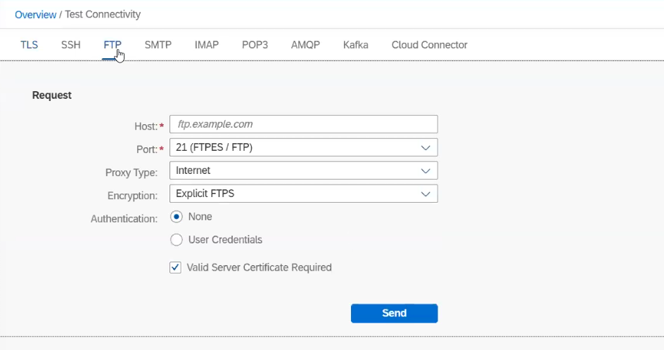
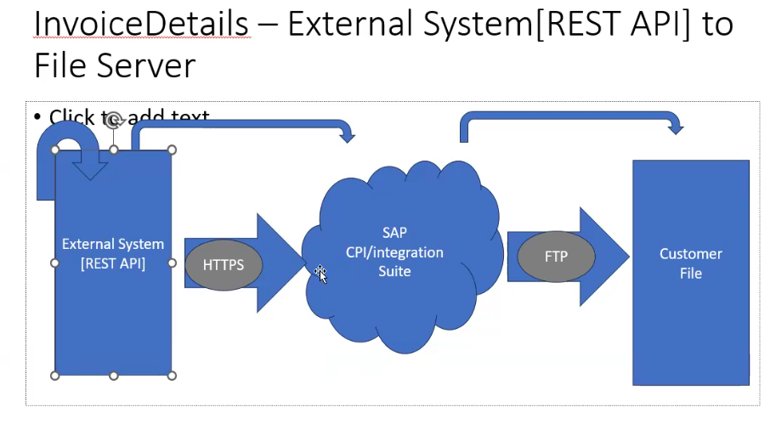
Content modifier: 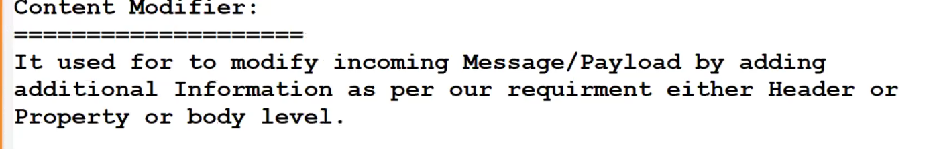
Content Modifier: Content modifier which is used to add additional information or additional data to the incoming message payload, here the data will be added in Message Header or Exchange property or message body level.
Here we have multiple number of Source Types that are available in the Content Modifier Expressions: If we want to fetch the data from the CPI Level using Camel expressions then we will use source type as Expressions. XPATH: If we want to fetch the particular data from input XML Payload then we will use source type as XPATH. Constant: If we want to create any constant field and if we want to assign the value for that field then we will use source type as Constant. Header: If we want to call header parameters then we will use source type as Header. Property: If we want to call the property parameters then we will use source type as Property.
Difference between message header and exchange property in content modifier Message header: whatever elements declared in message header that will replicate or populate in the receiver system. Exchange Property: The scope of the element declared in the exchange property is within in the scope of I-flow
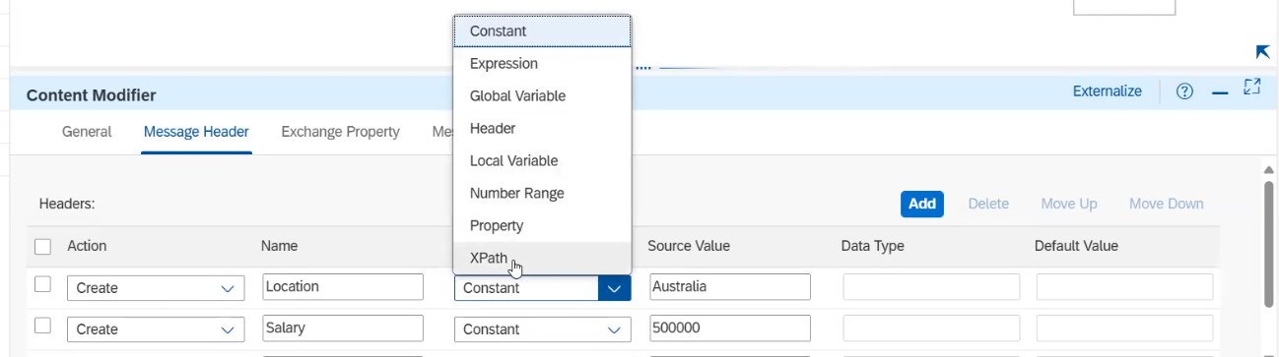
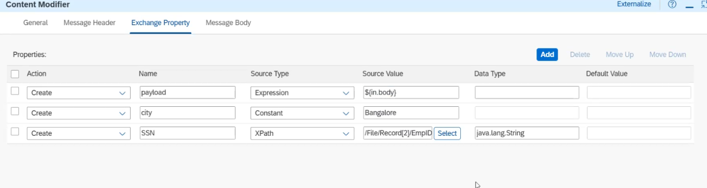
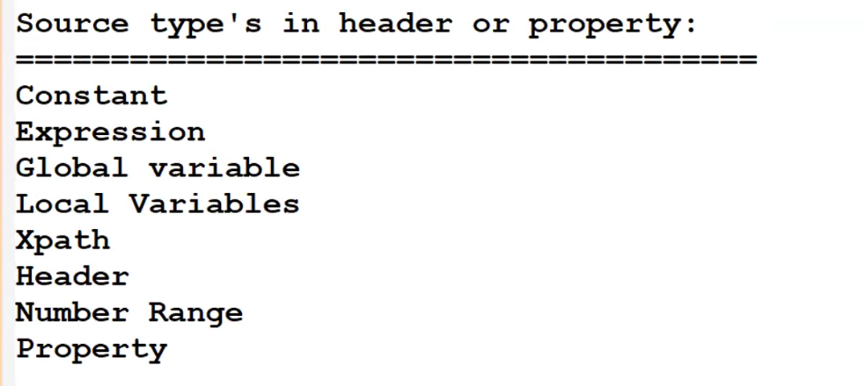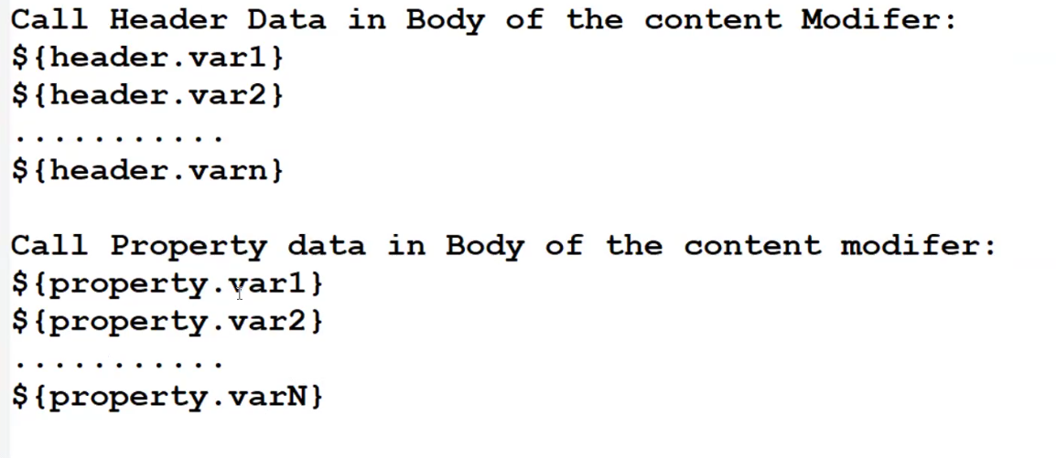
${in.body} : for payload
java.lang.String for xpath we can use data type
/customers/customer/address[2]/zip
//zip

If we are not passing any value [2] like this we will get first value

XPATH
Header and properties
https://help.sap.com/docs/cloud-integration/sap-cloud-integration/headers-and-exchange-properties-provided-by-integration-framework?locale=en-US&q=header+and+exchange+properties+provided+by+the+integration+framework

Sample payload:
<?xml version="1.0"?>
<customers>
<customer id="55000">
<name>Charter Group</name>
<address>
<street>100 Main</street>
<city>Framingham</city>
<state>MA</state>
<zip>01701</zip>
</address>
<address>
<street>720 Prospect</street>
<city>Framingham</city>
<state>MA</state>
<zip>01701</zip>
</address>
<address>
<street>120 Ridge</street>
<state>MA</state>
<zip>01760</zip>
</address>
</customer>
</customers>

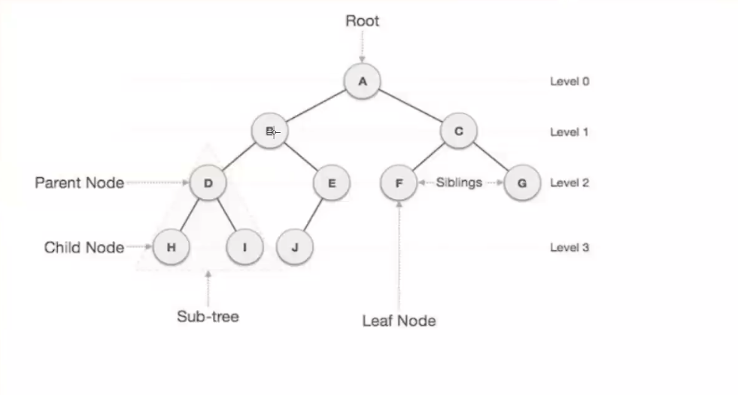
If we want allow headers to CPI then need to mention * in below highlited
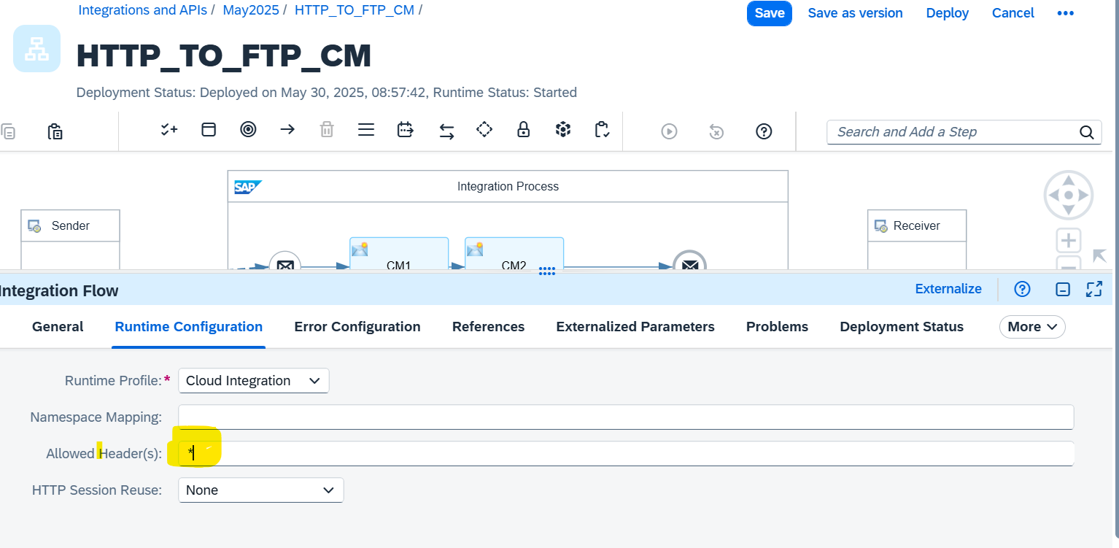
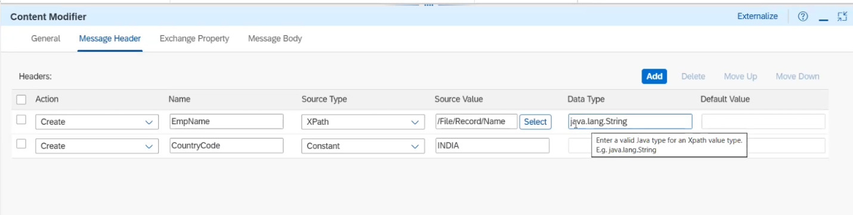

https://learning.sap.com/learning-journeys/developing-with-sap-integration-suite/explaining-the-camel-data-model-and-simple-expression-language_a5b1158e-da28-4dcf-818c-4273126903e7

Task 2: Need to populate third record zip value in output file

Router:
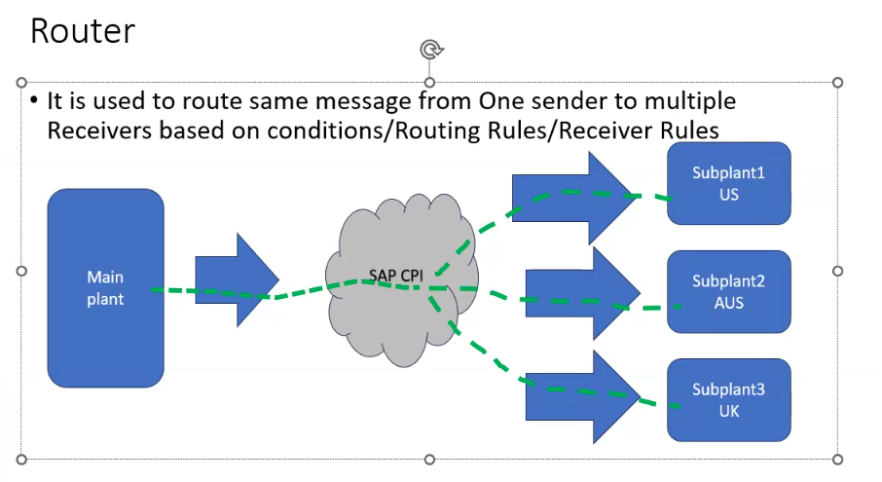
Based on value we can send the data by using.
Make a note : If any two condition satisfied it will pass first one condition only
XML and NON xml
<?xml version="1.0"?>
<customers>
<customer id="55000">
<name>Charter Group</name>
<address>
<street>100 Main</street>
<city>Vizag</city>
<state>Telangana</state>
<zip>01701</zip>
</address>
</customer>
</customers>

XML: XPATH need to maintain
/customers/customer/address/city = ‘Hyd’

NON XML : Expression need to use
Operator | Example
= | ${header.SenderId} = '1'
!= | ${header.SenderId} != '1'
> | ${header.SenderId} > '1'
>= | ${header.SenderId} >= '1'
< | ${header.SenderId} < '1'
<= | ${header.SenderId} <= '1'
and | ${header.SenderId}= '1' and ${header.ReceiverId} = '2'
or | ${header.SenderId}= '1' or ${header.ReceiverId}= '2'
contains | ${header.SenderId} contains '1'
not contains | ${header.SenderId} not contains '1'
in | ${header.SenderId} in '1,2'
not in | ${header.SenderId} not in '1,2'
regex | ${header.SenderId} regex '1.*'
not regex | ${header.SenderId} not regex '1.*'

Convertor
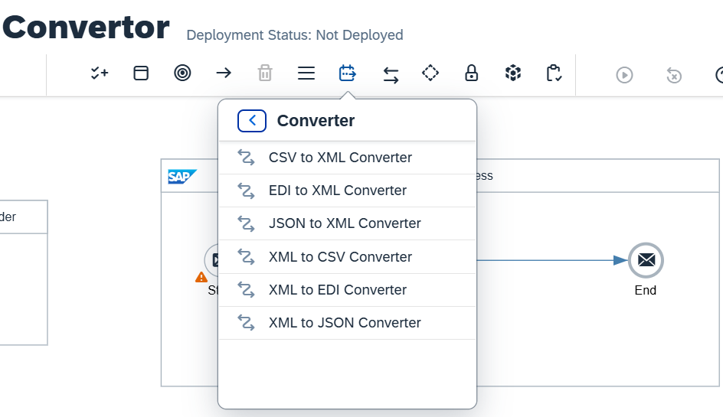
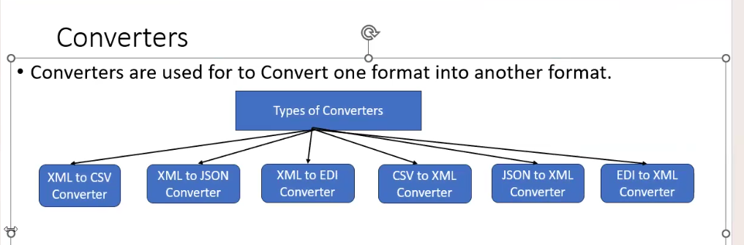
XML to CSV CONVERTOR: /
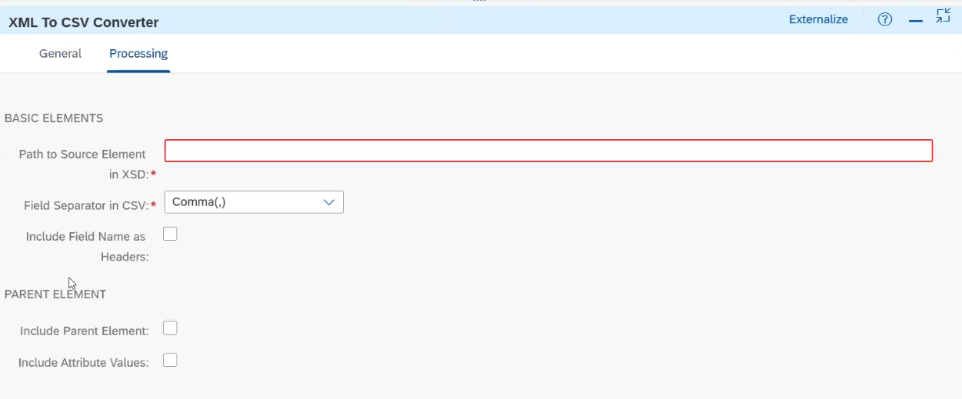
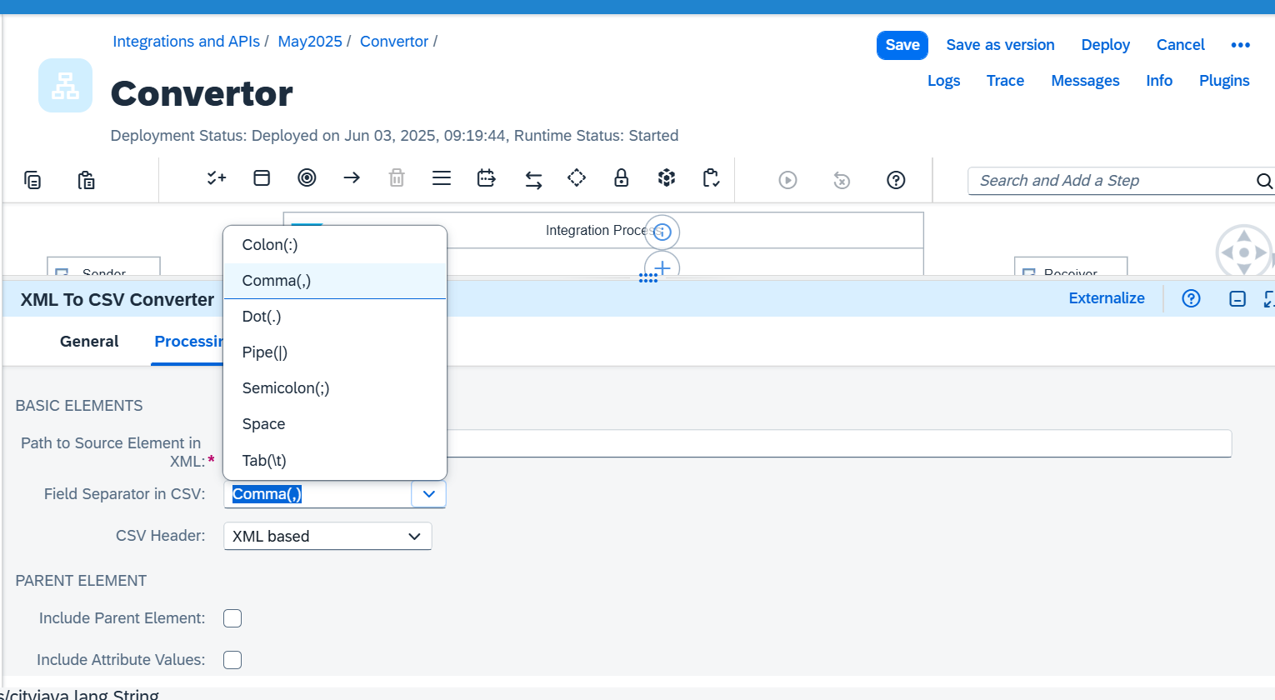
If we want customize field separator then we can hard code in Field separator in CSV option

CSV to XML Convertor: CSV TO XML converter is used to convert Text format into xml format.
Parameters: XML schema: we required receiver xsd structure.
Path to Target element in XSD: we need to maintain the XPATH to convert csv data to xml.
Filed Separator in CSV: We need to select what type of data that we getting from source (Comma, pipe delimited, Tab space delimited and others).
Exclude First Line Header: If we want to remove the header elements from the input text data then we will use this option.
CSV:
- It contains 1 or multiple rows/records
- It contains Header
- Field Separator-comma, pipe etc
- Fixed field length

Name,Phone,City,Pincode
Somi,9000044053,Hyd,500090
Hari,9000044055,Hyd,500090
Somi,9000044053,Hyd,500090

.txt or .csv

Type of files.
1.CSV
2.pipe
3.Tab
4.Fixedfield length
5.Semicolon
6.colon
7.Star

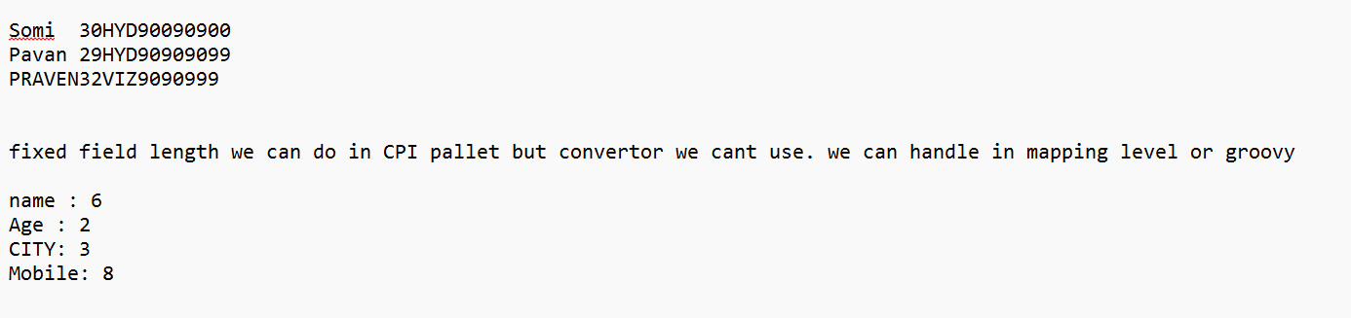

XML to XSD convertor:

https://www.liquid-technologies.com/online-xml-to-xsd-converter

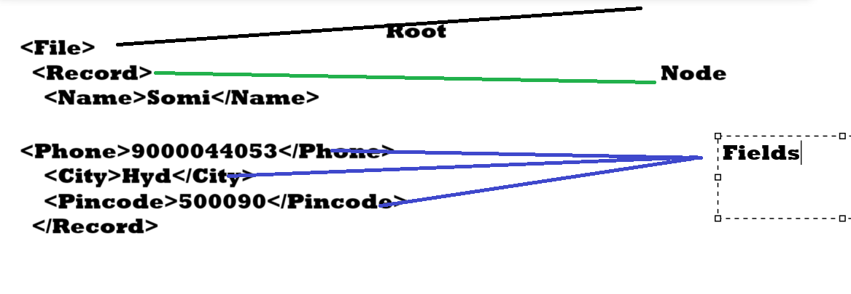
SAMPLE DATA

Name,Phone,city,Pincode
Somi,9000044053,Hyd,500090
Hari,9000044055,Hyd,500090
Somi,9000044053,Hyd,500090
----------------------------------------
<?xml version="1.0" encoding="UTF-8"?>
<File>
<Record>
<Name>Somi</Name>
<Phone>9000044053</Phone>
<City>Hyd</City>
<Pincode>500090</Pincode>
</Record>
<Record>
<Name>Hari</Name>
<Phone>9000044055</Phone>
<City>Hyd</City>
<Pincode>500090</Pincode>
</Record>
<Record>
<Name>Somi</Name>
<Phone>9000044053</Phone>
<City>Hyd</City>
<Pincode>500090</Pincode>
</Record>
</File>
------------------------------------------

minOccurs="0" maxOccurs="unbounded" --->minimum 0 ,maximum-n no of times
maxOccurs="unbounded"---->minimum 1 ,maximum-n no of times
<xs:element minOccurs="0" name="Name" type="xs:string" />----> minimum-0, maximum-1
------------------------------------------------------------------------------------------------------------------------------

<?xml version="1.0" encoding="utf-8"?>
<xs:schema attributeFormDefault="unqualified" elementFormDefault="qualified" xmlns:xs="http://www.w3.org/2001/XMLSchema">
<xs:element name="File">
<xs:complexType>
<xs:sequence>
<xs:element minOccurs="0" maxOccurs="unbounded" name="Record">
<xs:complexType>
<xs:sequence>
<xs:element minOccurs="0" name="Name" type="xs:string" />
<xs:element minOccurs="0" name="Phone" type="xs:string" />
<xs:element minOccurs="0" name="City" type="xs:string" />
<xs:element minOccurs="0" name="Pincode" type="xs:string" />
</xs:sequence>
</xs:complexType>
</xs:element>
</xs:sequence>
</xs:complexType>
</xs:element>
</xs:schema>
============================================================================

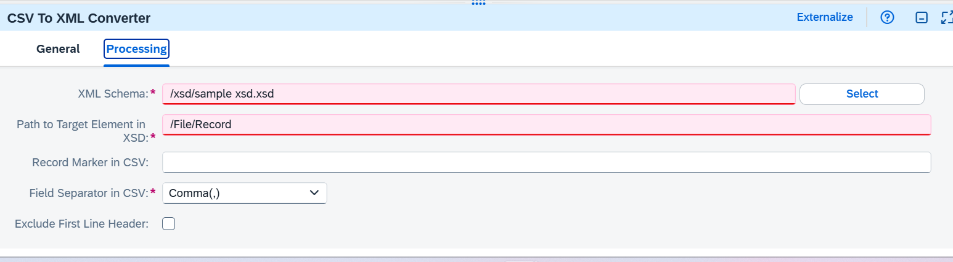
Record Marker in csv is used to if any record starts with particular value then that value need to maintain in that example in below. In the xsd no need to maintain that field in the xsd
Input:
Key,Name,Email,Company,City,Pincode
1,Somi,abc@gmail.com,LTI,HYD,500099
1,Satish,abc@gmail.com,LTI,HYD,500099
2,Pavan,123@gmail.com,DELO,HYD,500099

Output:

<?xml version='1.0' encoding='UTF-8'?>
<root>
<row>
<Name>Somi</Name>
<Email>abc@gmail.com</Email>
<Company>LTI</Company>
<City>HYD</City>
<Pincode>500099</Pincode>
</row>
<row>
<Name>Satish</Name>
<Email>abc@gmail.com</Email>
<Company>LTI</Company>
<City>HYD</City>
<Pincode>500099</Pincode>
</row>
</root>

Task: HTTP—CSV to XML---XML to CSV—FTP interface

JSON: Java simple object notation
https://jsonformatter.org/xml-to-json
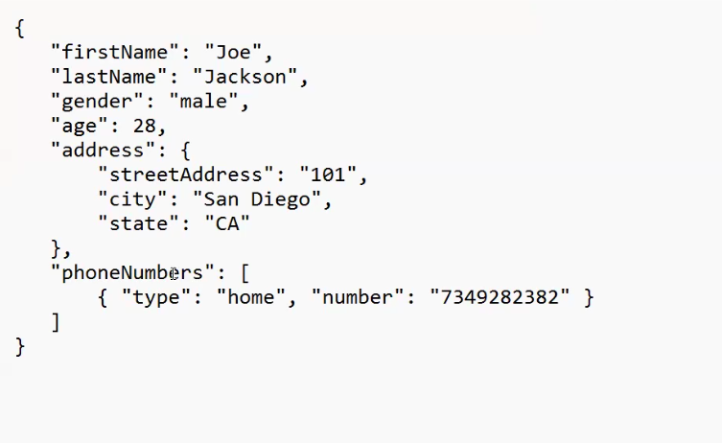
[ ]—Array
{ }—Object
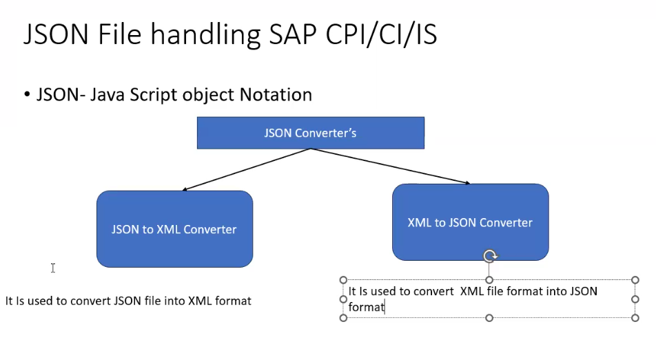
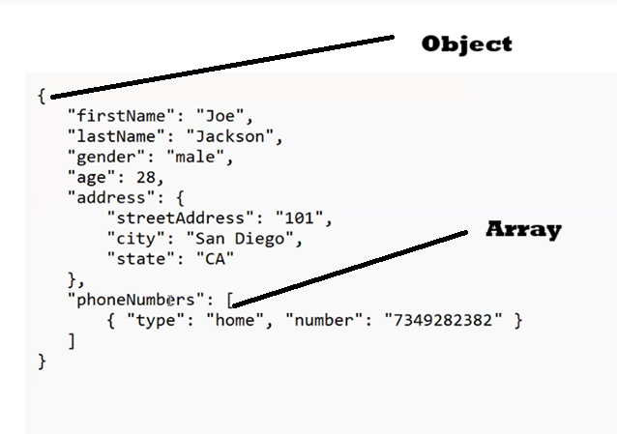
1.Data is in name/value pairs
2.Data is separated by comma
3.curly brace hold objects {}
4.Square brackets hold arrays []
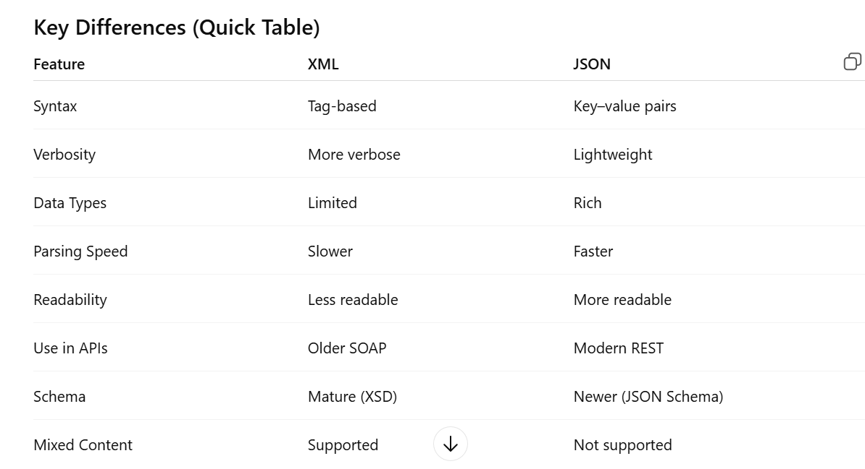

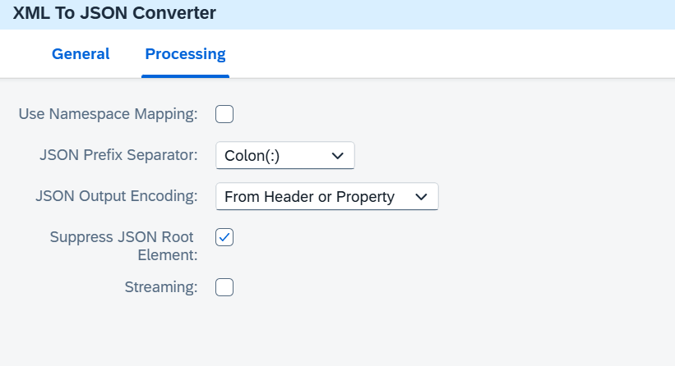

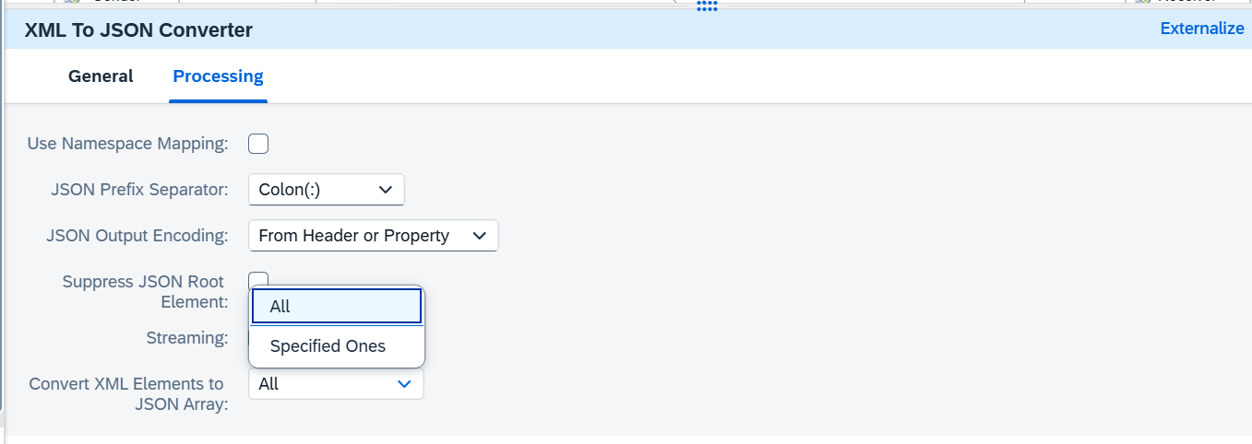

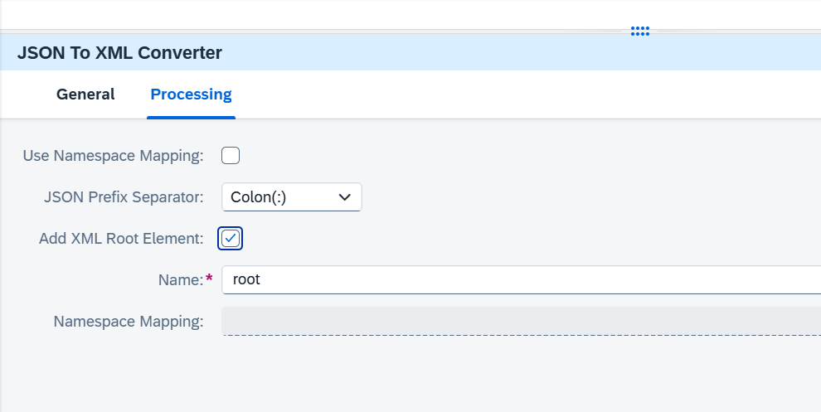
- If it is one record add xml root element is not required or optional.
- If we have multiple records without root In Josn file then it is mandatory to select that option in pallet for xml file generation.
<?xml version="1.0" encoding="UTF-8"?>
<library
xmlns="http://example.com/library">
<book>
<title>XML Basics</title>
<author>John Doe</author>
</book>
<book>
<title>Advanced XML</title>
<author>Jane Smith</author>
</book>
</library>

Monitoring:
Type of status in message monitoring
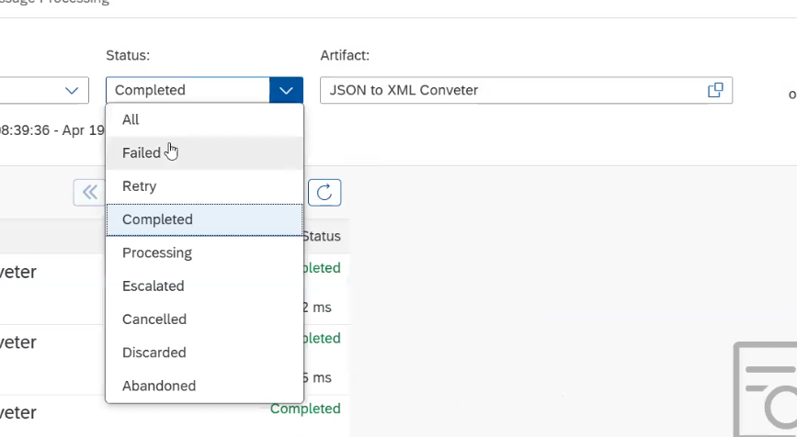

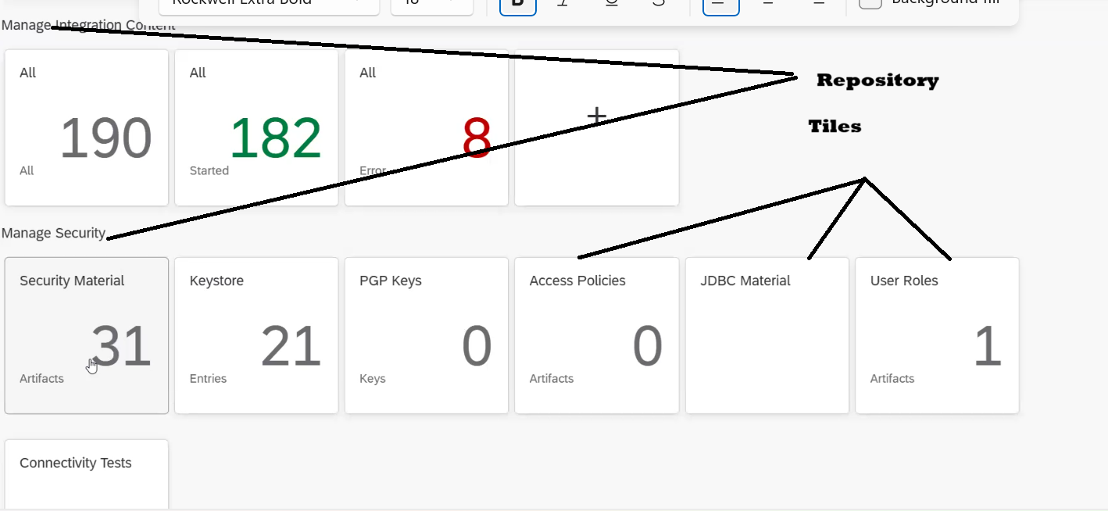
Multicast:
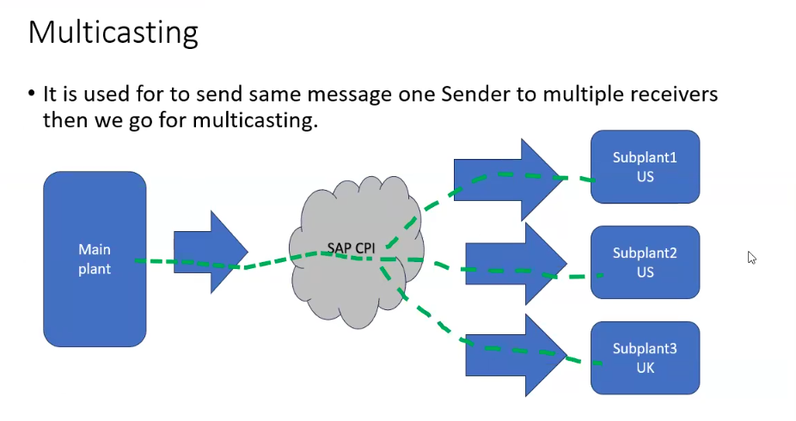
1. Parallel multicast
2. Sequential cast
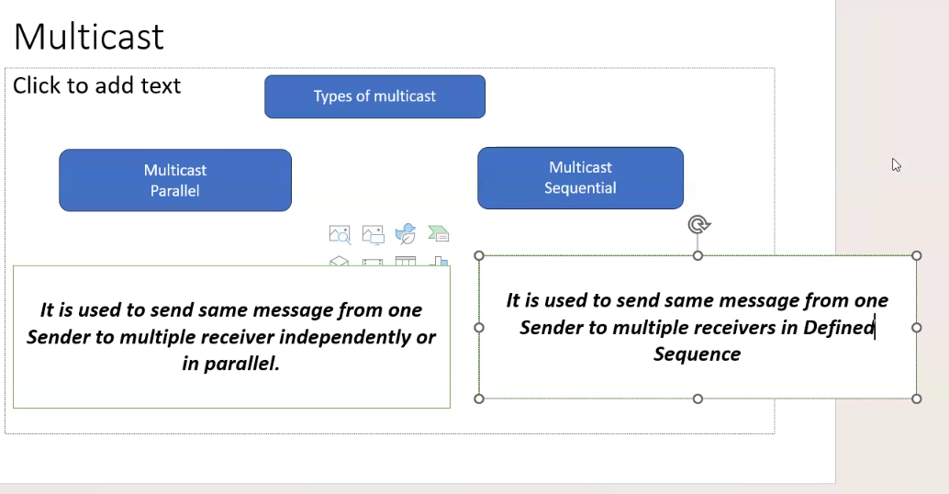
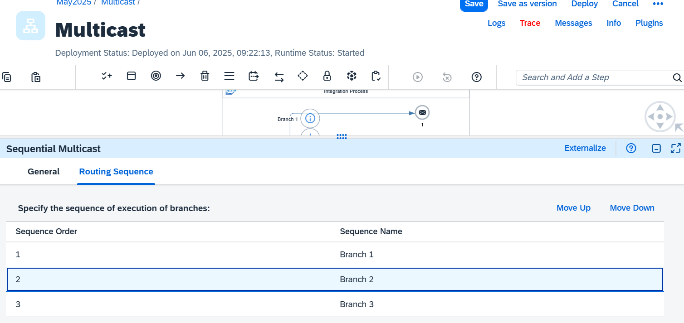
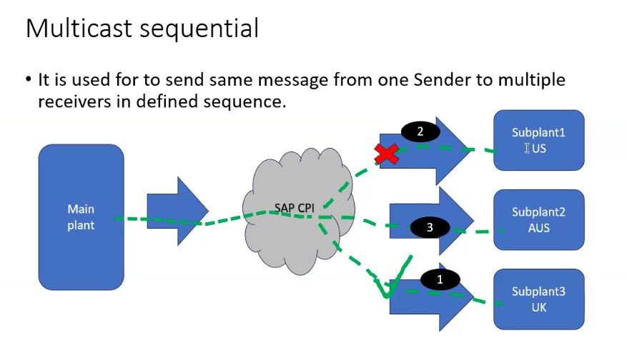

Exception sub process:
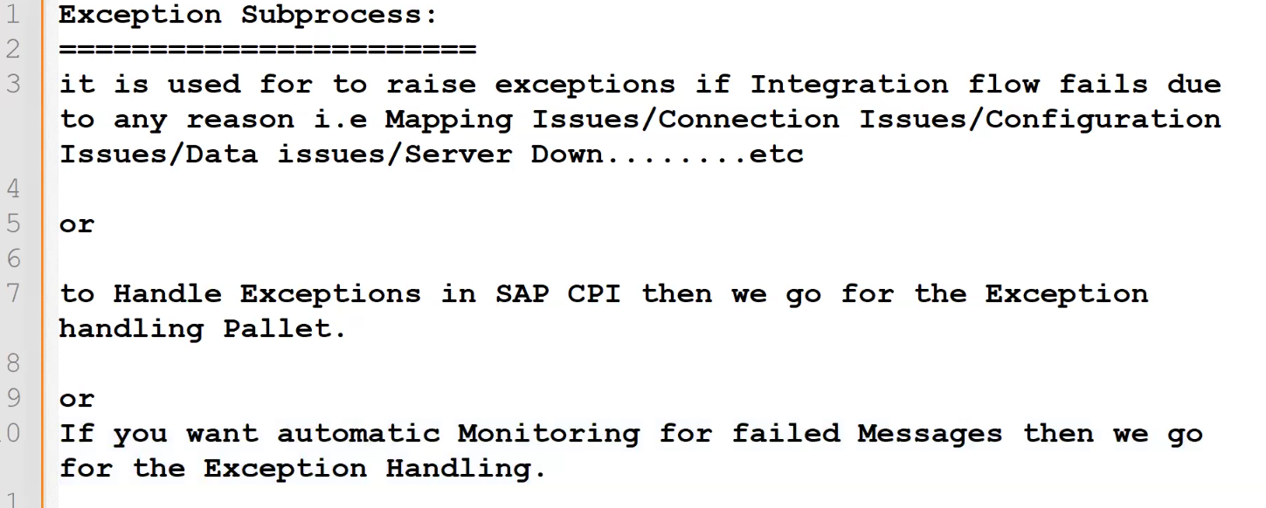
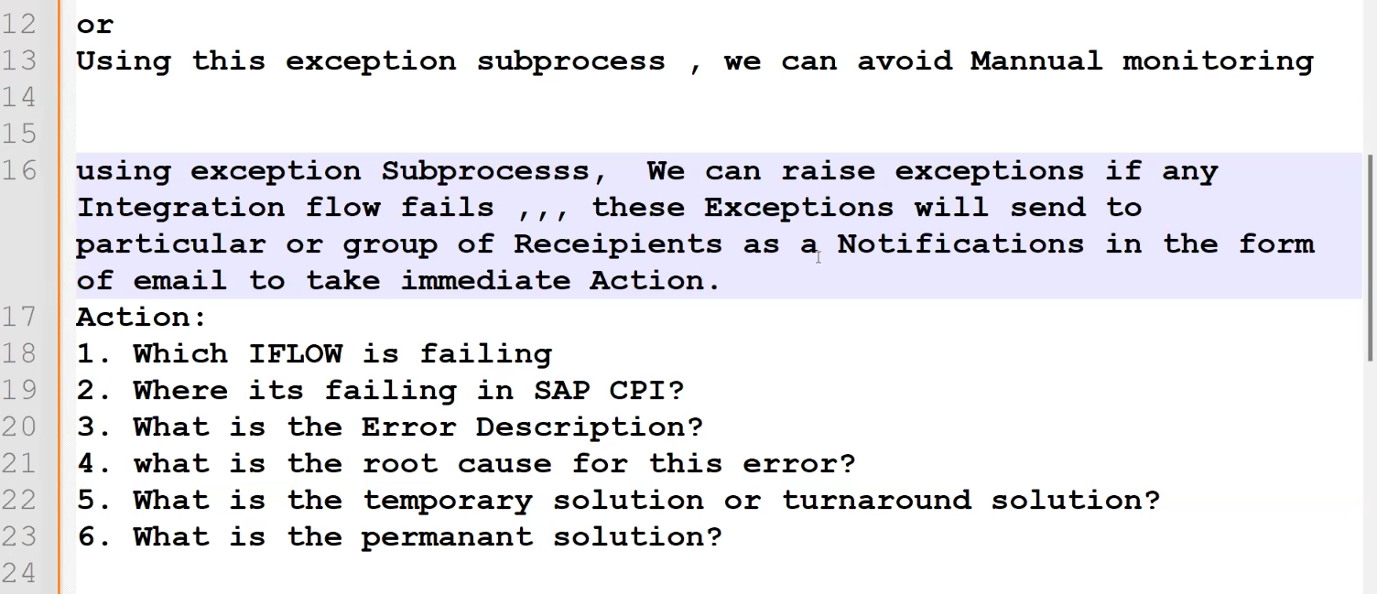
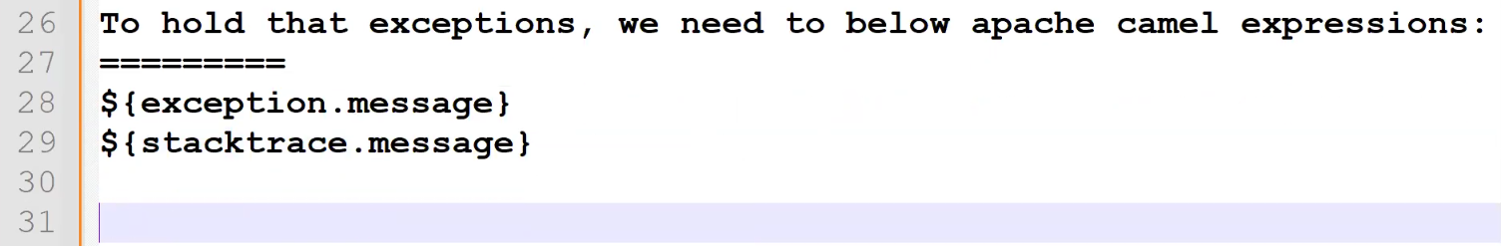
${exception.stacktrace}
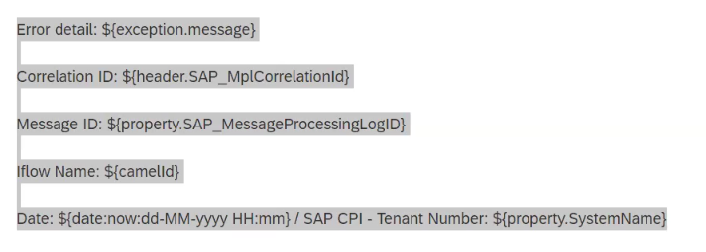
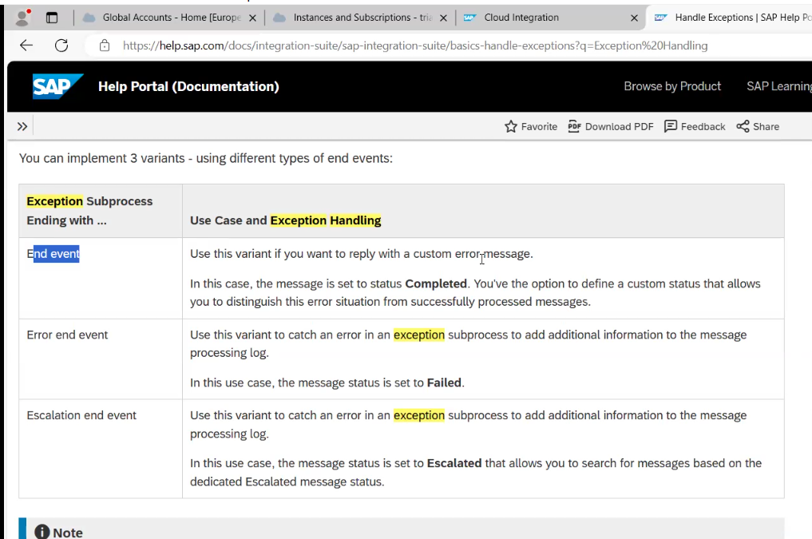

Error End Event: It will show the status failed in cpi and it won’t send any notification back to the source.

End Message: it will show completed in cpi but it will send status failed to the source.
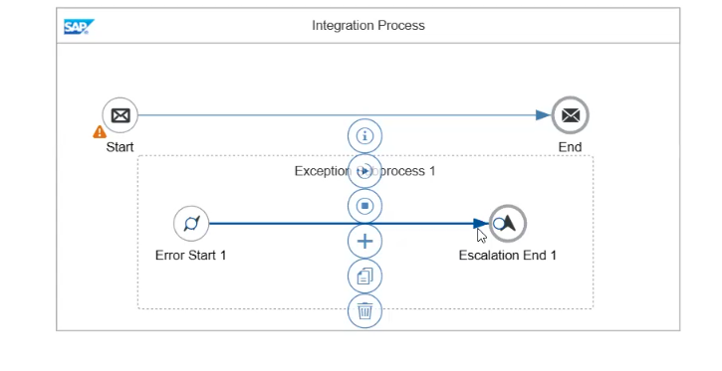
UDMS: User defined message search: Custom Id created in monitoring for tracking.
Below parameters need to maintain in CM for name and value.
https://help.sap.com/docs/cloud-integration/sap-cloud-integration/using-camel-simple-expression-language
Header and properties
https://help.sap.com/docs/cloud-integration/sap-cloud-integration/headers-and-exchange-properties-provided-by-integration-framework?locale=en-US&q=header+and+exchange+properties+provided+by+the+integration+framework

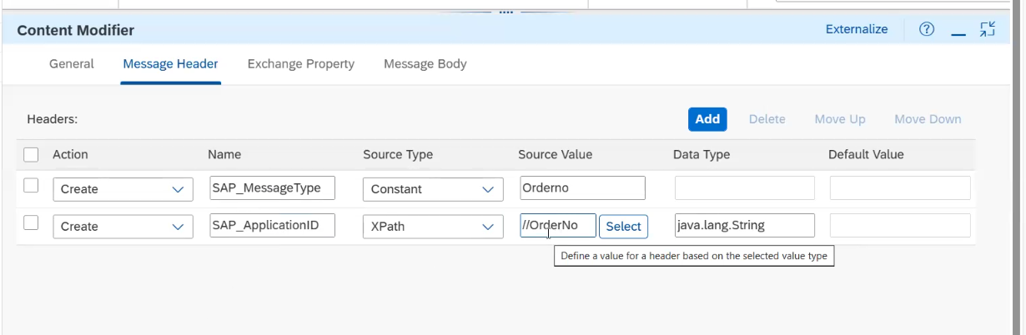

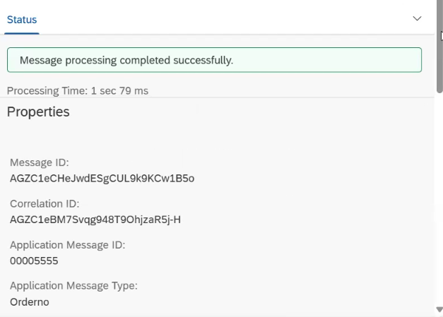

Odata adapter
:
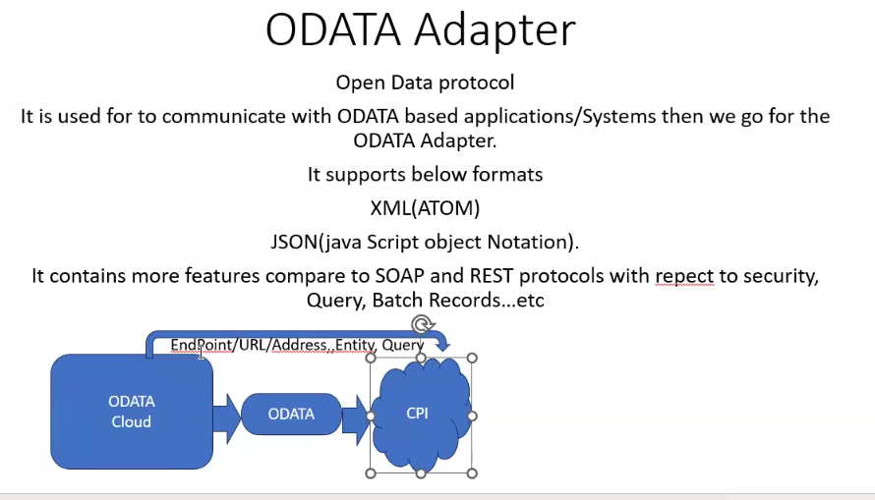
https://www.odata.org/documentation/odata-version-2-0/uri-conventions/
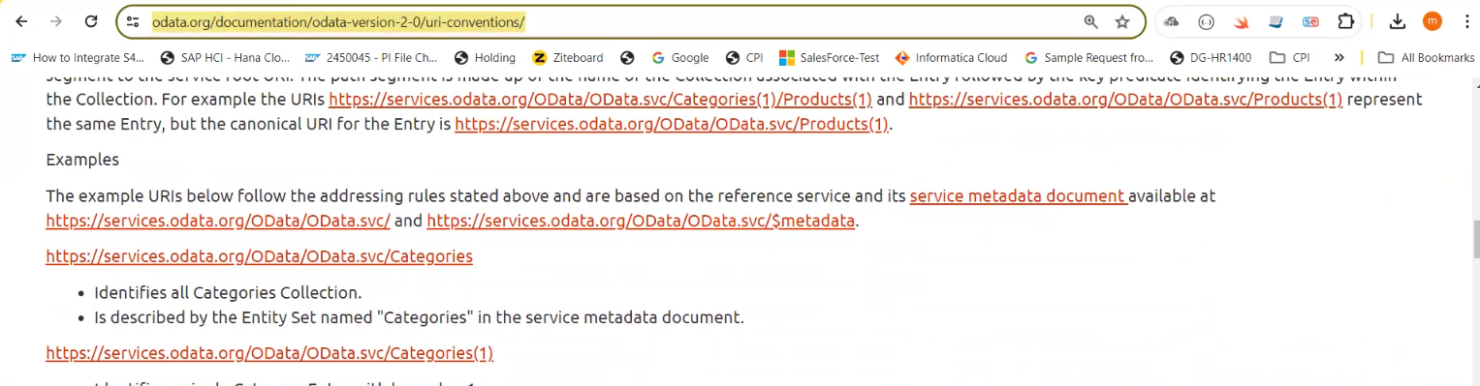

The operators supported in the expression language are shown in the following table.
Operator | Description | Example
Logical Operators
Eq | Equal | /Suppliers?$filter=Address/City eq 'Redmond'
Ne | Not equal | /Suppliers?$filter=Address/City ne 'London'
Gt | Greater than | /Products?$filter=Price gt 20
Ge | Greater than or equal | /Products?$filter=Price ge 10
Lt | Less than | /Products?$filter=Price lt 20
Le | Less than or equal | /Products?$filter=Price le 100
And | Logical and | /Products?$filter=Price le 200 and Price gt 3.5
Or | Logical or | /Products?$filter=Price le 3.5 or Price gt 200
Not | Logical negation | /Products?$filter=not endswith(Description,'milk')
Arithmetic Operators
Add | Addition | /Products?$filter=Price add 5 gt 10
Sub | Subtraction | /Products?$filter=Price sub 5 gt 10
Mul | Multiplication | /Products?$filter=Price mul 2 gt 2000
Div | Division | /Products?$filter=Price div 2 gt 4
Mod | Modulo | /Products?$filter=Price mod 2 eq 0
Grouping Operators
( ) | Precedence grouping | /Products?$filter=(Price sub 5) gt 10
In addition to operators, a set of functions are also defined for use with the filter query string operator. The following table lists the available functions. Note: ISNULL or COALESCE operators are not defined. Instead, there is a null literal which can be used in comparisons.
Function | Example
String Functions
bool substringof(string po, string p1) | https://services.odata.org/Northwind/Northwind.svc/Customers?$filter=substringof('Alfreds', CompanyName) eq true
bool endswith(string p0, string p1) | https://services.odata.org/Northwind/Northwind.svc/Customers?$filter=endswith(CompanyName, 'Futterkiste') eq true
bool startswith(string p0, string p1) | https://services.odata.org/Northwind/Northwind.svc/Customers?$filter=startswith(CompanyName, 'Alfr') eq true
int length(string p0) | https://services.odata.org/Northwind/Northwind.svc/Customers?$filter=length(CompanyName) eq 19
int indexof(string p0, string p1) | https://services.odata.org/Northwind/Northwind.svc/Customers?$filter=indexof(CompanyName, 'lfreds') eq 1
string replace(string p0, string find, string replace) | https://services.odata.org/Northwind/Northwind.svc/Customers?$filter=replace(CompanyName, ' ', '') eq 'AlfredsFutterkiste'
string substring(string p0, int pos) | https://services.odata.org/Northwind/Northwind.svc/Customers?$filter=substring(CompanyName, 1) eq 'lfreds Futterkiste'
string substring(string p0, int pos, int length) | https://services.odata.org/Northwind/Northwind.svc/Customers?$filter=substring(CompanyName, 1, 2) eq 'lf'
string tolower(string p0) | https://services.odata.org/Northwind/Northwind.svc/Customers?$filter=tolower(CompanyName) eq 'alfreds futterkiste'
string toupper(string p0) | https://services.odata.org/Northwind/Northwind.svc/Customers?$filter=toupper(CompanyName) eq 'ALFREDS FUTTERKISTE'
string trim(string p0) | https://services.odata.org/Northwind/Northwind.svc/Customers?$filter=trim(CompanyName) eq 'Alfreds Futterkiste'
string concat(string p0, string p1) | https://services.odata.org/Northwind/Northwind.svc/Customers?$filter=concat(concat(City, ', '), Country) eq 'Berlin, Germany'
Date Functions
int day(DateTime p0) | https://services.odata.org/Northwind/Northwind.svc/Employees?$filter=day(BirthDate) eq 8
int hour(DateTime p0) | https://services.odata.org/Northwind/Northwind.svc/Employees?$filter=hour(BirthDate) eq 0
int minute(DateTime p0) | https://services.odata.org/Northwind/Northwind.svc/Employees?$filter=minute(BirthDate) eq 0
int month(DateTime p0) | https://services.odata.org/Northwind/Northwind.svc/Employees?$filter=month(BirthDate) eq 12
int second(DateTime p0) | https://services.odata.org/Northwind/Northwind.svc/Employees?$filter=second(BirthDate) eq 0
int year(DateTime p0) | https://services.odata.org/Northwind/Northwind.svc/Employees?$filter=year(BirthDate) eq 1948
Math Functions
double round(double p0) | https://services.odata.org/Northwind/Northwind.svc/Orders?$filter=round(Freight) eq 32d
decimal round(decimal p0) | https://services.odata.org/Northwind/Northwind.svc/Orders?$filter=round(Freight) eq 32
double floor(double p0) | https://services.odata.org/Northwind/Northwind.svc/Orders?$filter=round(Freight) eq 32d
decimal floor(decimal p0) | https://services.odata.org/Northwind/Northwind.svc/Orders?$filter=floor(Freight) eq 32
double ceiling(double p0) | https://services.odata.org/Northwind/Northwind.svc/Orders?$filter=ceiling(Freight) eq 33d
decimal ceiling(decimal p0) | https://services.odata.org/Northwind/Northwind.svc/Orders?$filter=floor(Freight) eq 33
Type Functions
bool IsOf(type p0) | https://services.odata.org/Northwind/Northwind.svc/Orders?$filter=isof('NorthwindModel.Order')
bool IsOf(expression p0, type p1) | https://services.odata.org/Northwind/Northwind.svc/Orders?$filter=isof(ShipCountry, 'Edm.String')

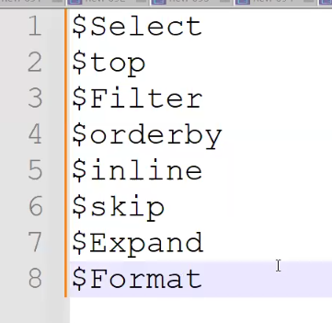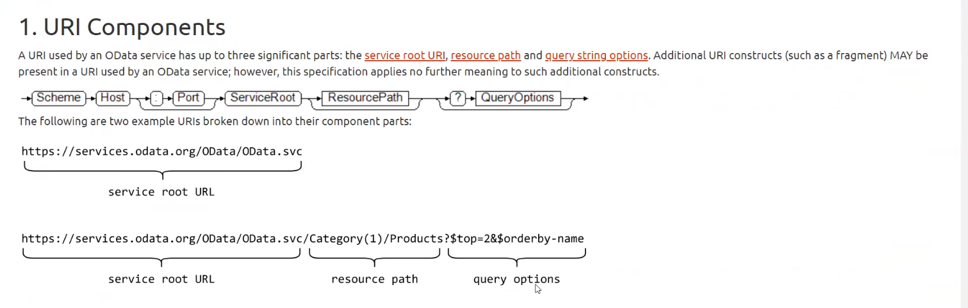
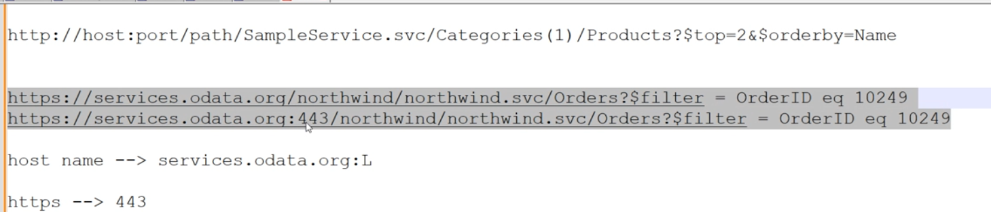

https://services.odata.org/V3/Northwind/Northwind.svc/
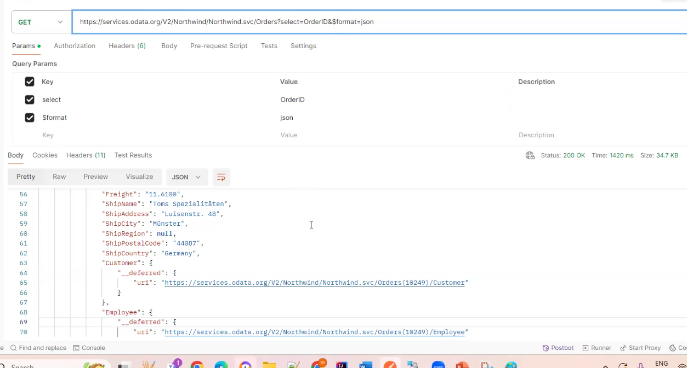
Select = OrderID&format = json
If you want to see the count of all records then you need to use inlinecount allpages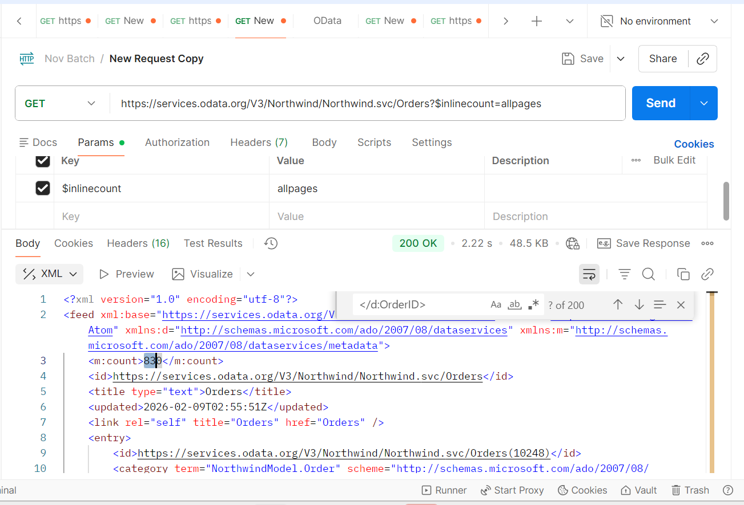
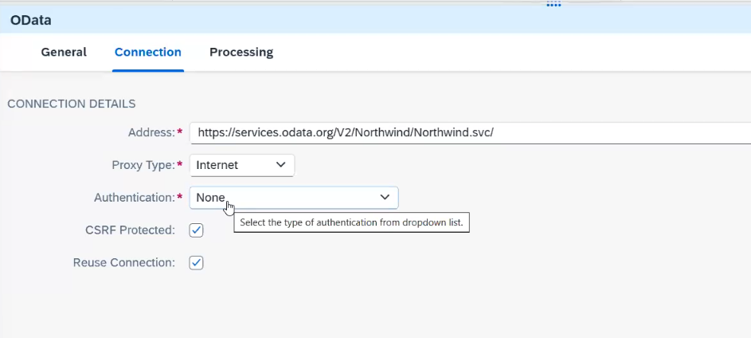
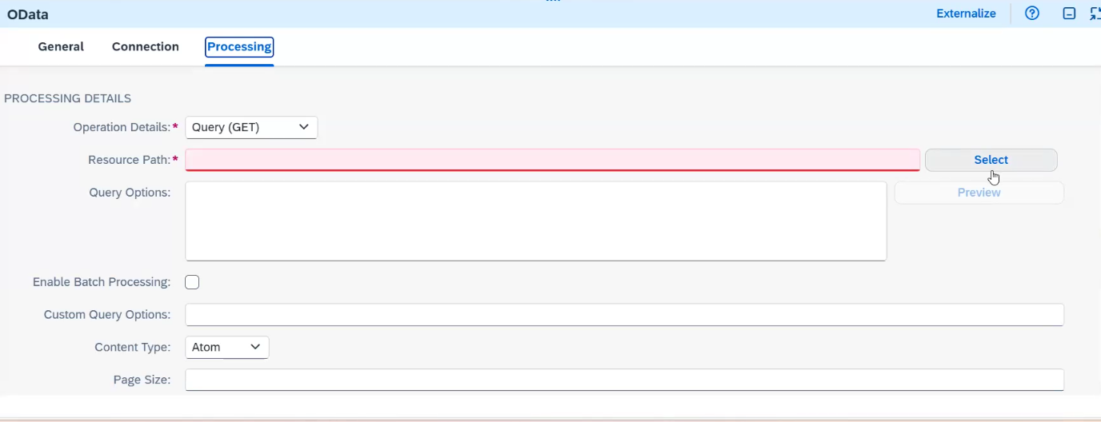
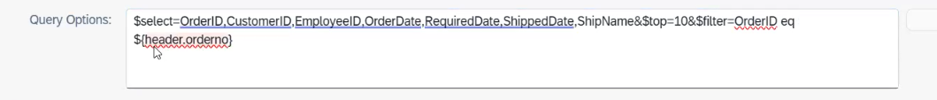

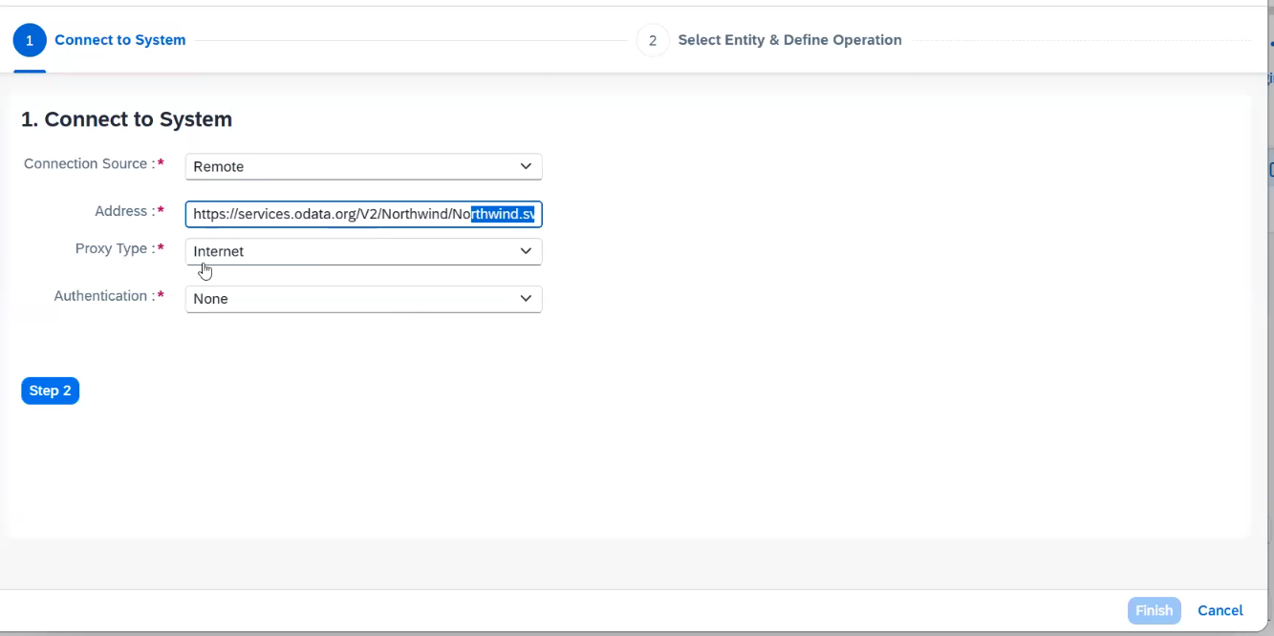
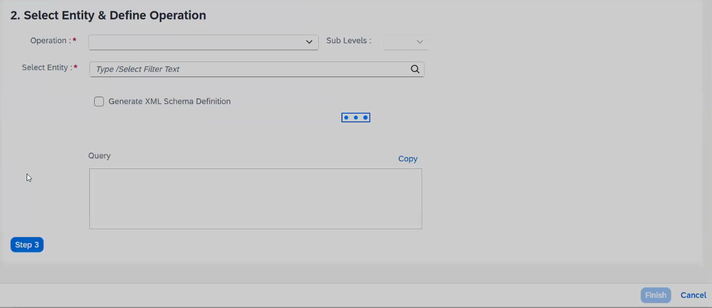
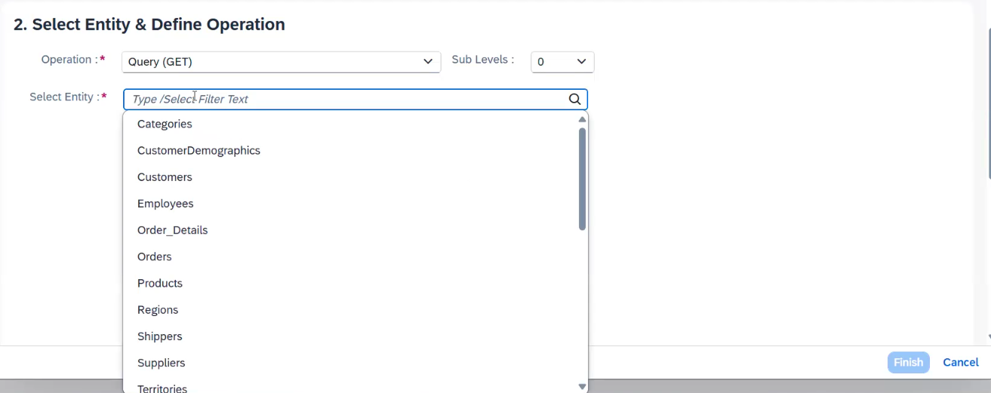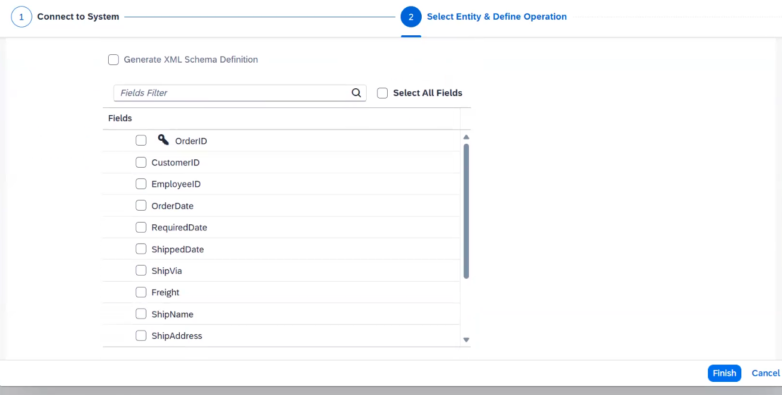
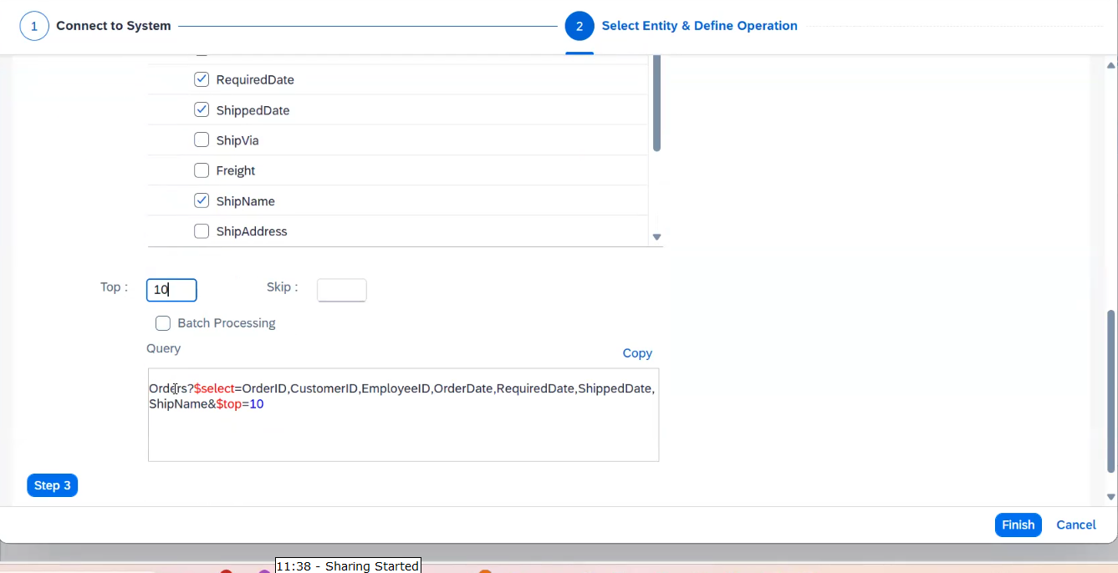

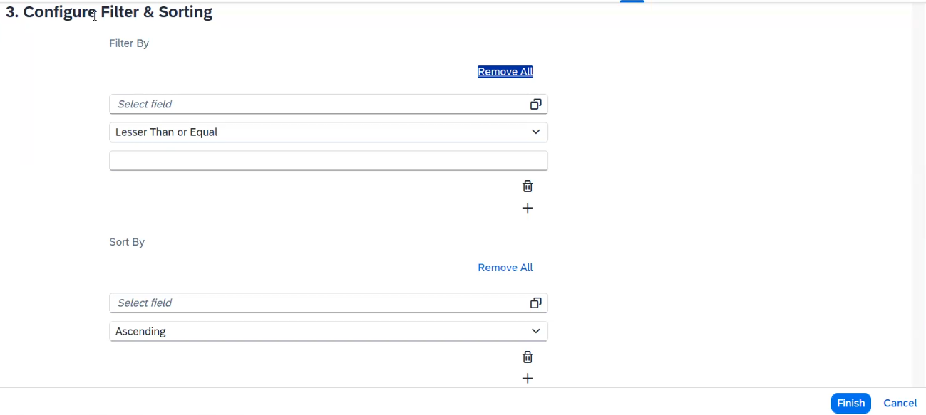

By using header in ODATA filter
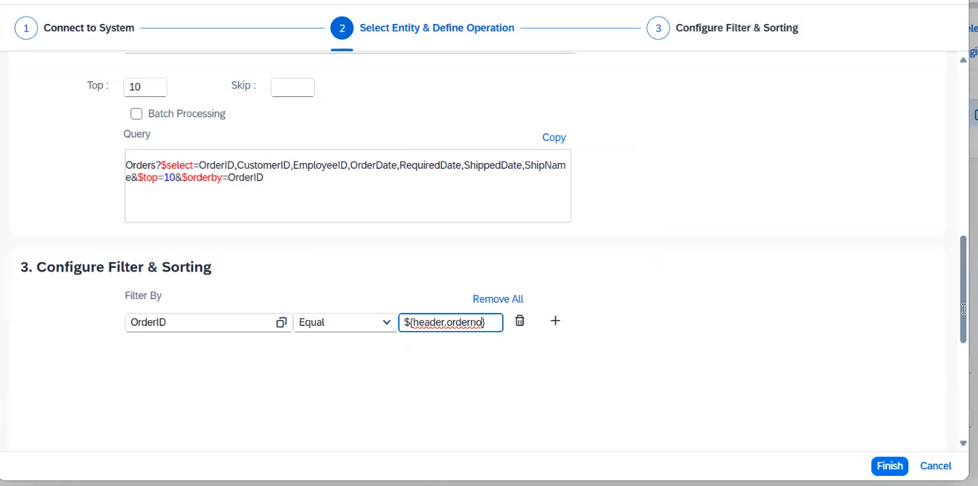
Odata sender:
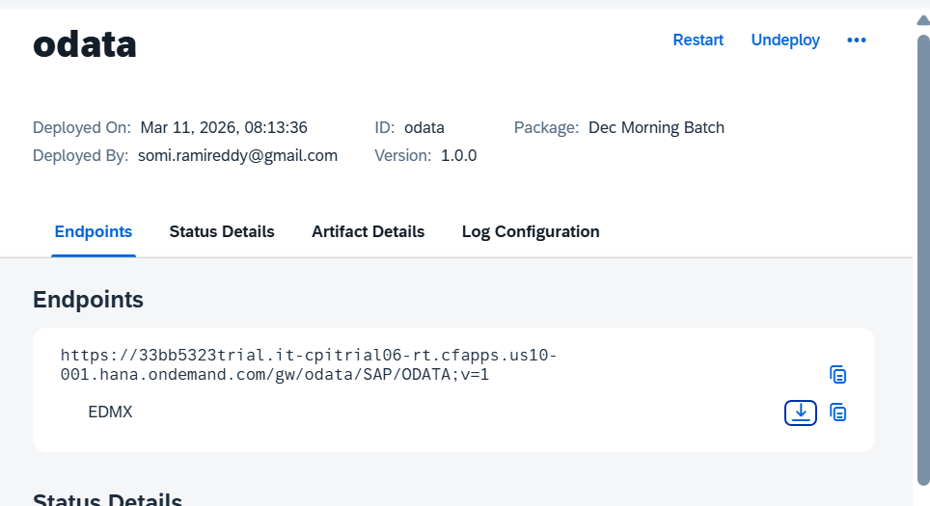

Process direct: If we want to send the data from one iflow to another iflow we can use this process direct.
Producer
Consumer
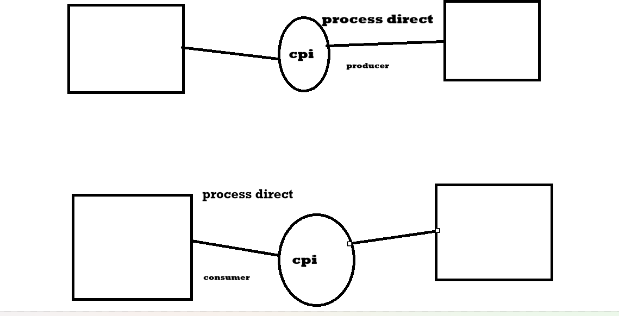
Constant/expression:
/india
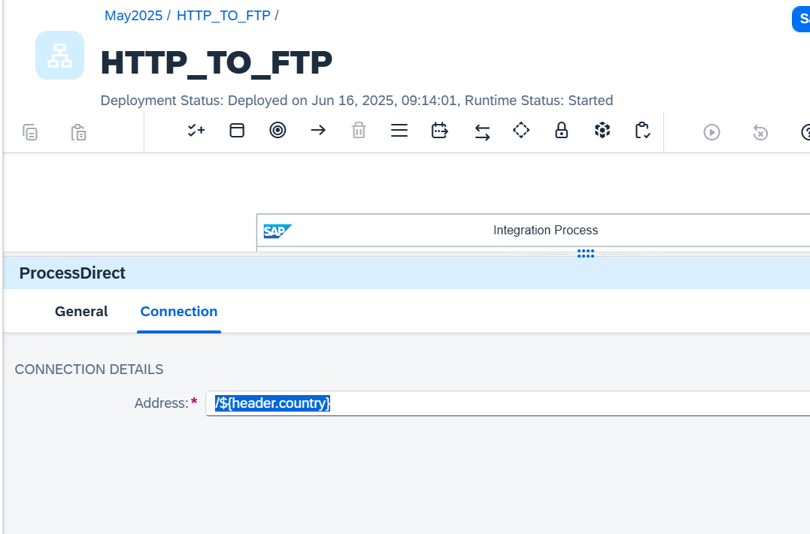

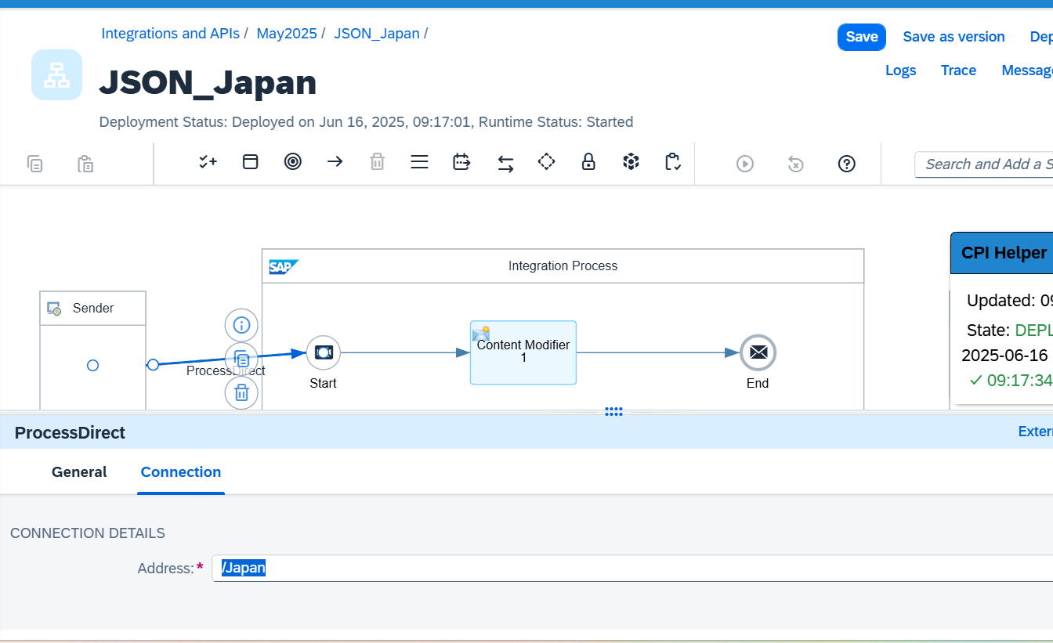

Local Integration Process:
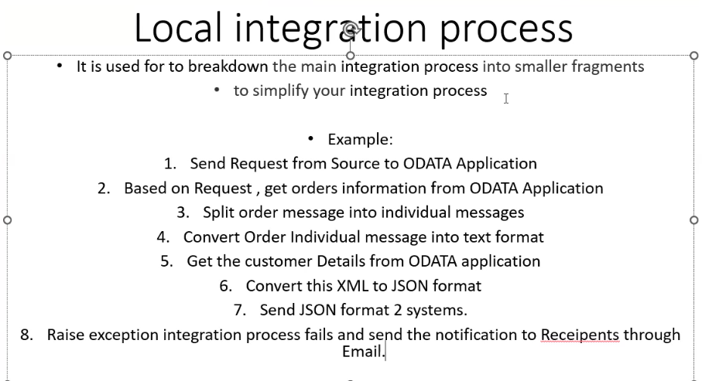
Looping Process Call:
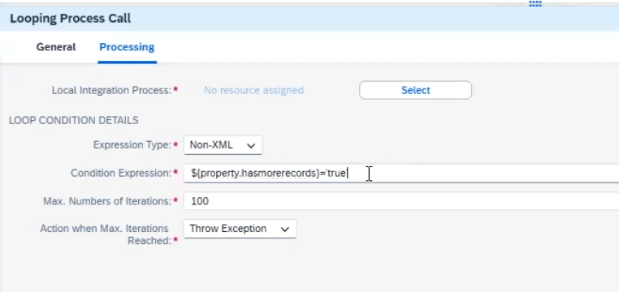
Max no iterations : it will retry above conditions not satisfied .
Throw exception : it will fall after max iterations
End Loop:
IDEMPOTENT PROCESS CALL:
It is used to stop duplicate messages for processing to the Target system.
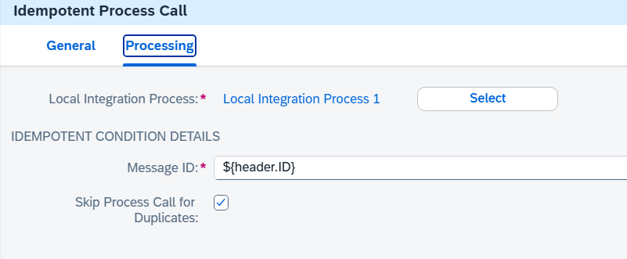
Message ID : It is nothing but from Source we are taking the value like invoice number etc from Content Modifier
If it is duplicate we can see the value like property
CamelDuplicateMessage true | true
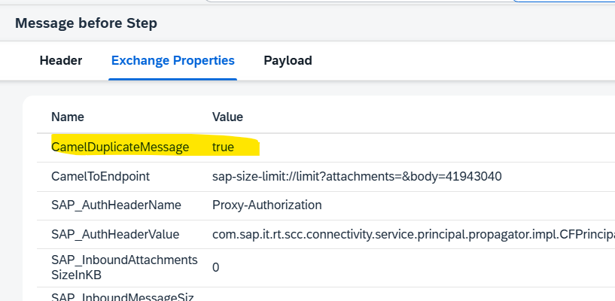

Status code:
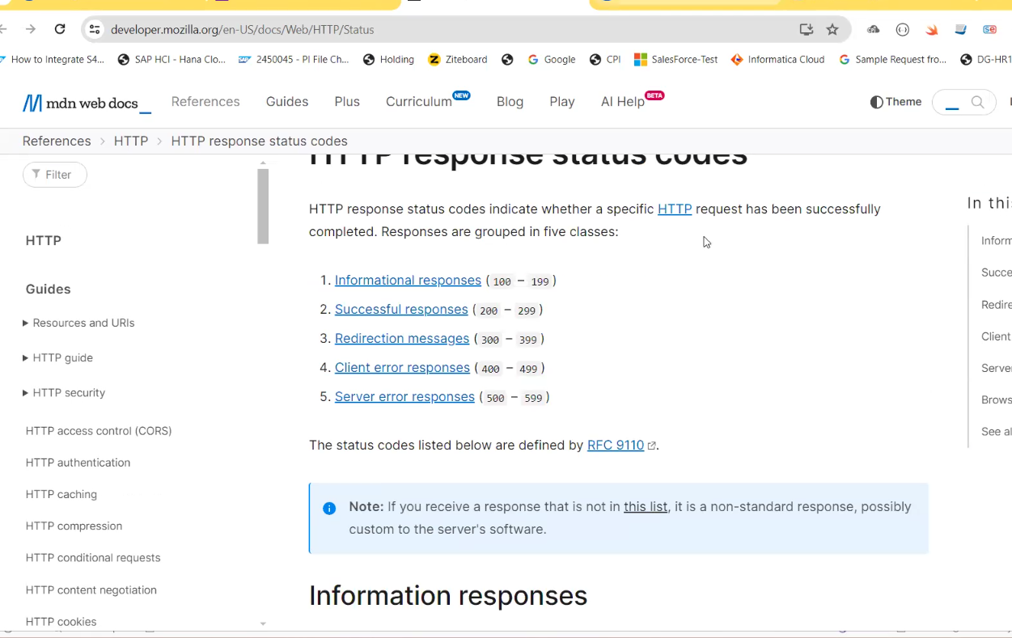

Content enricher:
Content enricher which is used to add additional data to the incoming original message then will go for content enricher.
Parameters: Aggregation algorithm: combine: If we use Aggregation algorithm as Combine, then the data will add at any level in the xml data.
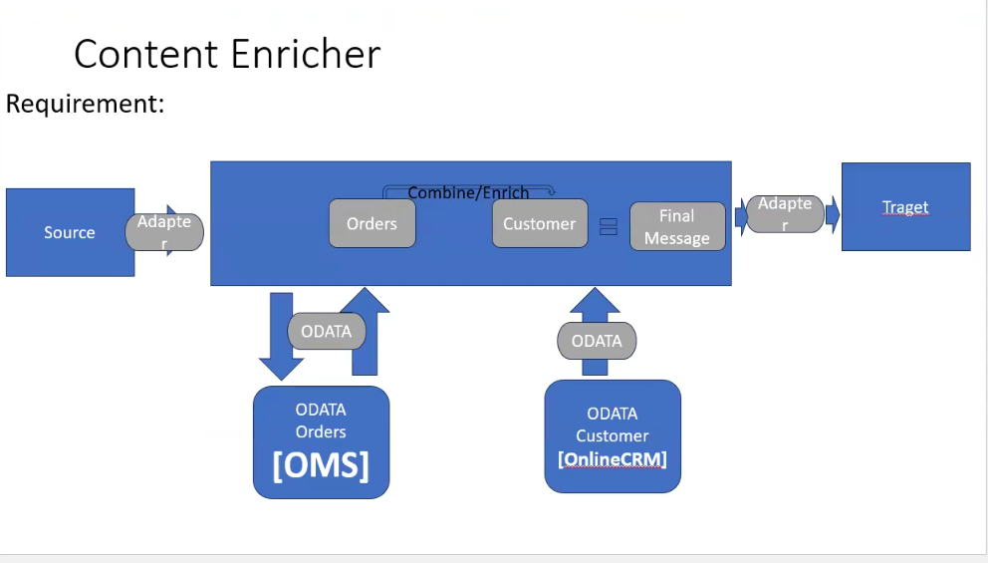
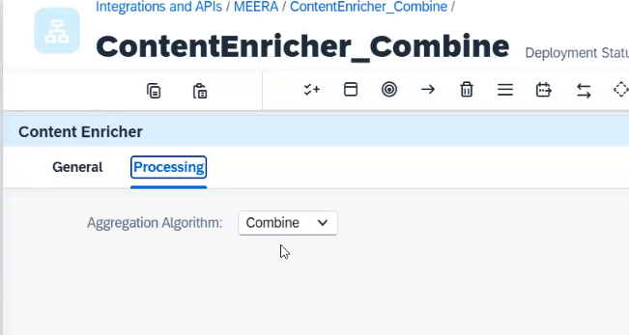
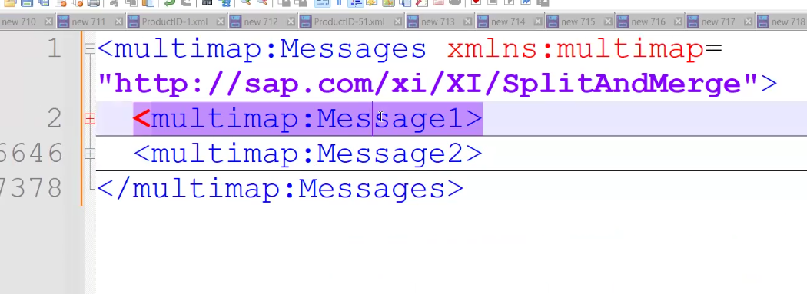
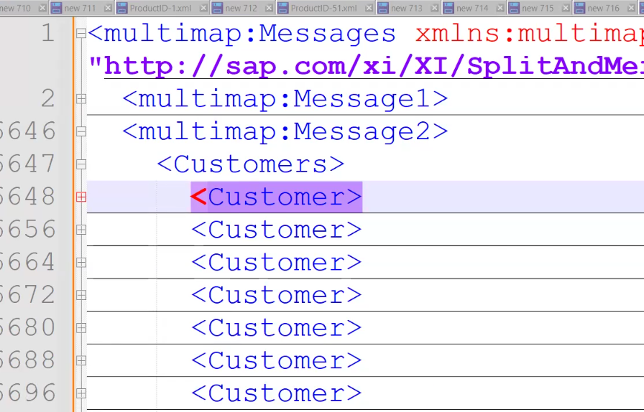
Like message 1 order and message 2 customer data

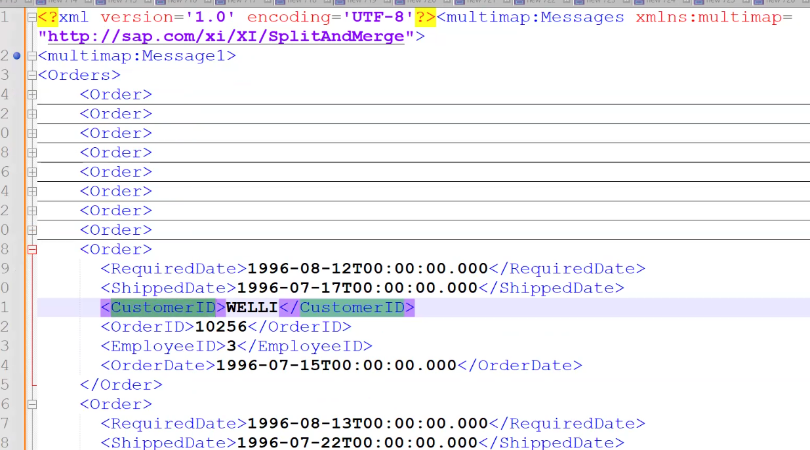
Enrich: If we want to add the data at the particular position in the incoming xml data then we will use Aggregation algorithm as Enrich.

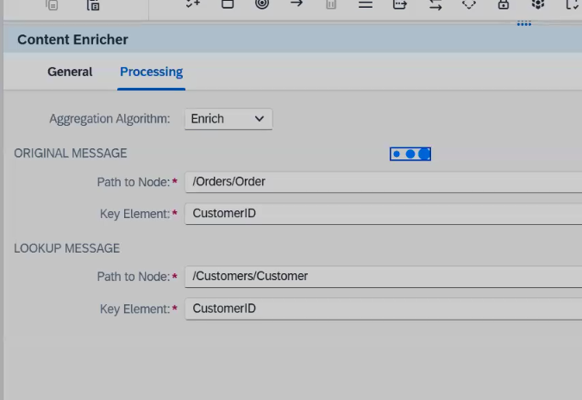
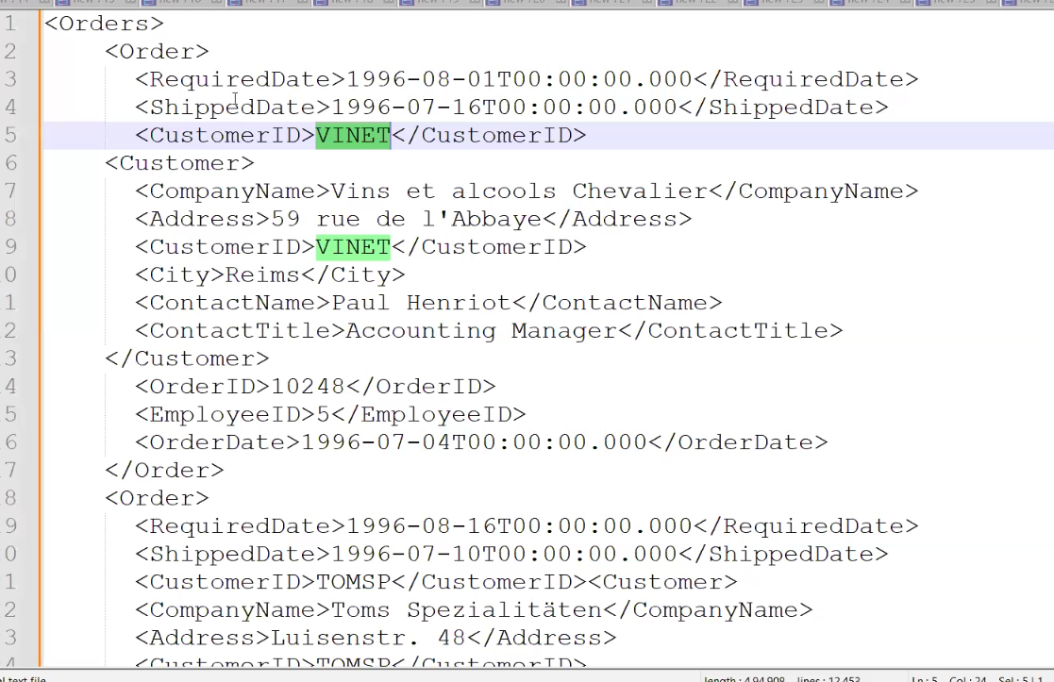

SFTP

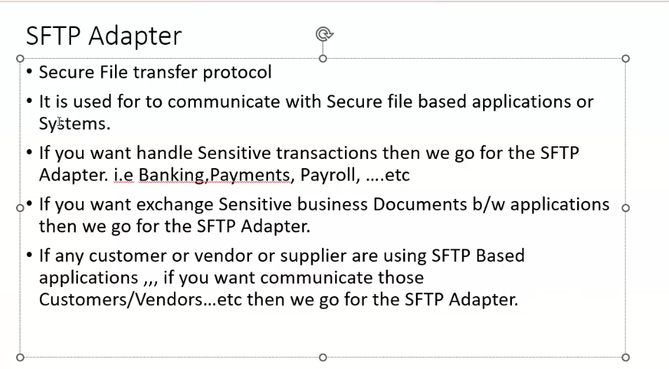

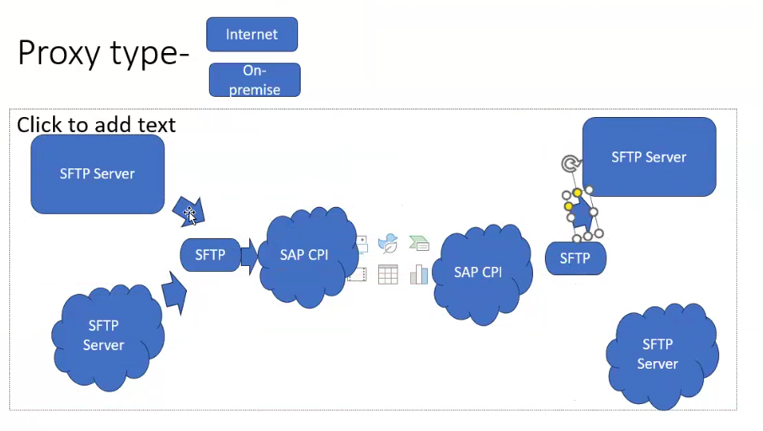
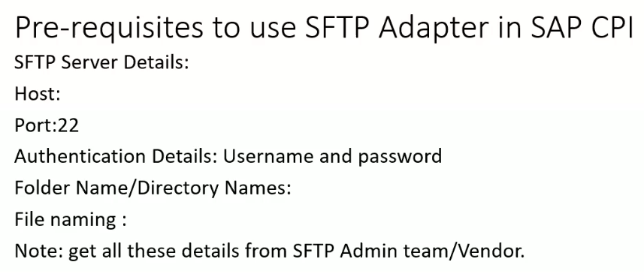
https://www.files.com/

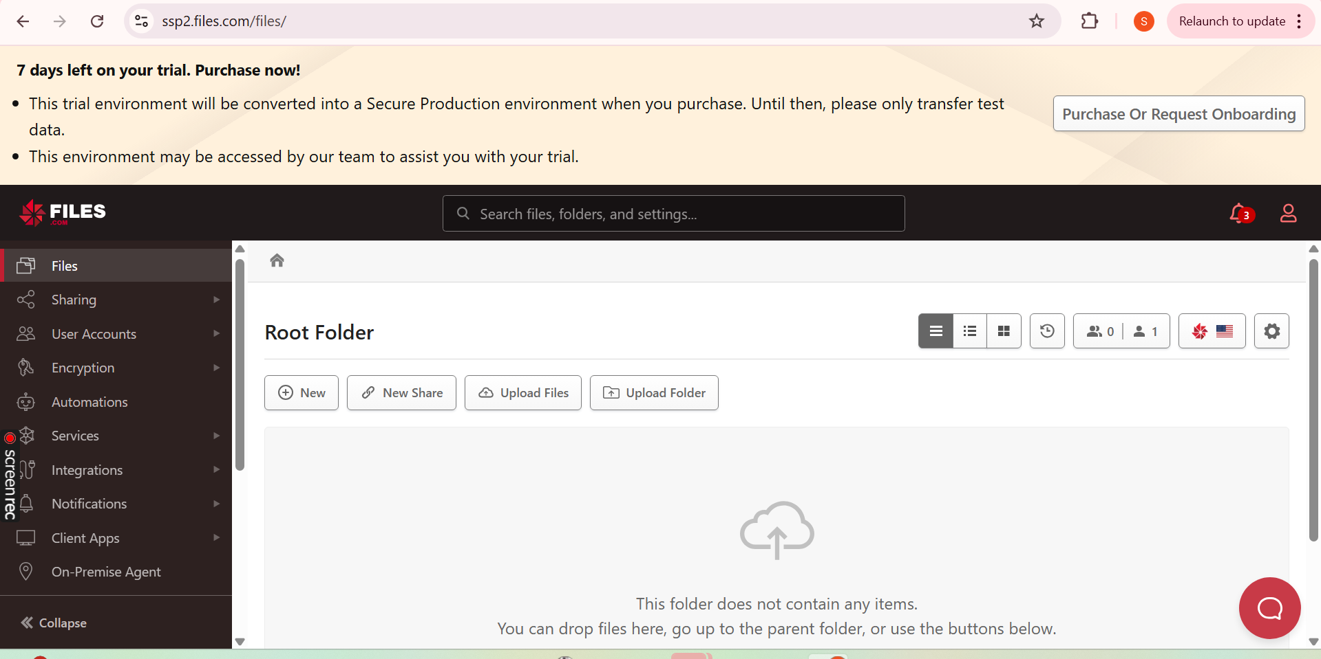

Username : somi.ramireddy@gmail.com
Hostname : ssp2.files.com
/in
/out

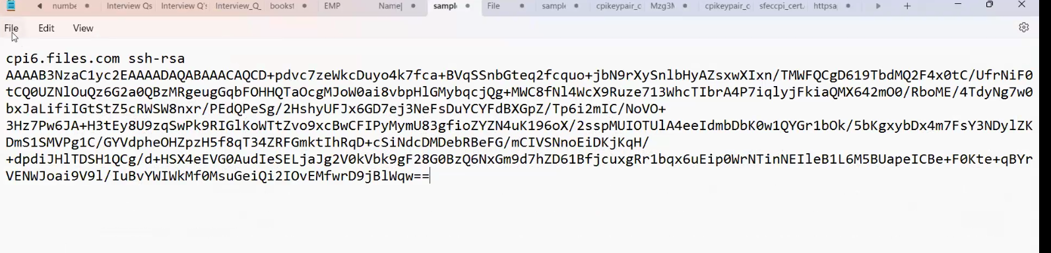
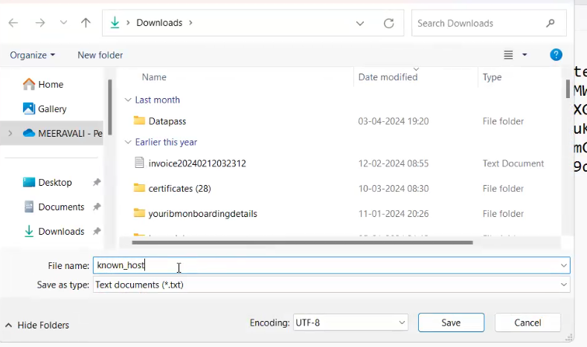
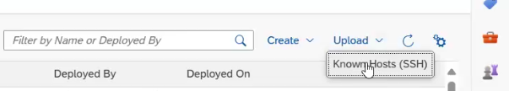
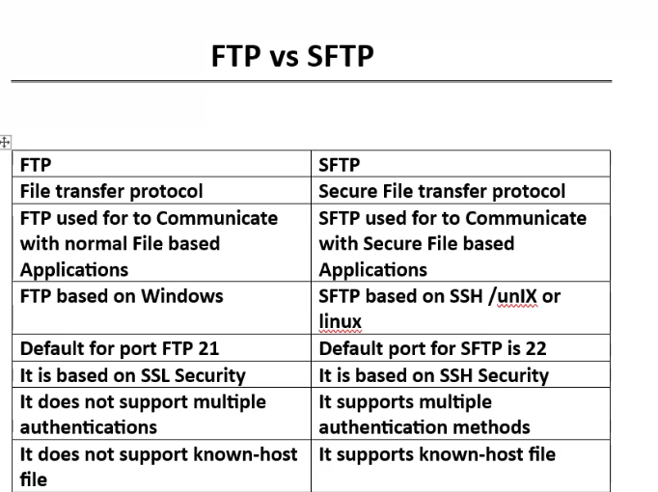

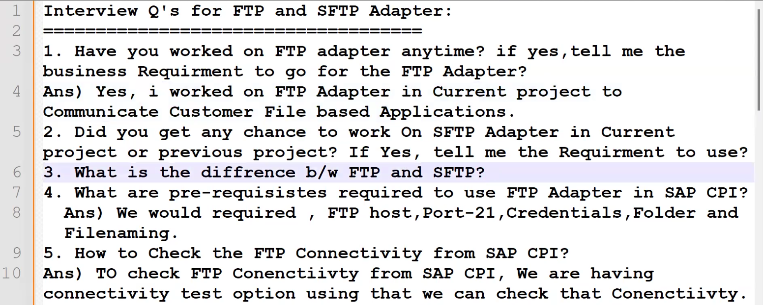
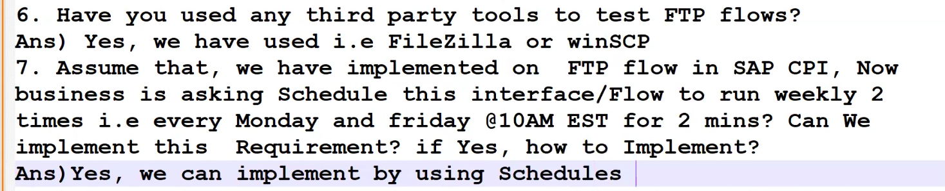
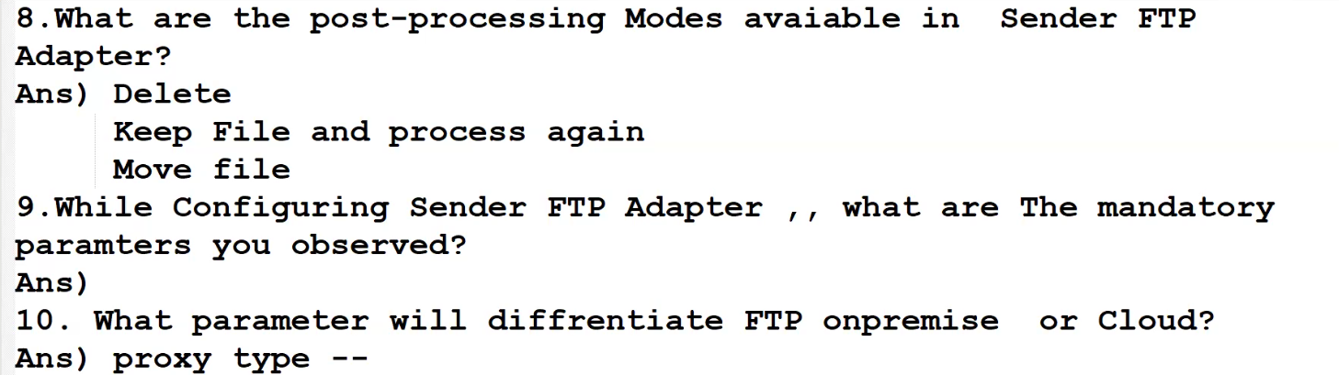
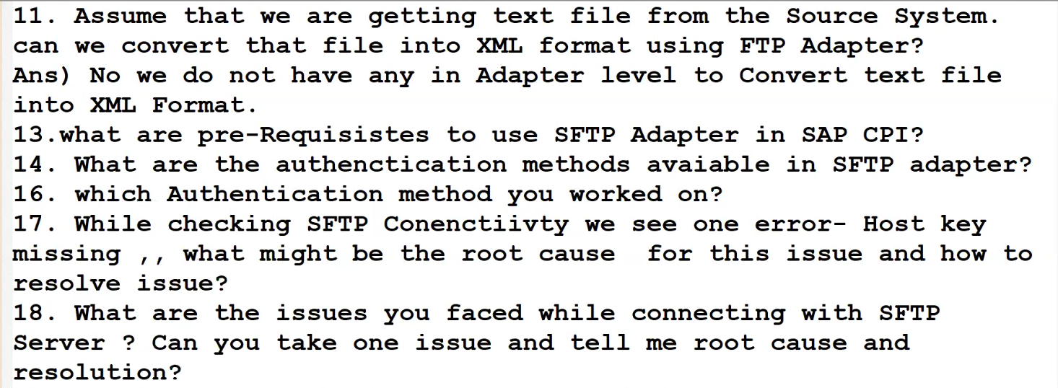
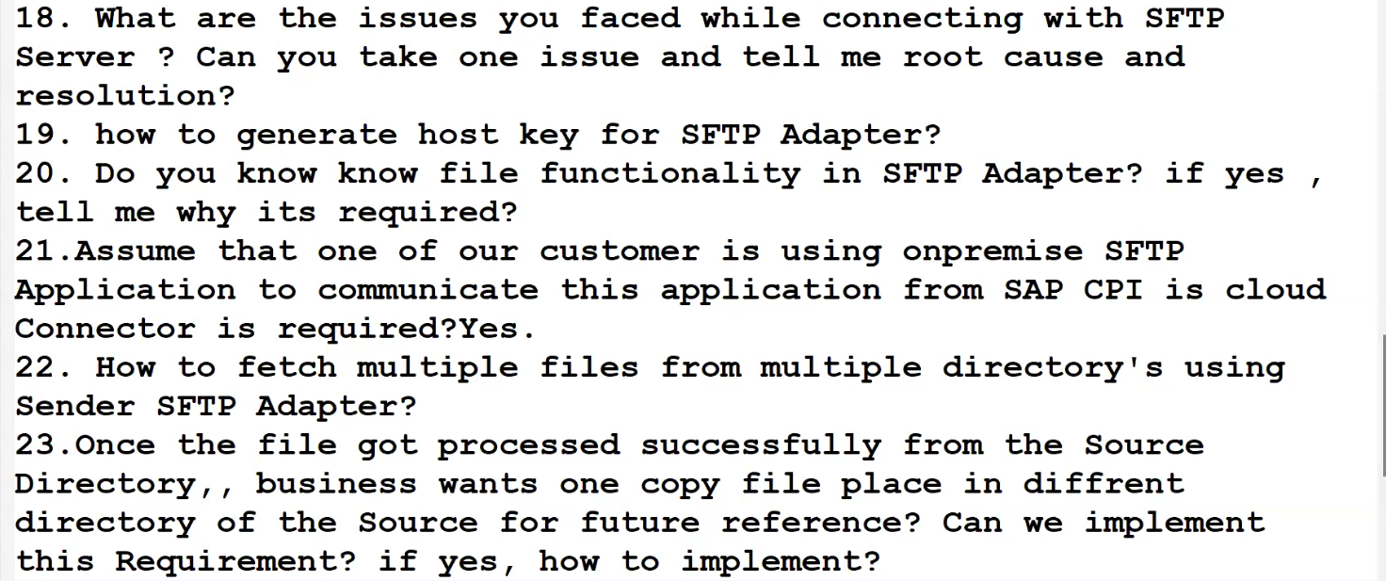
Send: If want to pass data to the target at any point in iflow then we can use send step.
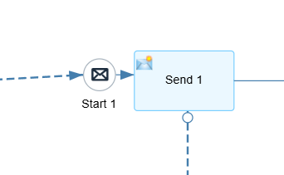
Poll enricher:If we want get data from SFTP then we can use poll enricher
->Combine xml:
Message1
Message2
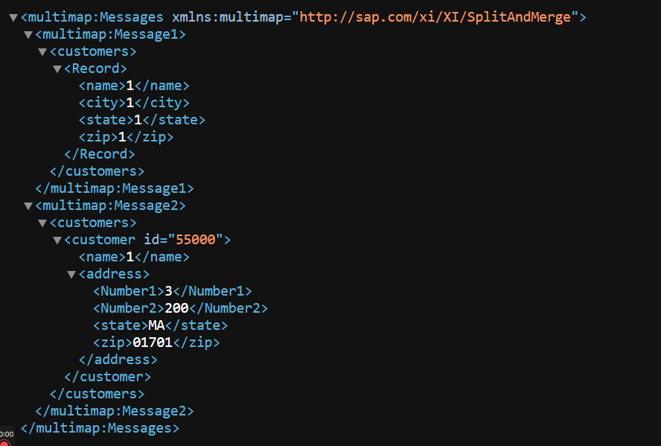
->Replace: It will replace source message with sftp file
->Concate
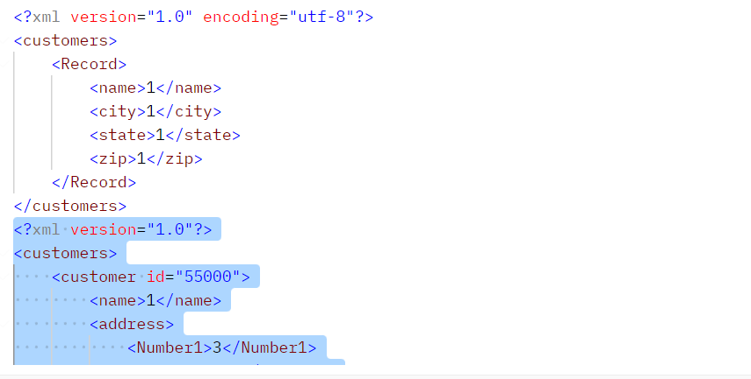

Difference between SOAP AND REST
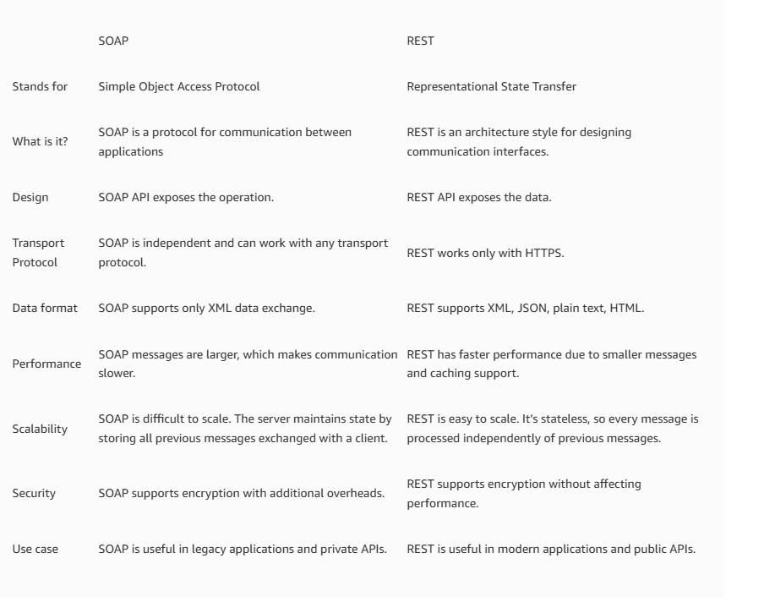
Data Store operations:
Data store operation which is used to store data in cpi then we will go for data store operations. Using this data store operations we can store large amount of payload.
For Retry mechanism also we can use instead of JMS
Write: If you want to write data into data store then we will select write operation.
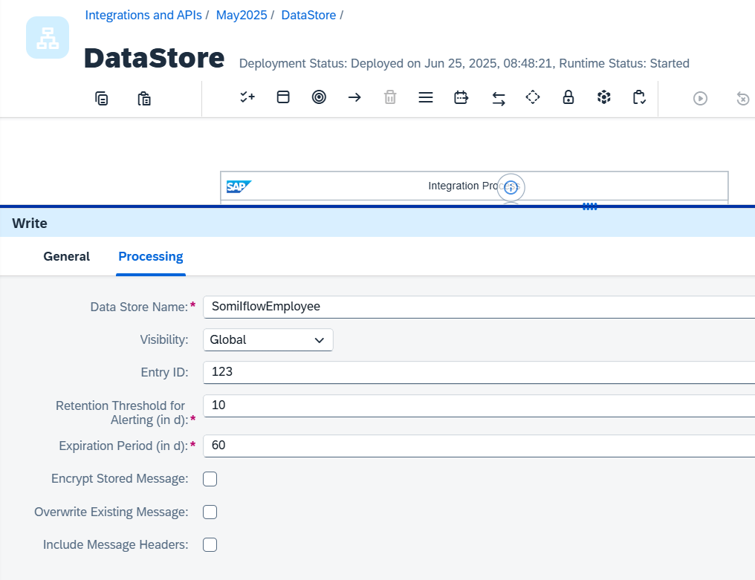
Visibility: Global and integration flow level
Retention thereshold: Just for alerting
Expiration: Automatically will be delete after expire
Max days : 180 days

Get: which is used to fetch particular message then we will use GET operation
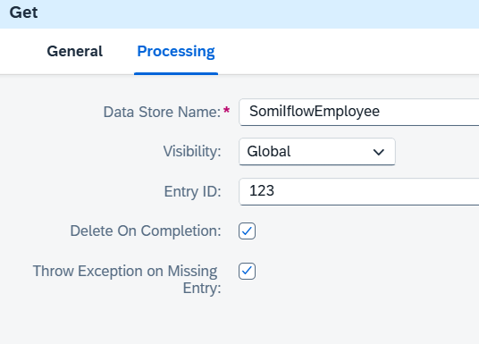
Select: which is used to select or fetch bulk amount messages then we will go for select data store operatoion.
Splitter:
Splitter which is used to split large message into small messages then we are go for splitter pallet.
Difference between general and iterating splitter:
In general splitter first line it will consider header and in iterating splitter first line header also consider data record.
- General Splitter: The General splitter splits the incoming bulk of amount of data into small messages with the envelope elements.
- Linebreak used for csv files or text files
- If you use this then header and line will come into the output.
- If you use grouping then no of lines in the data will group.
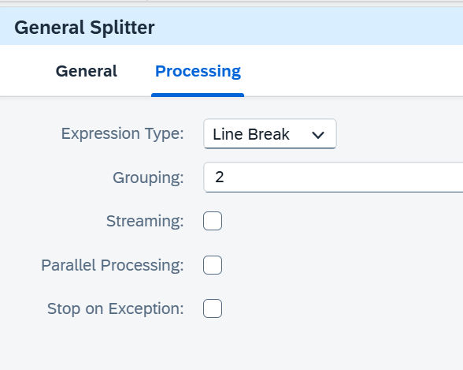
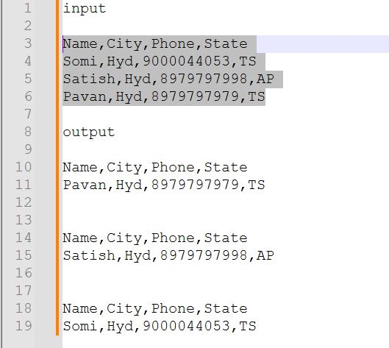

Concurrent process:
If you pass 2 then post 2 If not selected it will single in parallel

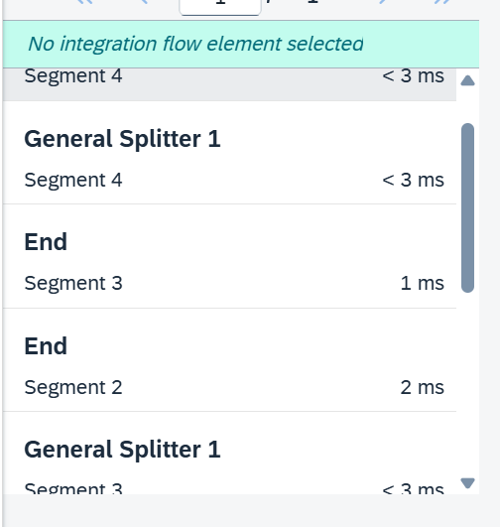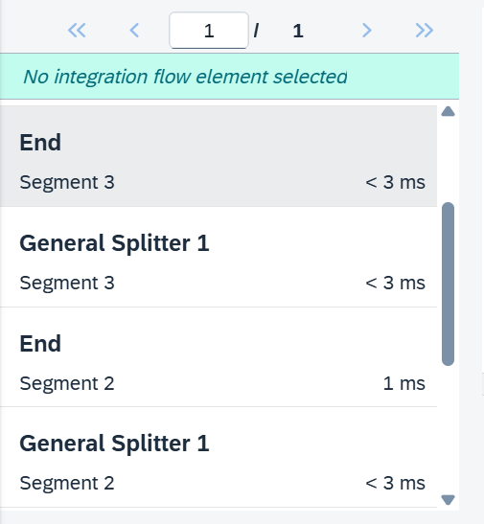

2.
IDOC SPLITTER:
It is used to split IDOC when multiple IDOC’S came in simple file and tag should be <IDOC>
<?xml version="1.0" encoding="UTF-8"?>
<Orders>
<IDOC BEGIN="1">
<EDI_DC40 SEGMENT="1">
<DOCNUM>0000000000001111</DOCNUM>
<IDOCTYP>MATMAS05</IDOCTYP>
<MESTYP>MATMAS</MESTYP>
<SNDPRN>SAP100</SNDPRN>
<RCVPRN>EXTSYS</RCVPRN>
</EDI_DC40>
<E1MARAM SEGMENT="1">
<MATNR>000000000000100001</MATNR>
<MEINS>PC</MEINS>
<MATKL>0010</MATKL>
</E1MARAM>
</IDOC>
<IDOC BEGIN="1">
<EDI_DC40 SEGMENT="1">
<DOCNUM>0000000000001112</DOCNUM>
<IDOCTYP>MATMAS05</IDOCTYP>
Kopoikmnjy67 [
[

Mapping :
Arthimatic: It require 2 inputs and always allow numeric values as input
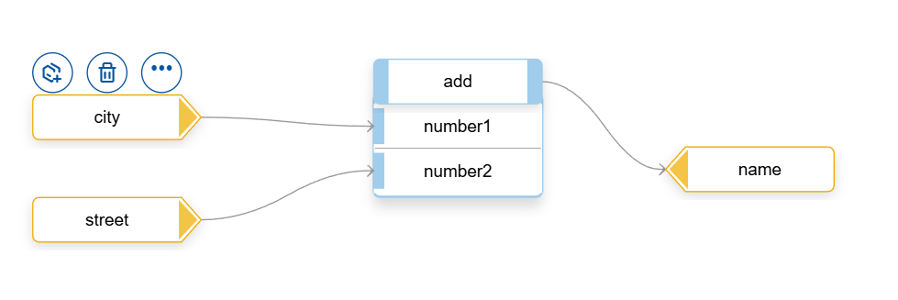
Absolute: It will always pass positive value if the input is negative also
Round: 12.01 to 12.49= 12 and 12.50 to 12.99=13, -12.01 to -12.49= -12 and -12.50 to -12.99=-13
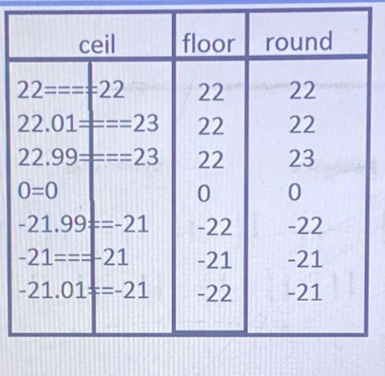

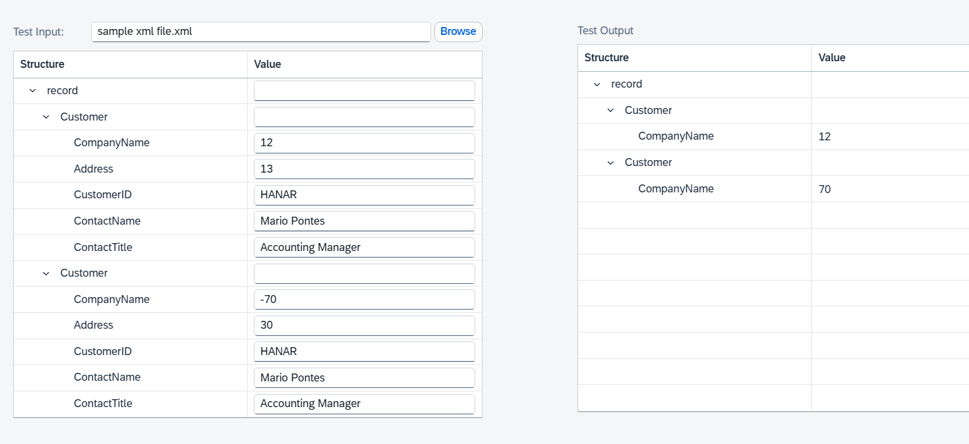
TEXT:
Index of 2: If you find the value of 2nd input in the 1st input then corresponding index will come in output
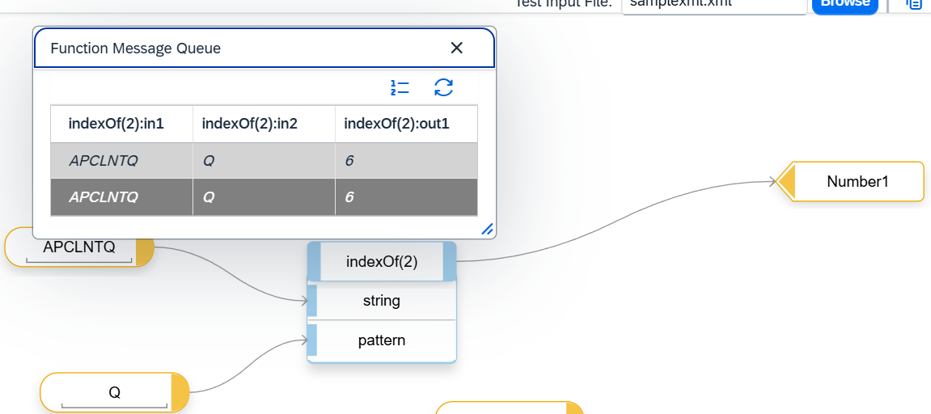
Index of 3
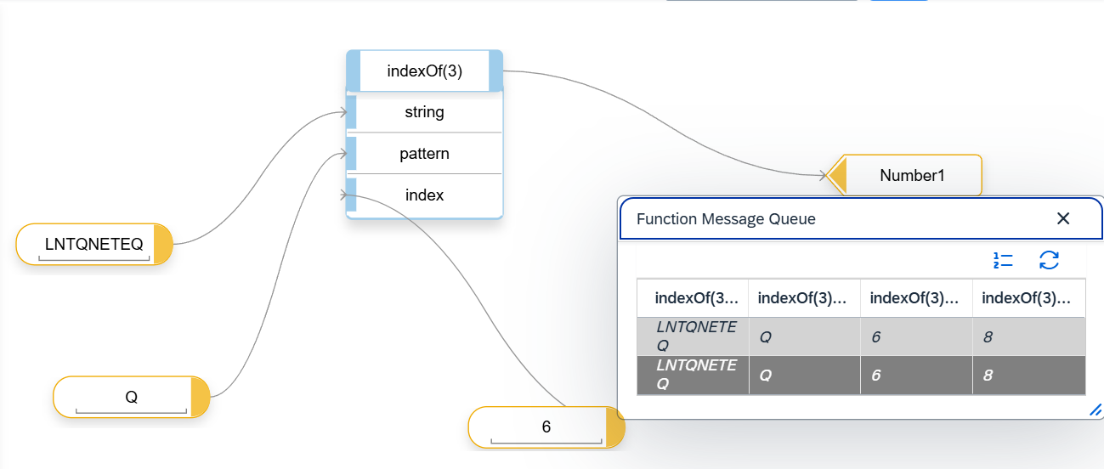

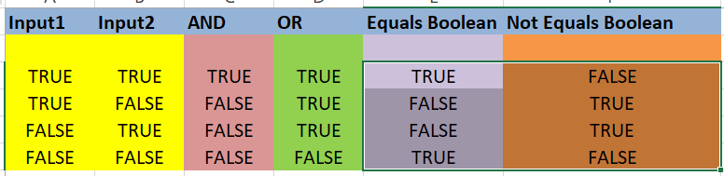
Value mapping :
Based on input value we can the change the output value like a table
- Jan
- Feb
- Mar
If we want to add entries in quality and production system then we can use value mapping. In this case no need to change in mapping or iflow.
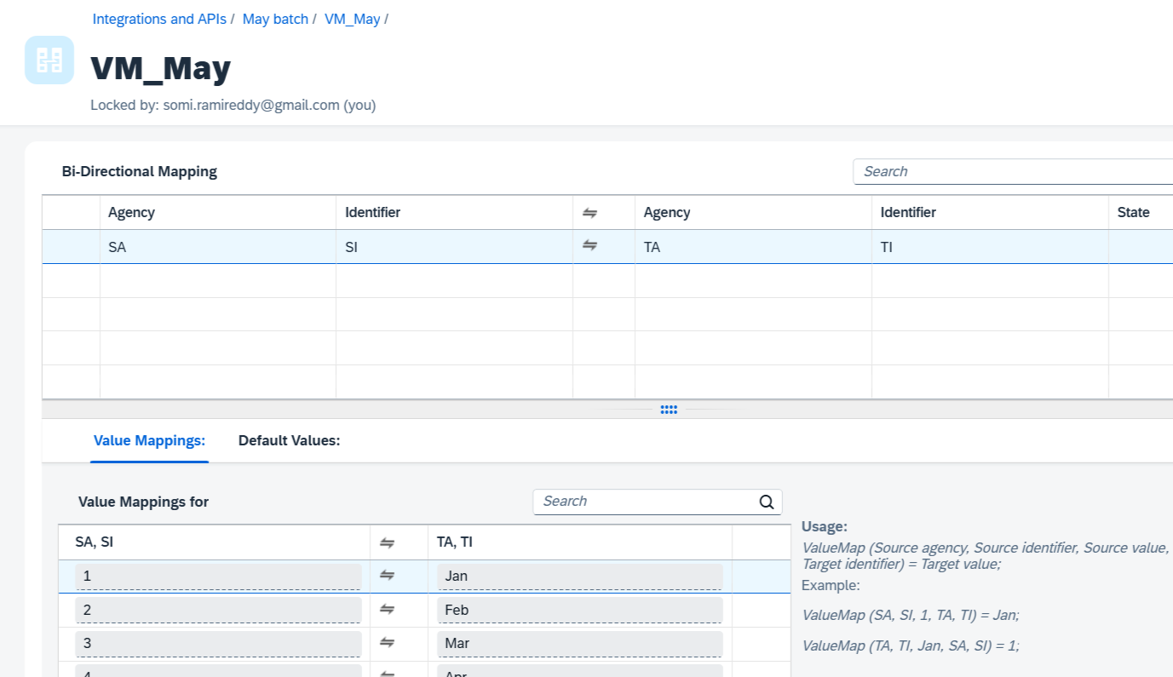

Substring:
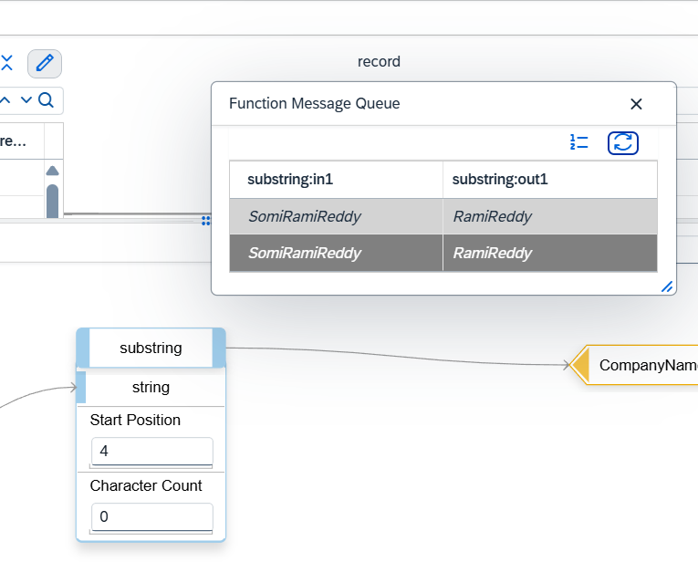
Fixed value mapping :
If there is no change code moved to QA and PRD then we can use this.

Replace String:
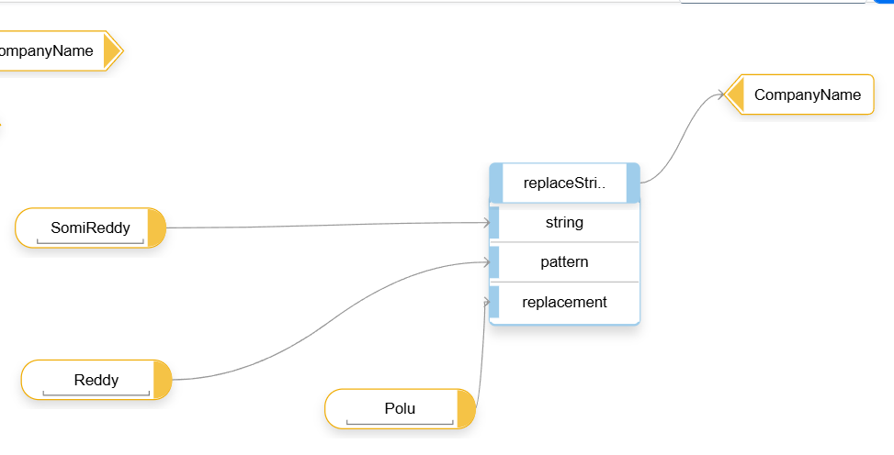
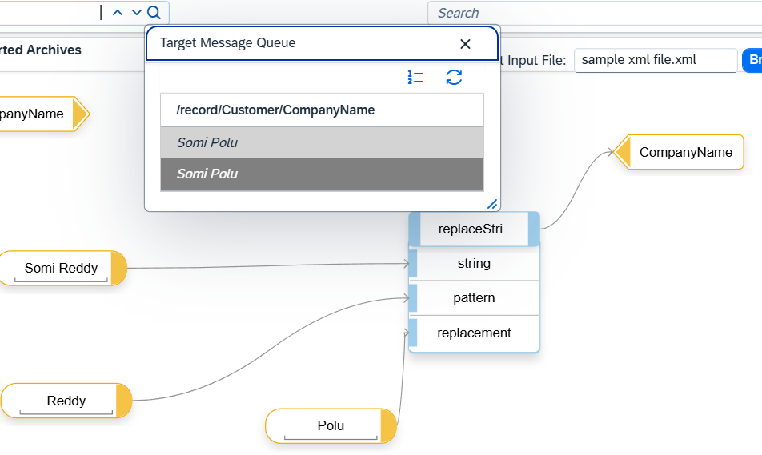

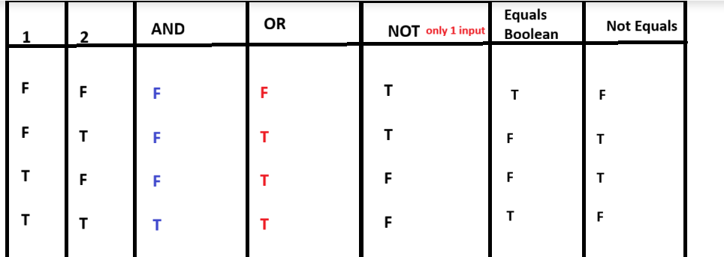
Max and Min occurrence:

<xs:element name="item" maxOccurs="unbounded"> 1,*
<xs:element name="note" type="xs:string" minOccurs="0" 0,1
<xs:element name="country" type="xs:string"/>- 1,1
<xs:element name="CompanyName" type="xs:string" minOccurs="0" maxOccurs="unbounded" />---0,*

Gather : Gather which is used to combine the multiple messages into single message.
Join : Join which is used to collect the messages from different routers/branches
Gather which is used to combine the multiple messages into single message from join function.
If it is camelsplitcomplete is true then only message will send to target.
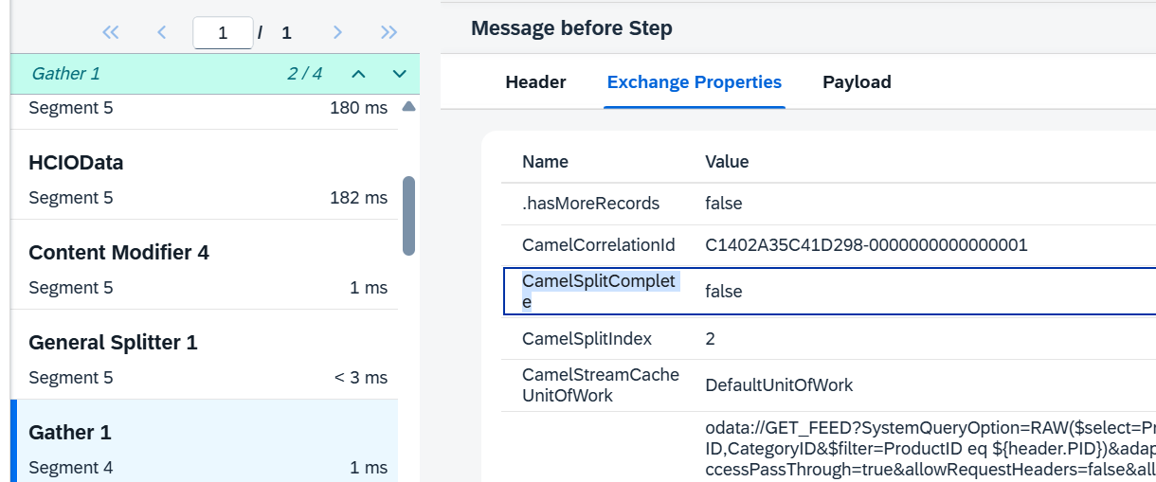
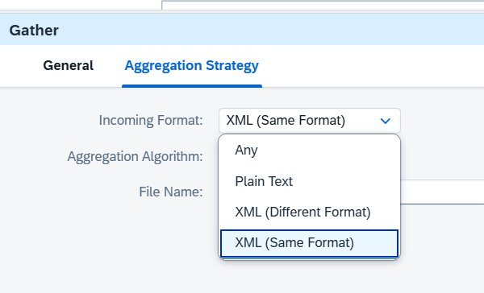
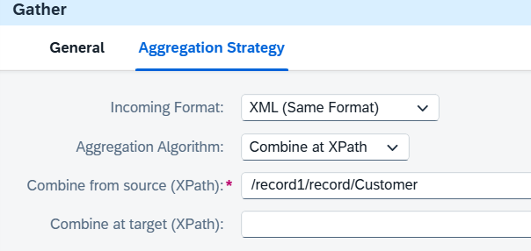
/record1/record/Customer
or
//Customer
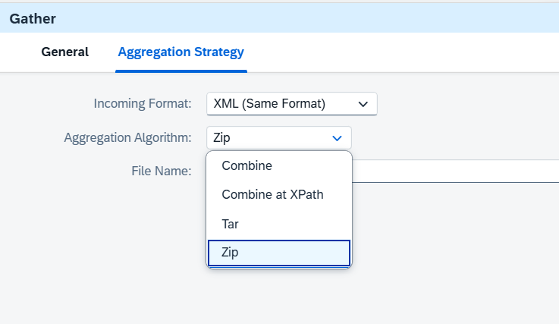
Soap Adaptor
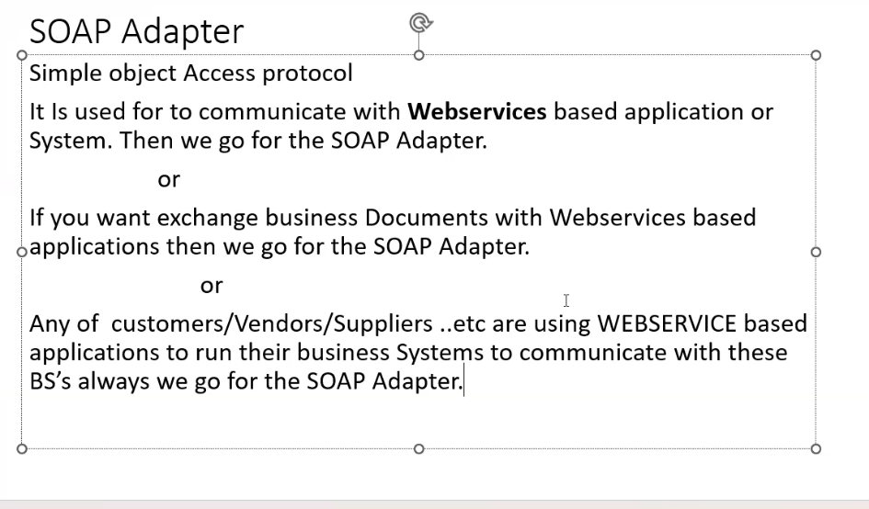
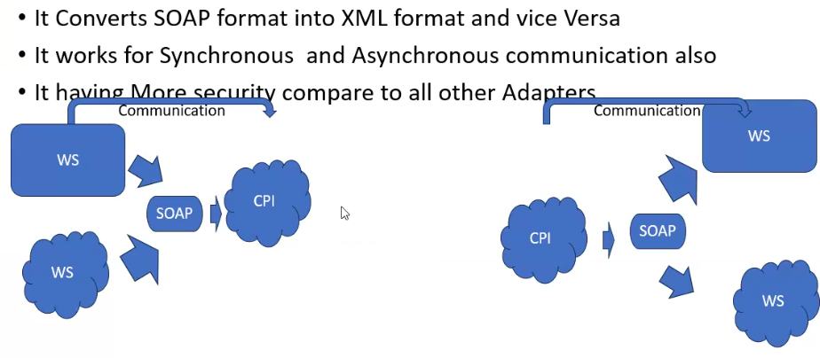
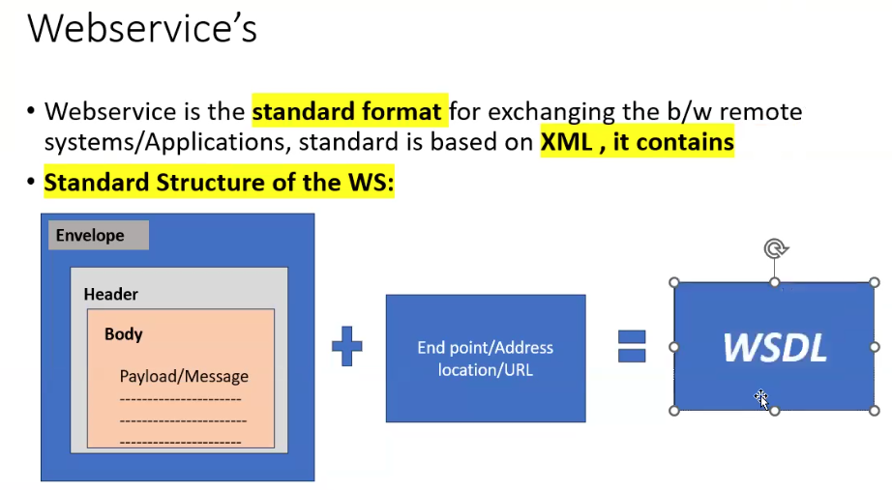
Message protocol
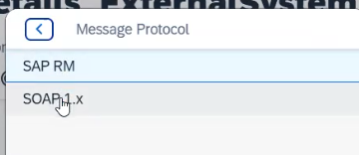
Service definition two types one is manual and wsdl
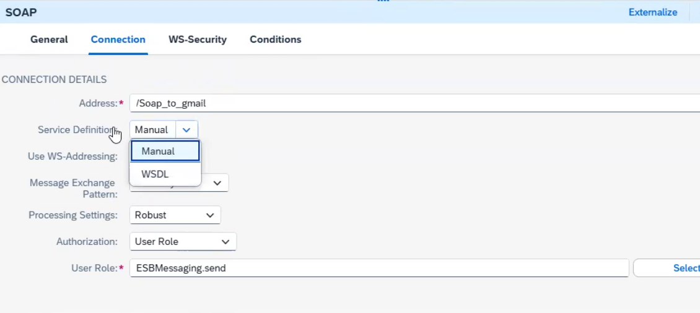
https://www.dataaccess.com/webservicesserver/NumberConversion.wso
If you want to see the wsdl then need to add at end ?wsdl to the url
https://www.dataaccess.com/webservicesserver/NumberConversion.wso?wsdl
Service definition: Manual means it will create end point wsdl automatically
Message exchange : one way:
Prpcess setting :Robust : response will come for one way also
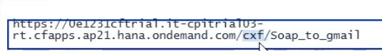
WSDL : we can import client wsdl file

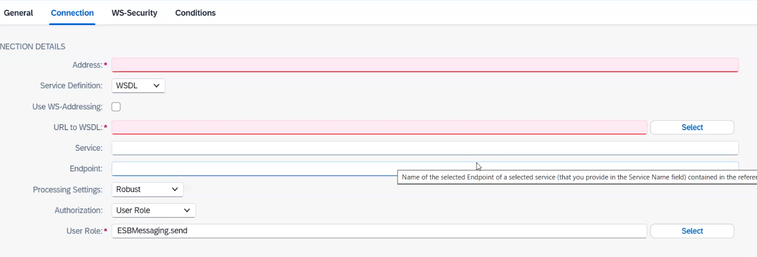

If you want to find end point of web service in wsdl then control+F then enter Address and you can find in below like this.

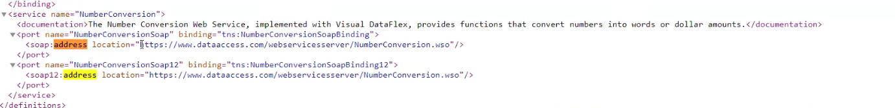
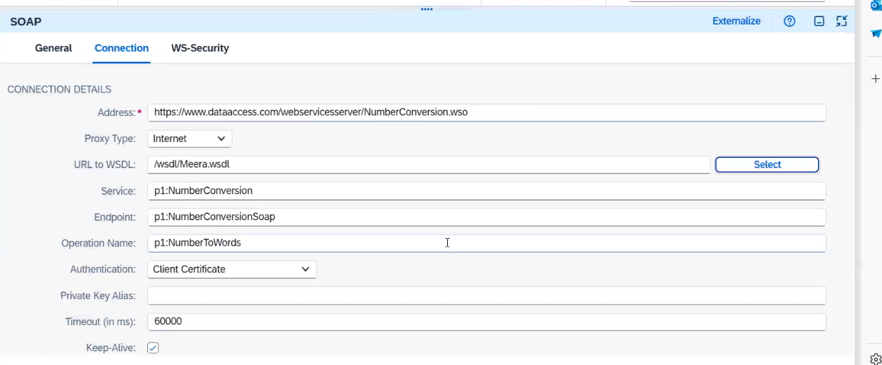
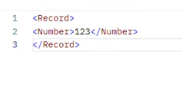
aggregator:
It will combine related individual messages and processed in bulk message. You will collect messages and store individual messages until complete related set of messages have been received.
It will support xml. In correlation need to provide of correlation like category id

Example: After store close need to send the data to the sap system.
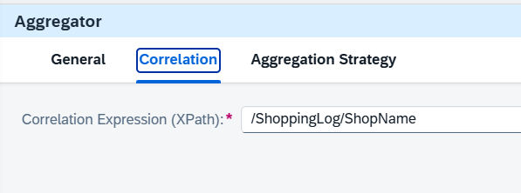
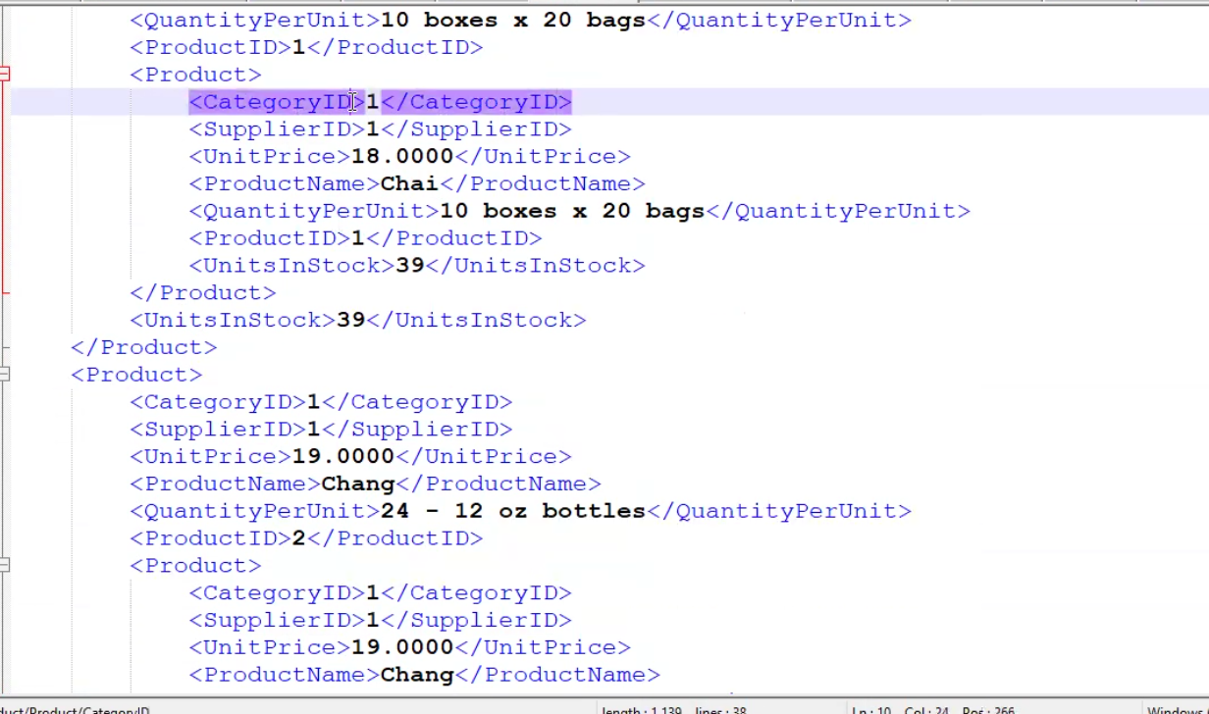
Combine it will combine message
Lastmessage: if any particular value will come uptill then it will create in data store.
Message sequence: Based on sequence it will create.
Completion time: It will wait utill that time . if end message will come it will pickup otherwise based on time it will pickup.

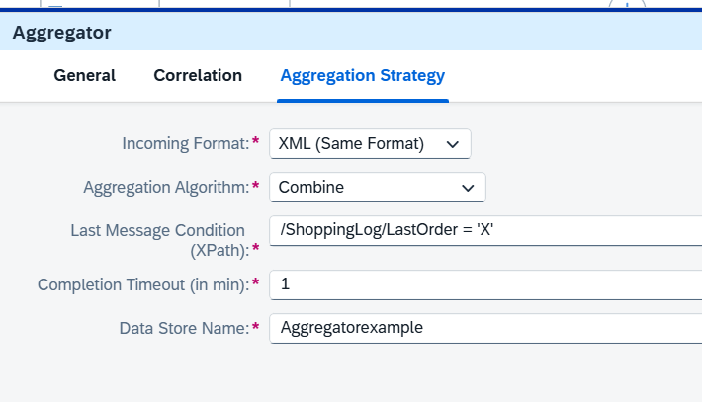
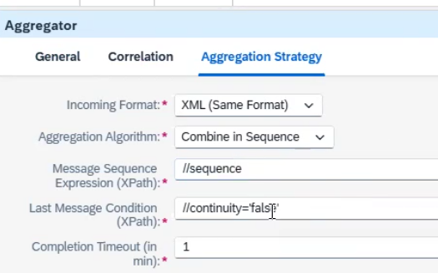

After :
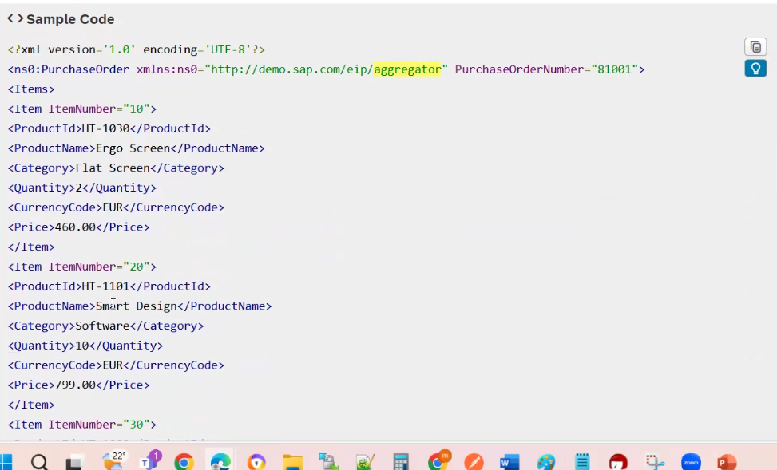

PGP KEY
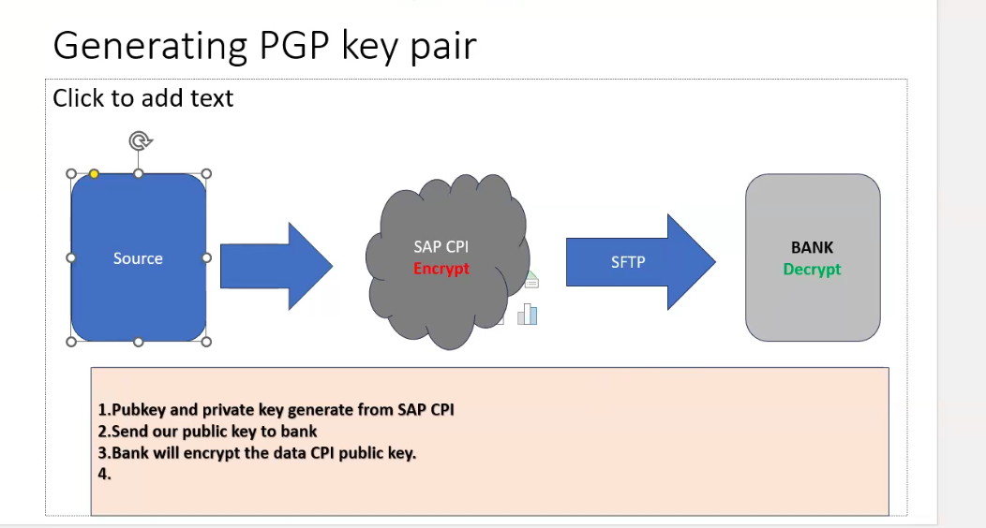
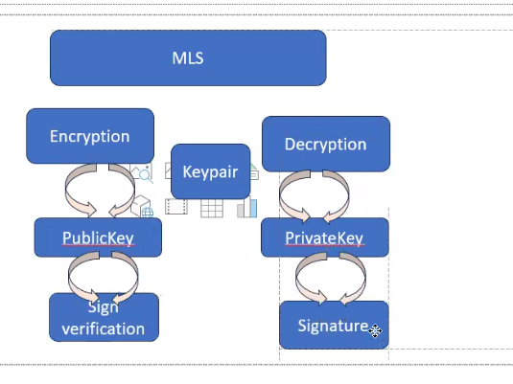
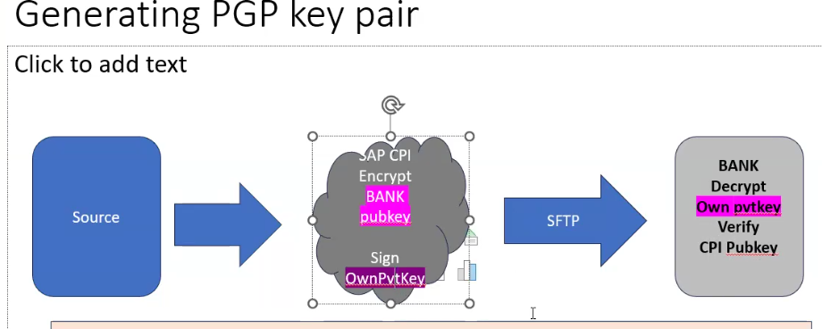
PGP
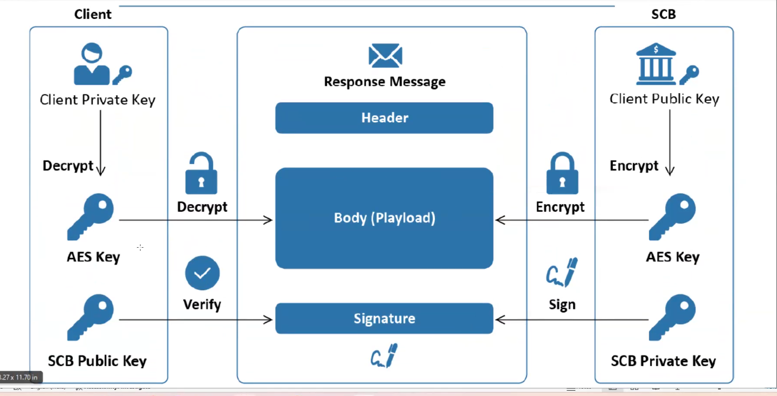
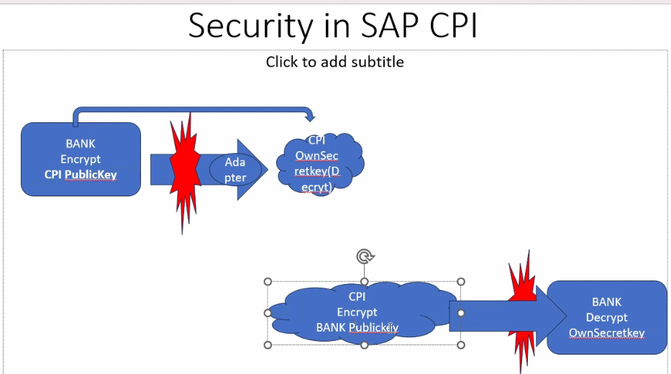
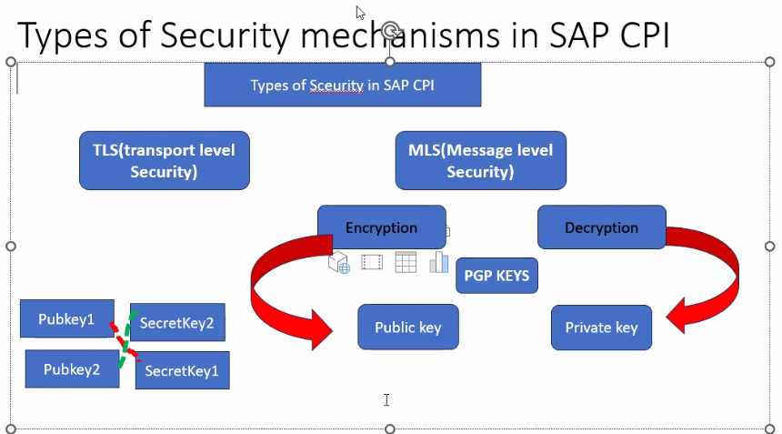
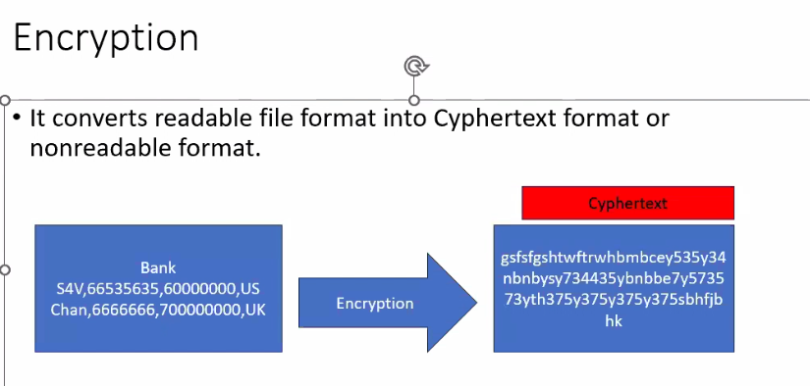
Onlinepgp.com to generate keys

When they created the algorithm which one they used below AES,Blowfish etc
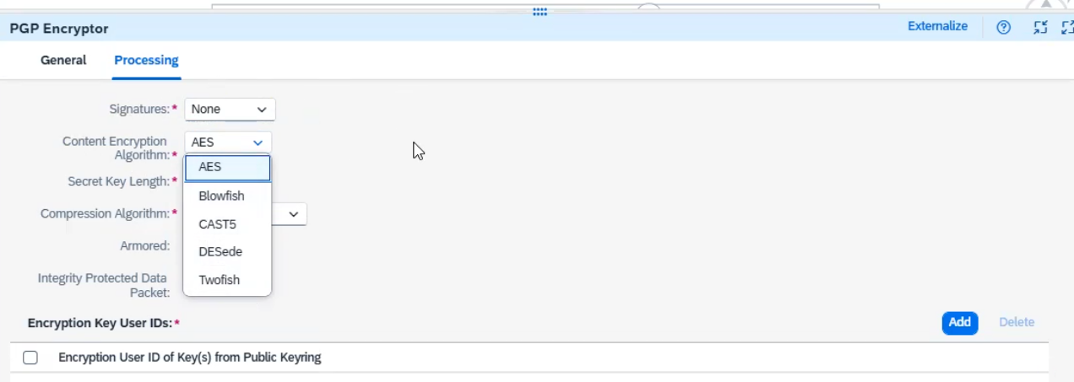
Length of the secret:
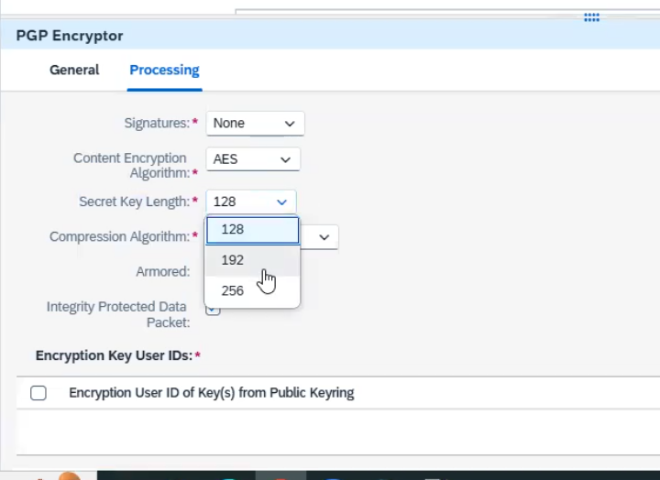
Compression algorithm
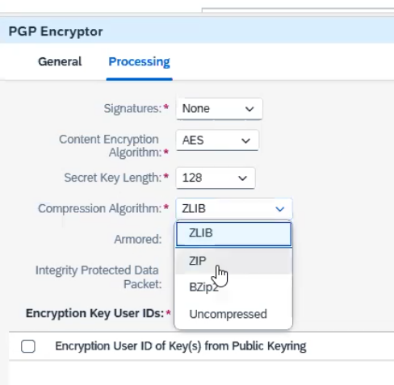

In keystore
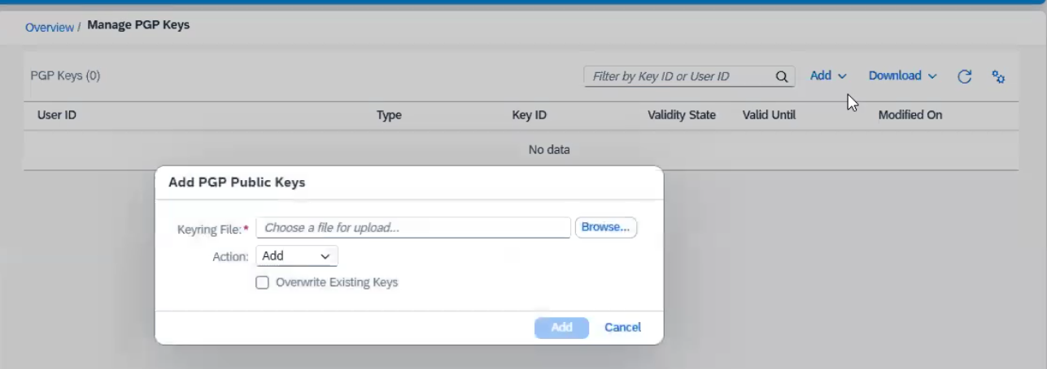
Content encryotion
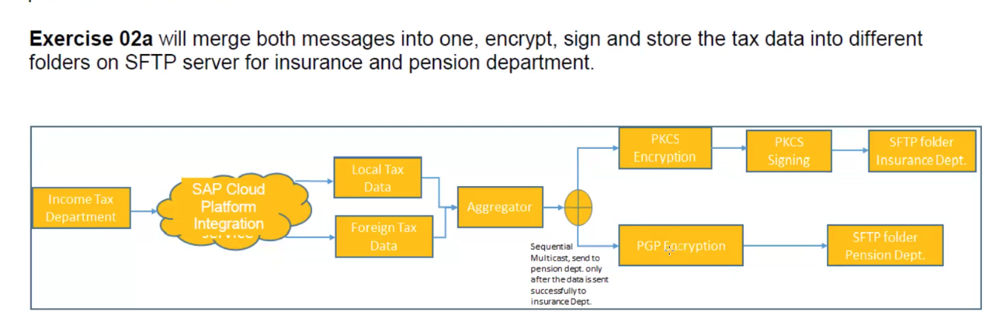

Interview:
- Difference between v2 and V4 in odata:
V2
- J
END TO END IMPLEMENTATION:
Functional Team: FSD (Functional specification document) or FD (Functional Document)

1. Source System
2. Target System
3. Type of format
4. Type of connection
5. Sample Data
6. Frequency of the interface
7. Mapping Document

TSD (Technical specification Document)

INTERFACE DETAILS

IFLOW DIAGRAM

Development: Once development is done need to testing
UNIT TESTING: POSITIVE AND NEGATIVE TEST CASE
QUALITY: Transport –1. File Transport and 2. CTS transport
Functional Team: Functional Testing, smoke testing
UAT: User Acceptance test Client

Production: Test results, UAT email, CAB Meeting Need to represent in cab meeting
Change request approved in cab meeting then change will move to production with the help of basis team
Externalize: how to create need to open {{Need to add any name}}
Need to update the value in configure tab with production values then save and deploy
First time transaction in production: Golden transaction

Transport:
File transport and cts we have
Cloud transport management in sap cpi

IDOC: IDOC: If we want to communicate with SAP Systems then we will use IDOC Adapter. It only supports XML language.
ASYN –Communication : It will send the message but we will not get response

https://sapzero2hero.com/2022/03/21/sap-cpi-how-to-send-idoc-from-sap-erp-to-sap-cpi/
First, we need to backend connectivity like we need to create
SM59 T-Code for RFC destination
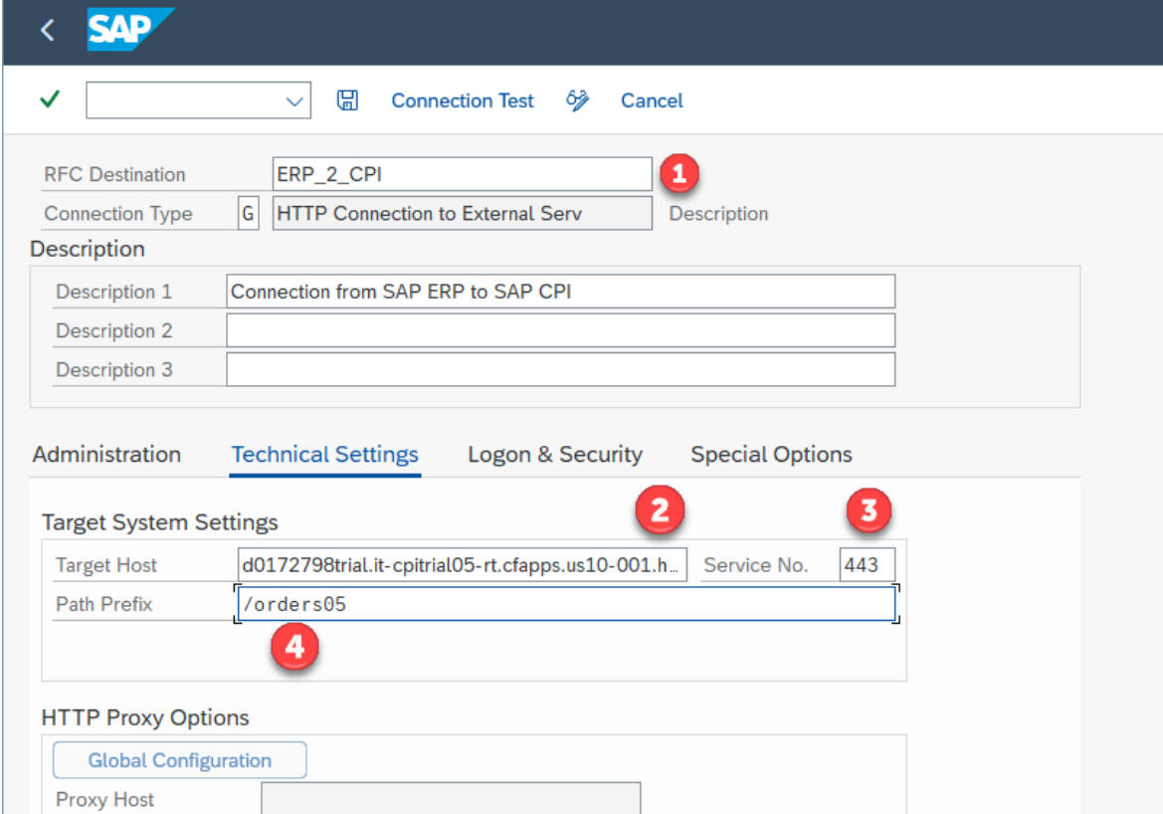
https://3db1eee8trial.it-cpitrial05-rt.cfapps.us10-001.hana.ondemand.com/cxf/Idoc
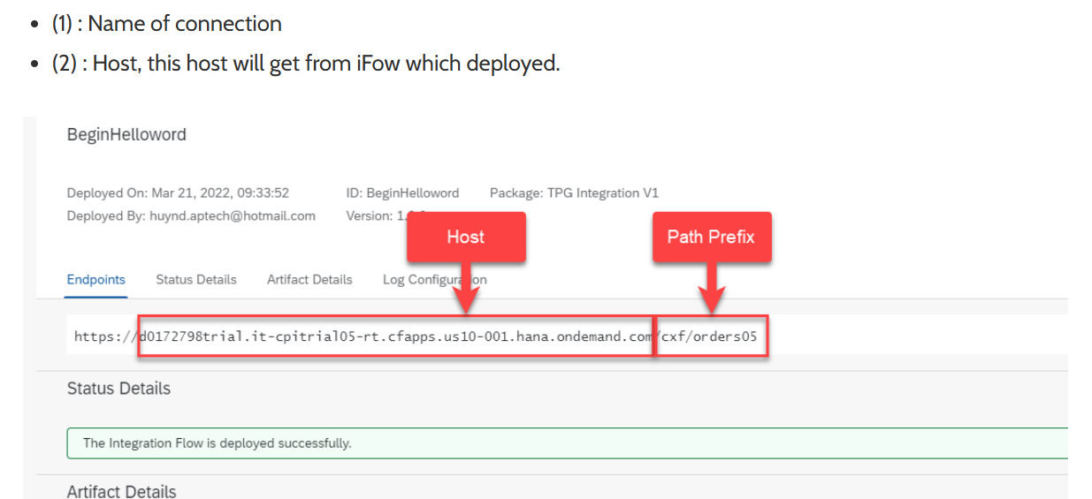
WE21 T-Code for Port Creation
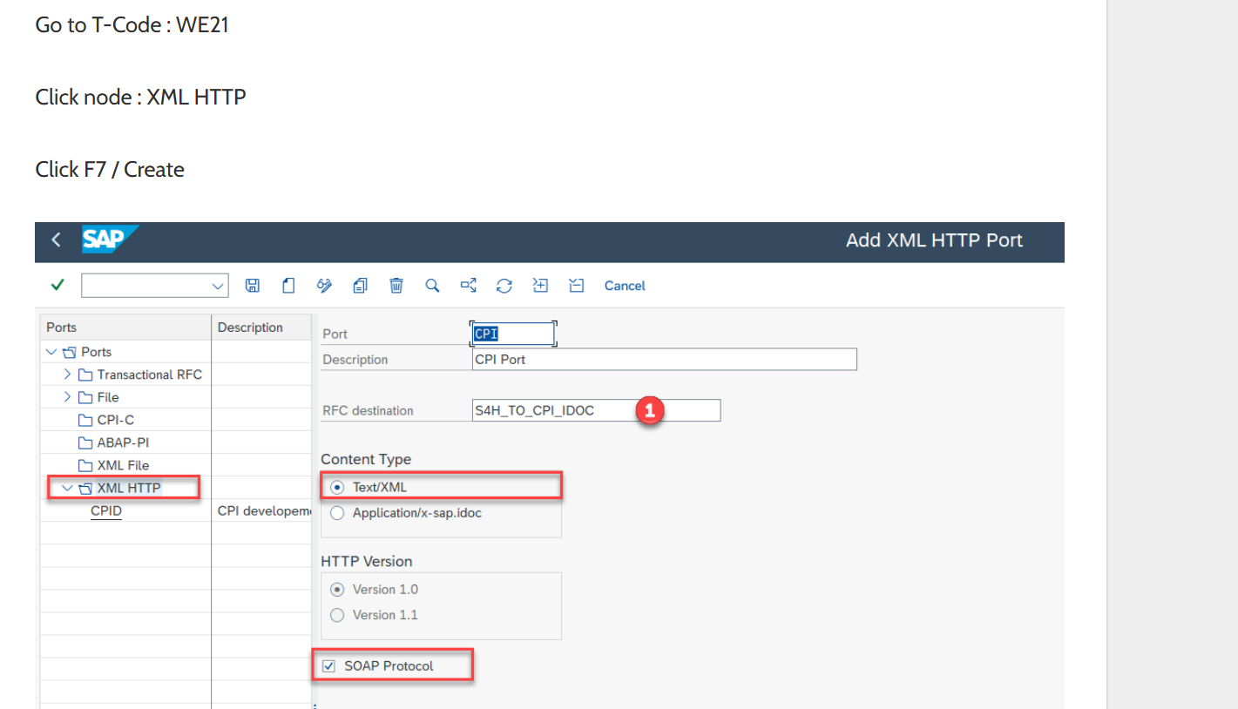
BD54 T-Code for Logical System
WE20 T-Code for partner profile
Sender IDOC Adapter: Address: It is the user defined value. Receiver IDOC Adapter: Address: We need to get the URL from the Receiver SAP Team. Proxy Type: Need to identify the System is on-premises or cloud. If it is on-premises then we required Location ID value. Authentication: Basic, Client Certificate and None.
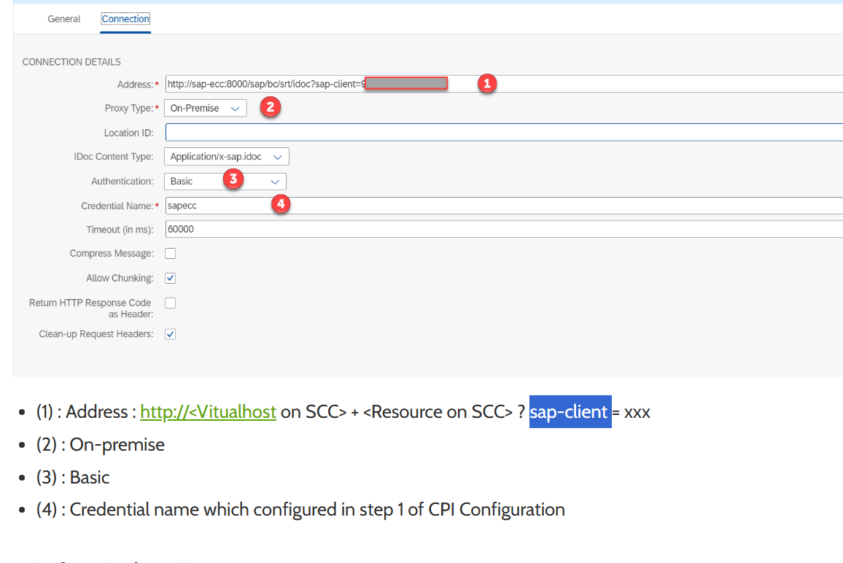

<MATMAS05>
<IDOC>
<EDI_DC40> Control segments
<TABNAM>EDI_DC40</TABNAM>
<MANDT>800</MANDT>
<DOCNUM>0000000000678745</DOCNUM>
<DOCREL>640</DOCREL>
<STATUS>03</STATUS>
<DIRECT>1</DIRECT>
<OUTMOD>2</OUTMOD>
<IDOCTYP>MATMAS05</IDOCTYP>
<MESTYP>MATMAS</MESTYP>
<SNDPOR>SAPID3</SNDPOR>
<SNDPRT>LS</SNDPRT>
<SNDPRN>T90CLNT090</SNDPRN>
<RCVPOR>XI_00_800</RCVPOR>
<RCVPRT>LS</RCVPRT>
<RCVPRN>MDM_001</RCVPRN>
<CREDAT>20050613</CREDAT>
<CRETIM>185234</CRETIM>
<SERIAL>20050613185229</SERIAL>
</EDI_DC40>
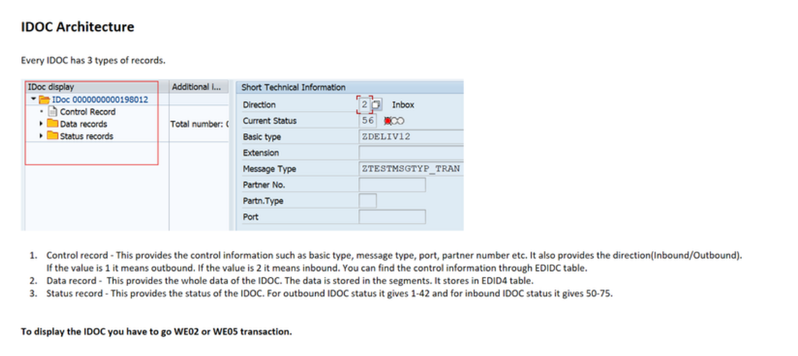

Cloud connector:
https://sapzero2hero.com/2023/04/22/sap-scc-how-to-install-sap-cloud-connector-scc/
https://tools.hana.ondemand.com/#cloud

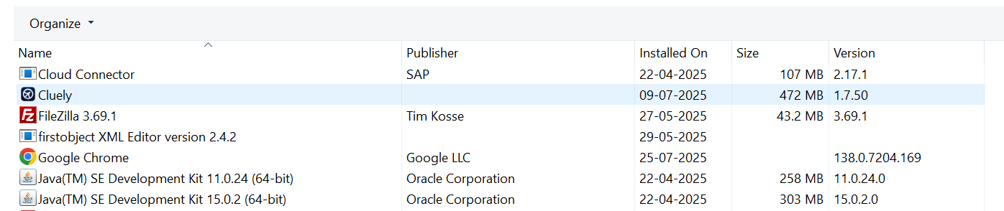

https://localhost:8443/

API MANAGEMENT:

OAUTH TOKEN:
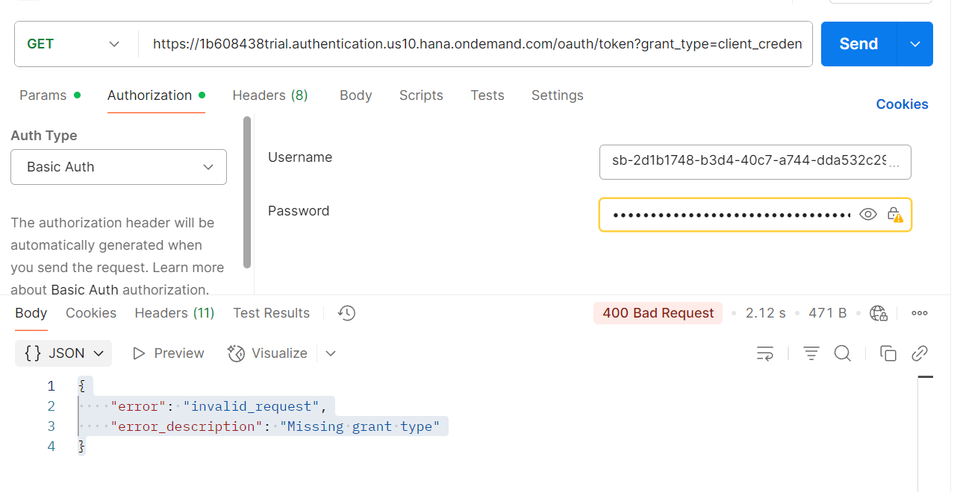
Add Params : grant_type = client_credentails
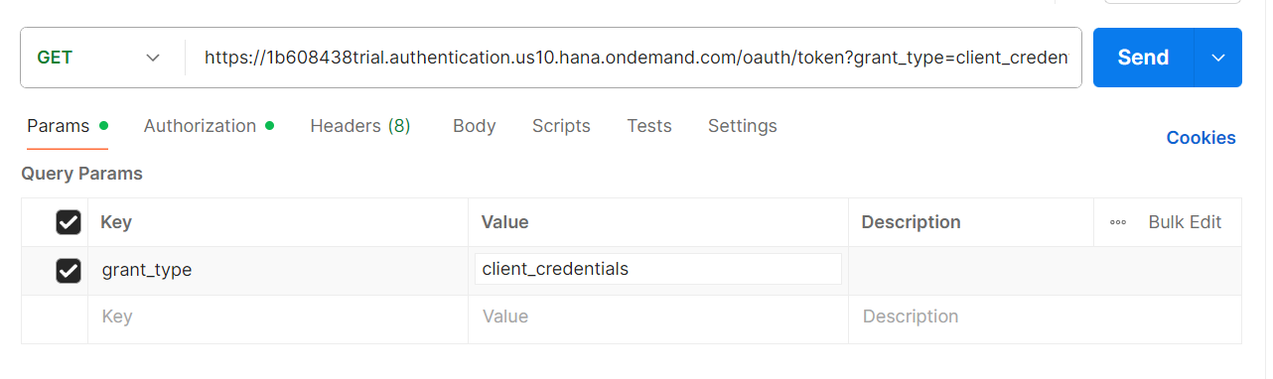

Filter Pallet:
Filter which is used to filter out or find out or Sort out required in message from the incoming payload.
We can use for only xml files
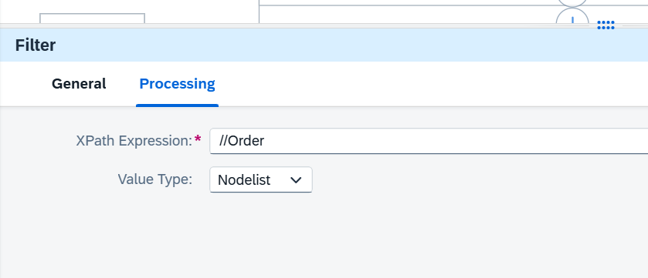
Parameters:
XPATH Expression: we need to maintain the XPATH to filter the data.
Value Type:
Node list: If we want filter the Records level data then we will use this one.(multiple records)
Node: If we want filter the elements then we will use Value type as Node.(singlerecords)
Boolean : If you use this and output will be true or false
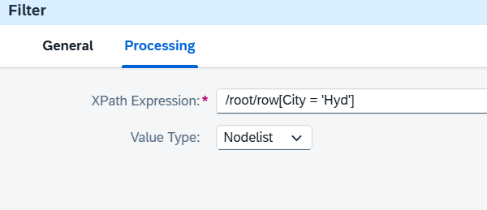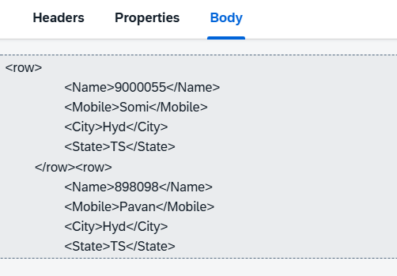
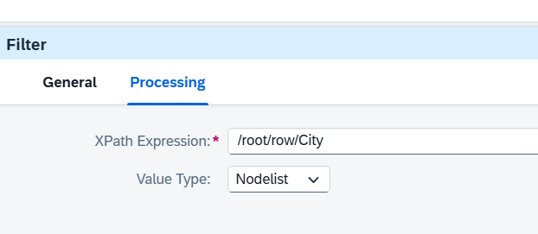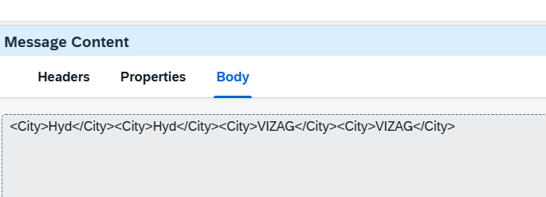
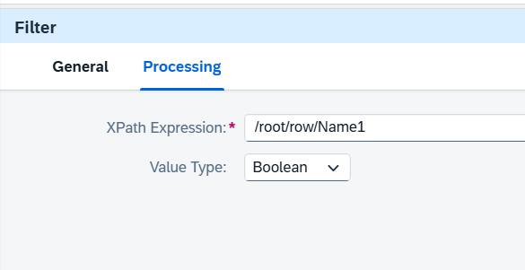

XML modifier PallET:
XML modifier is used to modify xml file or message or payload.
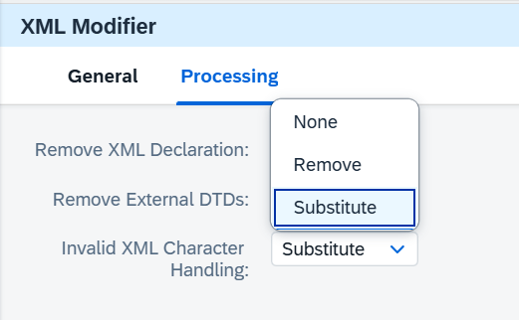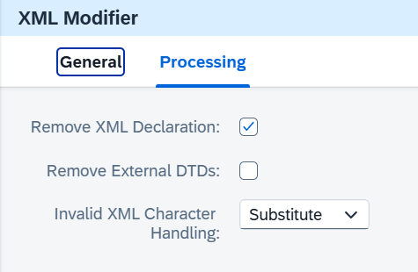
- It will remove xml declaration
- It will remove dtd
- Special chars : None/remove
XML VALIDATOR:
It is used to validate XML file as per xsd
Message Digest:
A Message Digest is a fixed-length, unique digital fingerprint generated from input data (such as text, XML, JSON, or binary).
It is produced using a hash algorithm like MD5, SHA-1, SHA-256, or SHA-512.

✔ Key characteristics:
- One-way → cannot be reversed to get the original data
- Fixed size → output is always the same length, regardless of input size
- Unique → small changes in input create completely different results
- Used for integrity → ensures data was not alteredRouter
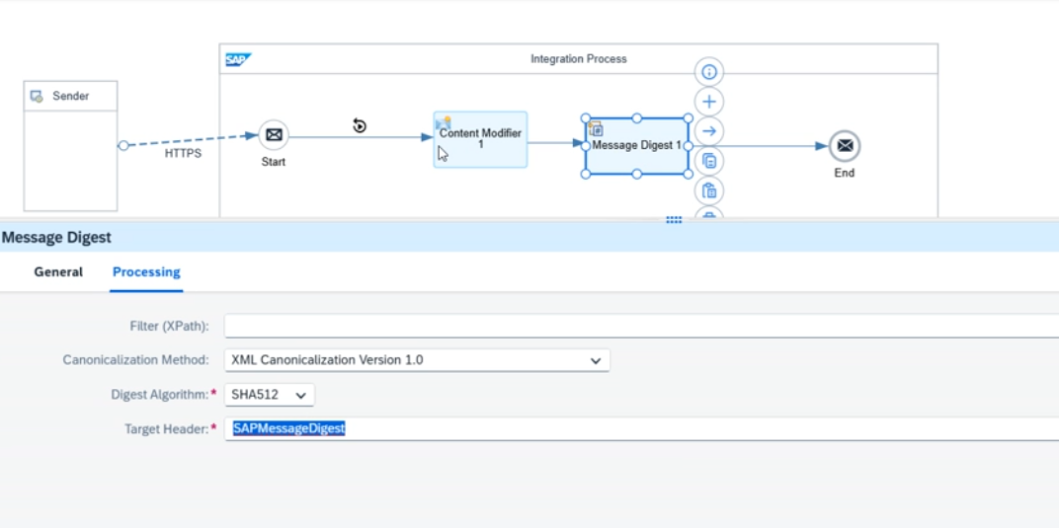
Persist:

Api.sap.com

Externalize
Need to add {{ABC}} in the required place like url,authe etc
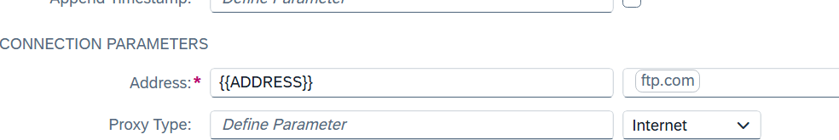

JDBC: It is used to connect JDB server to get the data. We need to upload jdbc driver. In below sample
url also there
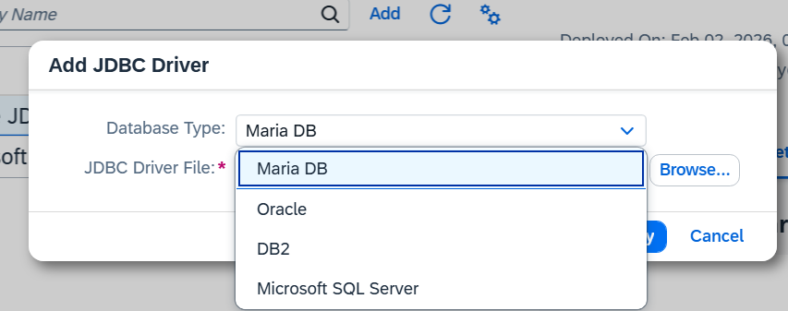
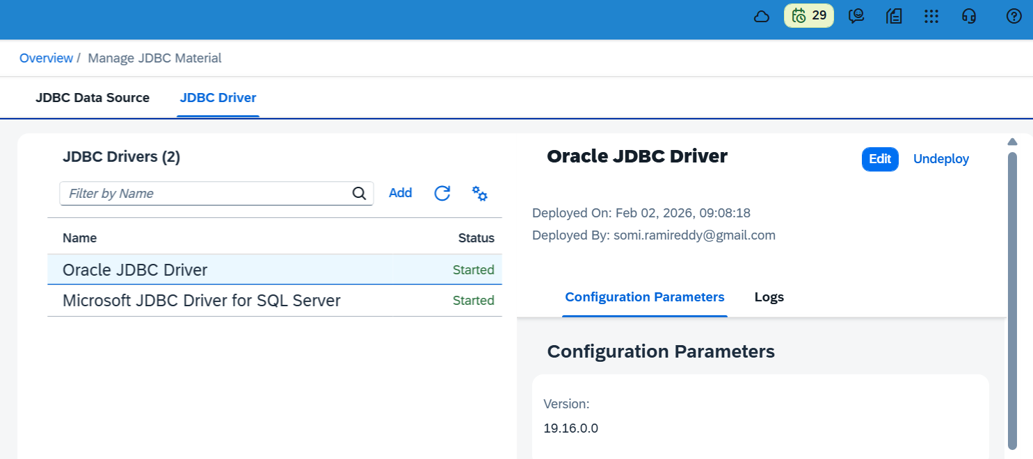

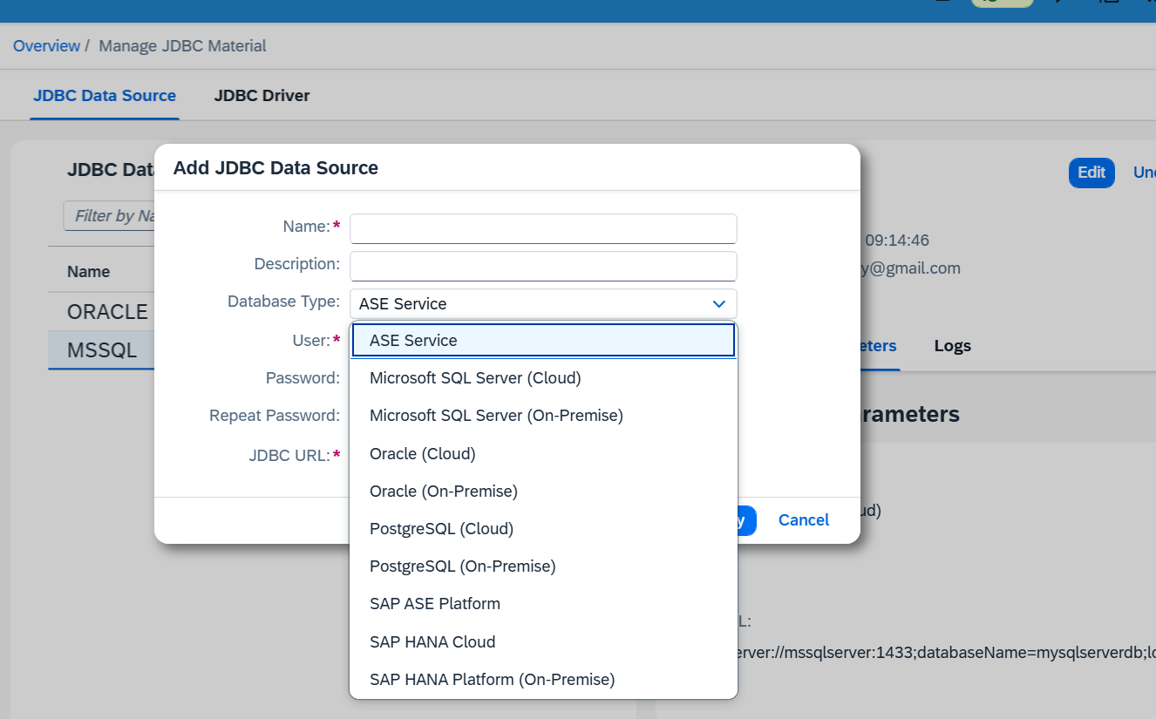

JDBC --->TO CONNECT TO ANY DATABASE WE USE JDBC
https://help.sap.com/docs/integration-suite/sap-integration-suite/jdbc-receiver-adapter?locale=en-US---> SUPPORT DATABASE
WE NEED TO CREATE JDBC DRIVERS ---> FOR SOME DATABASE
URL ------------------------------------->>>>>>>>
MSQL

jdbc:sqlserver://[serverName[\instanceName][:portNumber]][;property=value[;property=value]]

jdbc:sqlserver://mssqlserver:1433;databaseName=mysqlserverdb;loginTimeout=0

If we import jdbc database driver then we can only add the jdbc data source .

ORACLE
jdbc:oracle:thin:@<host>[:<port>]:<SID>
jdbc:oracle:thin:@myoracle:1521:my_sid

nOW THE CONNECTIVITY IS ESTABLISHED NOW HOW WE CAN FETCH DATA
QUEERY ---> SELECT ,INSERT , UPDATE

jdbc adapter we only have at the receiver we donot have sender

Select * from tablename where empid = 134

<root>
<Statement>
<dbTableName action="SELECT">
<table>test</table>

<access>
<emp_id></emp_id>
<emp_name></emp_name>
</access>

<key>
<emp_id123>123</emp_id123>
<emp_name123>234</emp_name123>
</key>

</dbTableName>
</Statement>
</root>

Select emp_id, emp_name from test
where emp_id123 = 123
and emp_name123 = ""

Insert into Tablename (col1 , col2 ) values ( 123, 456)

<root>
<Statement>
<dbTableName action="INSERT">
<table>test</table>

<access>
<emp_id>121</emp_id>
<emp_name>test121</emp_name>
</access>

<access>
<emp_id>122</emp_id>
<emp_name>test122</emp_name>
</access>

<access>
<emp_id>123</emp_id>
<emp_name>test123</emp_name>
</access>

</dbTableName>
</Statement>
</root>

Update TableName set col1 = val1 , col2 = val2 where empid = 134

<root>
<Statement>
<dbTableName action="UPDATE">
<table>test</table>

<access>
<emp_id>123</emp_id>
<emp_name>SUJANN</emp_name>
</access>

<key>
<emp_id123></emp_id123>
<emp_name123>234</emp_name123>
</key>

</dbTableName>
</Statement>
</root>

DELETE FROM table_name WHERE condition;

jdbc adater supports sql xml format .

API MANAGEMENT:
- First assign the roles of api and then come to setting runtime and activate
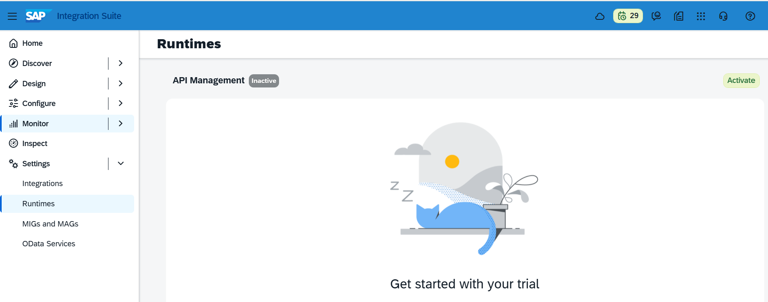
- Below tiles are related to API
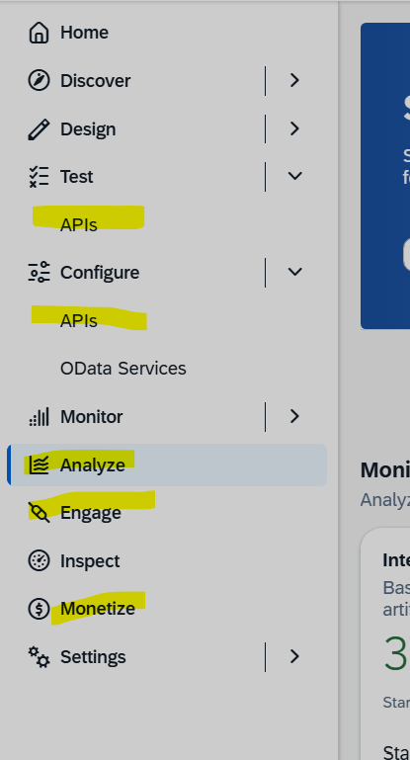

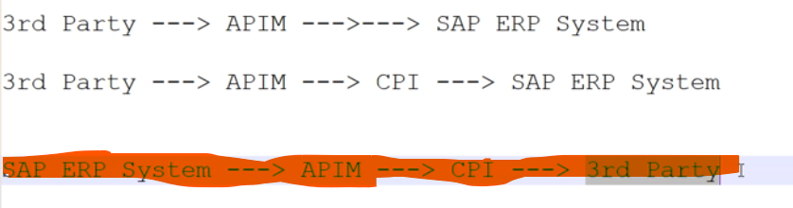
- API proxy contains manage security. We can create or manage API proxy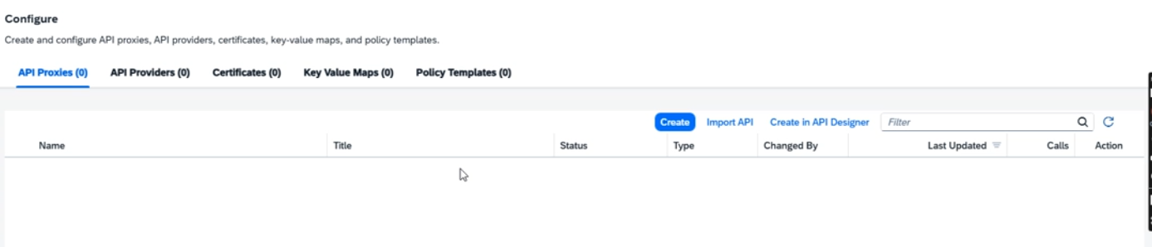
- API provider we can provide cpi or sap url in this
- We can create API PROVIDER
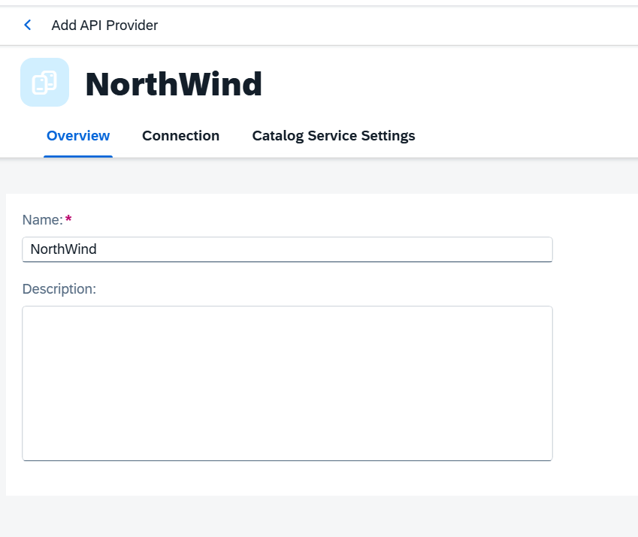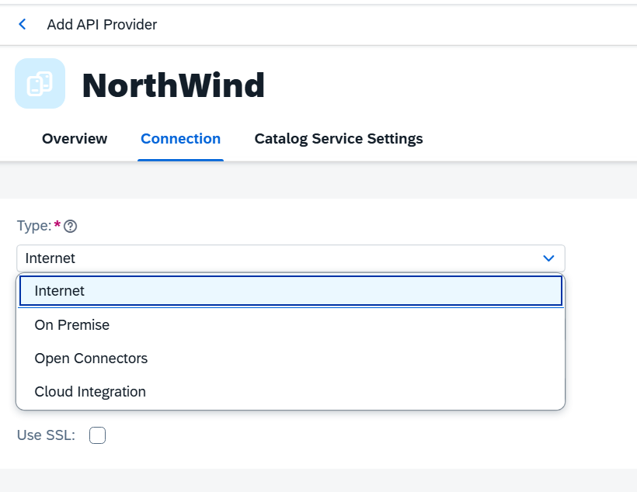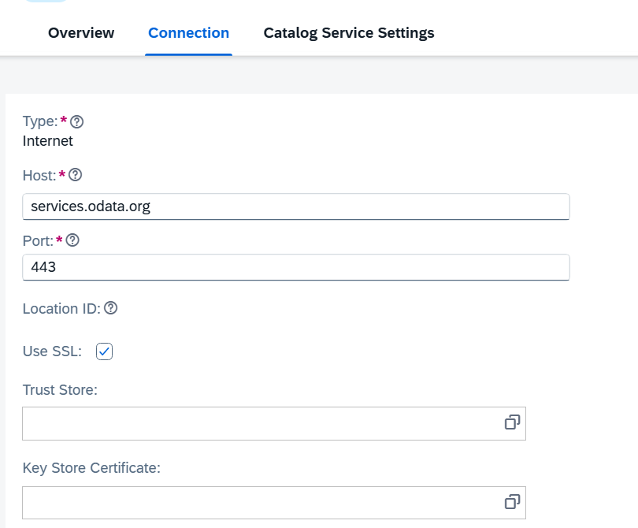
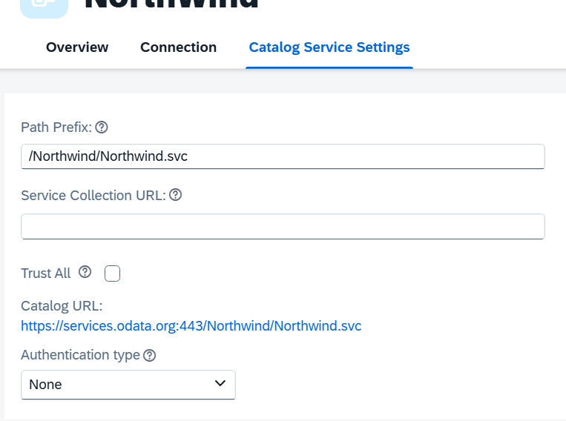
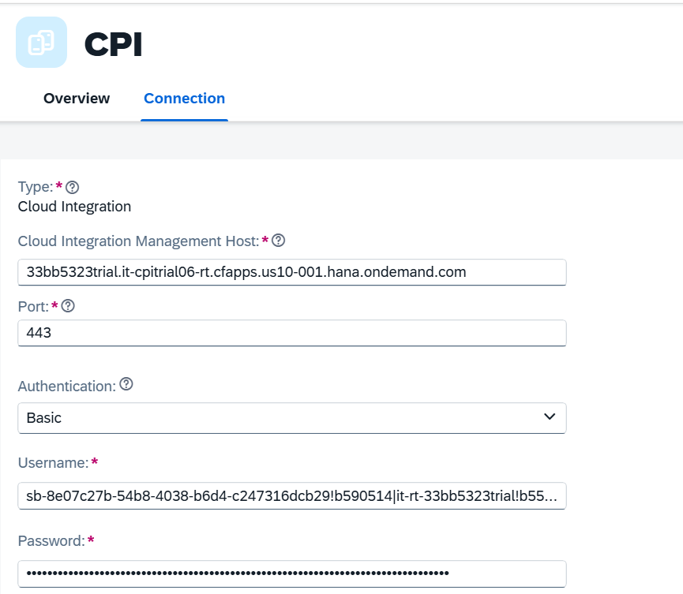

- Need to create Service in btp cockpit
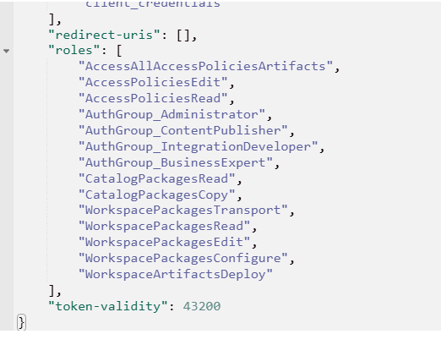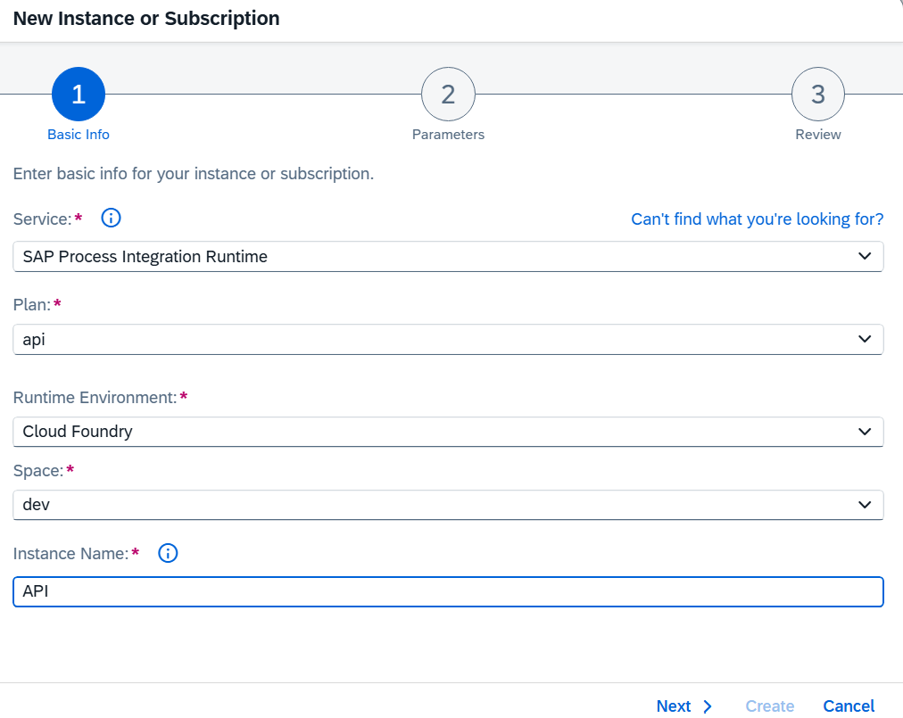
- Then need to configure in APIM
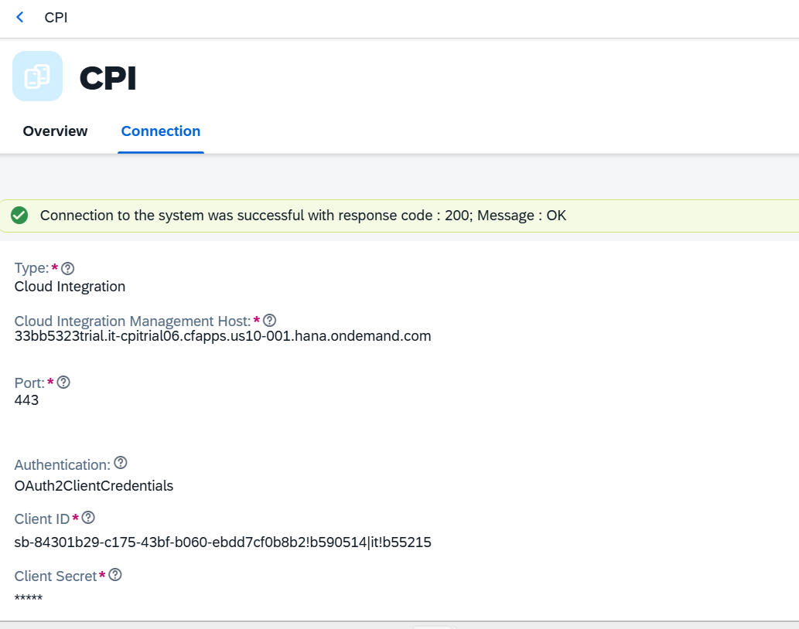
- In API proxy we can select cpi and then we need list of API based http,soap and odata
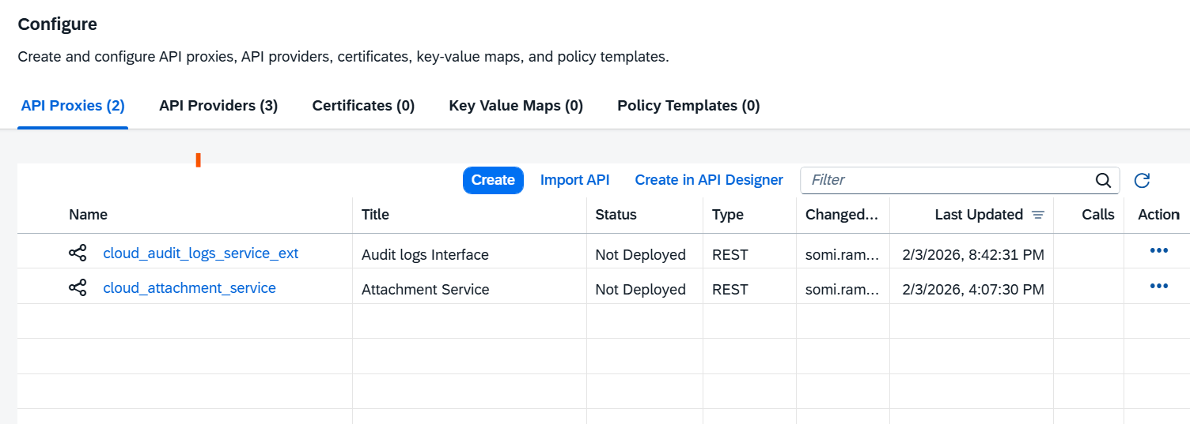
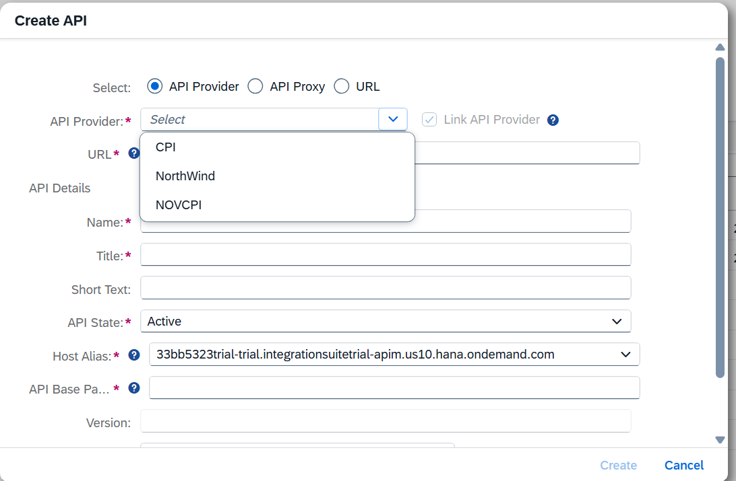
- Once you select CPI and then we can see discover in that we can see list of API in SAP CPI
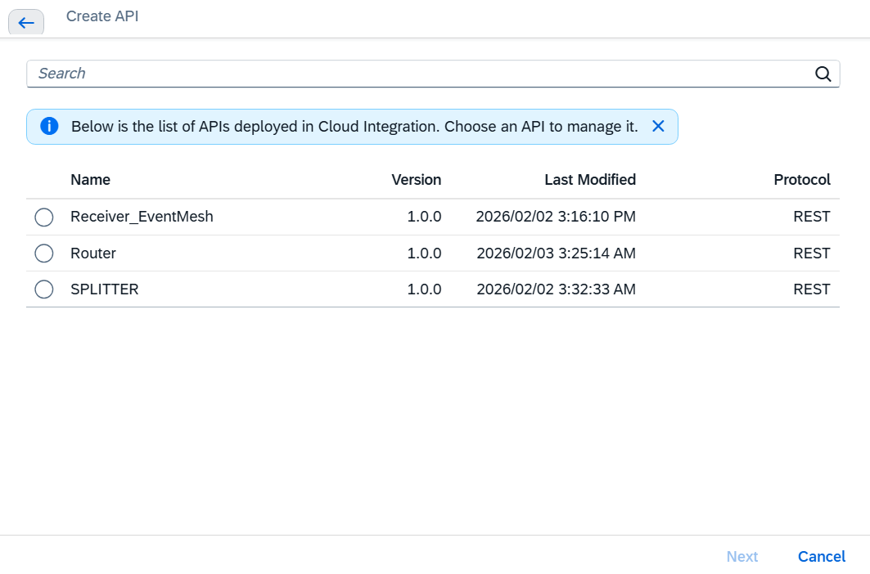
Once you select in above list then need to provide authentication

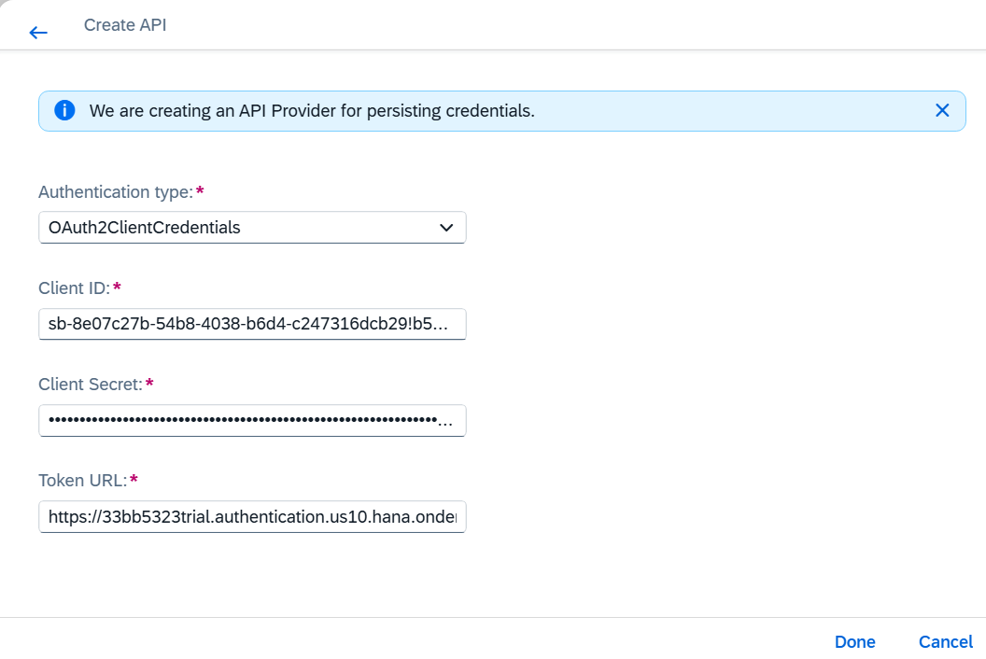

- Dfgdf
- Verify APIKEY :

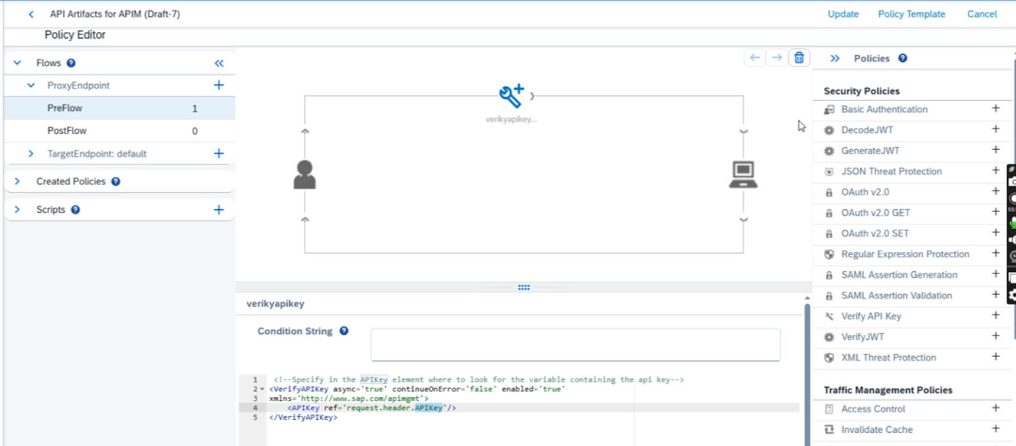

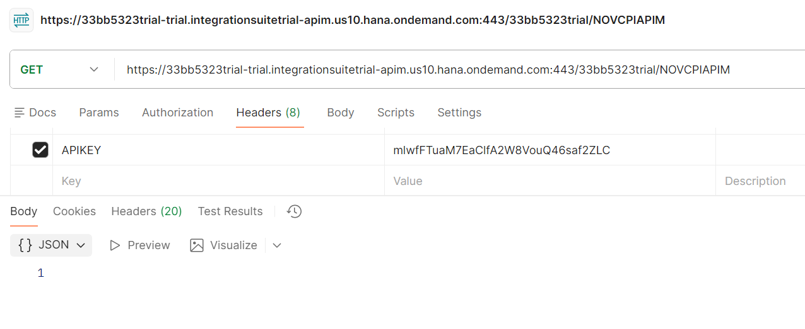
- Oauth: in general token grant_type=client_credentails
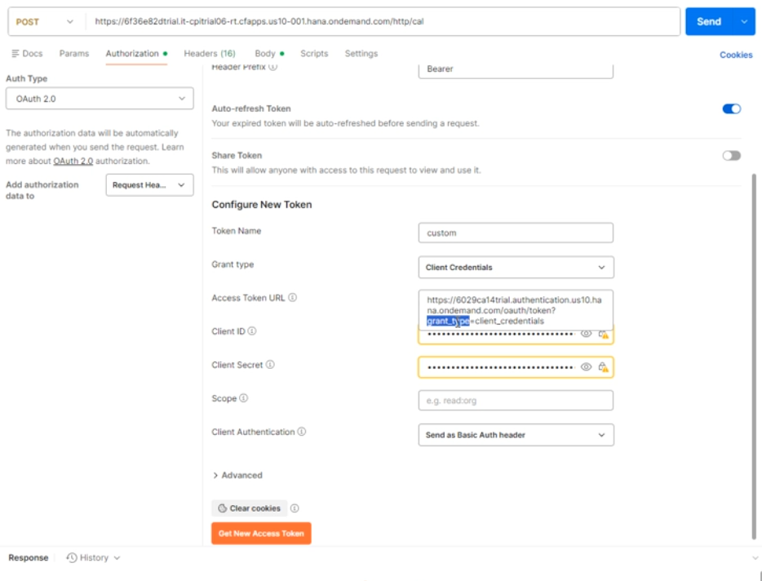
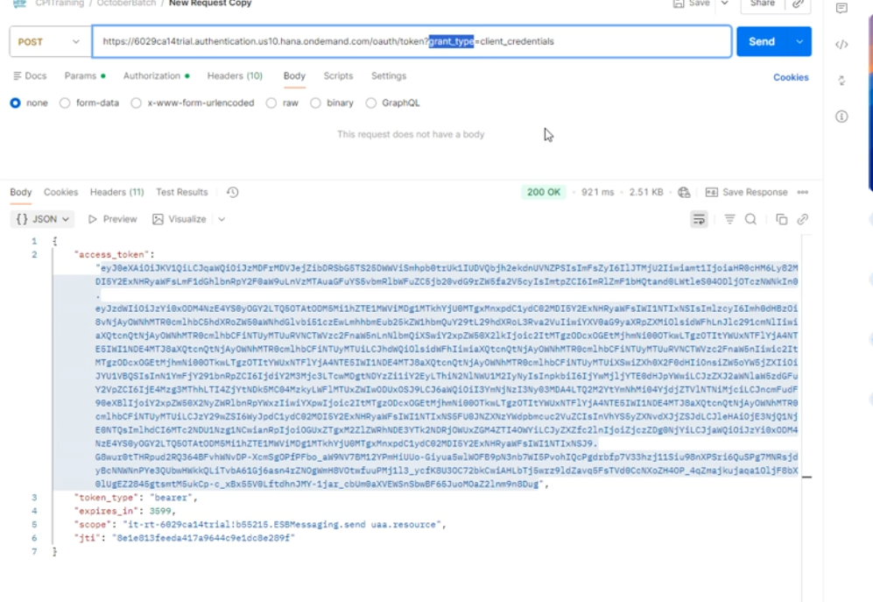
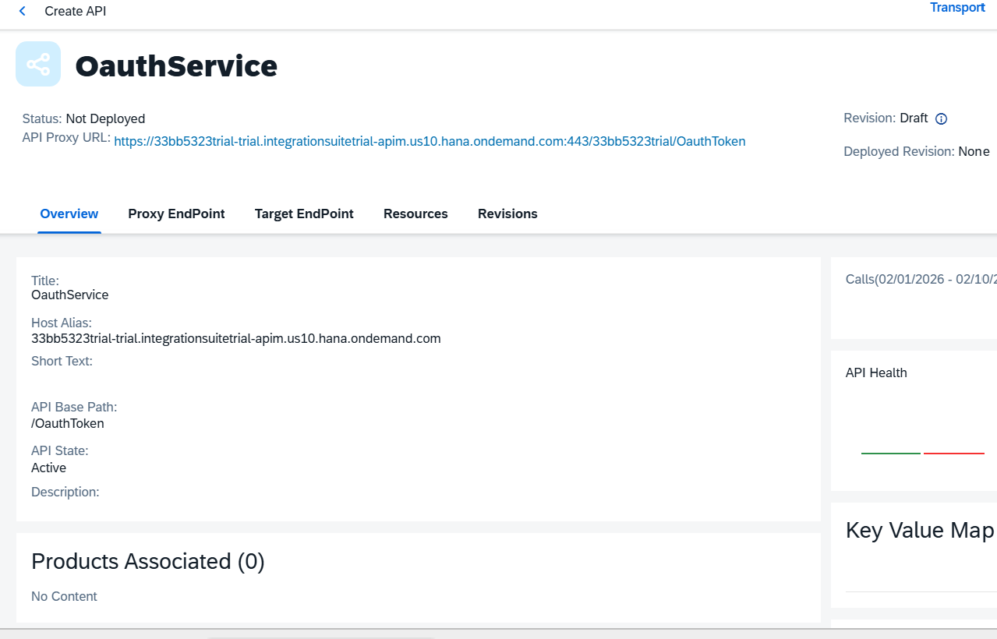
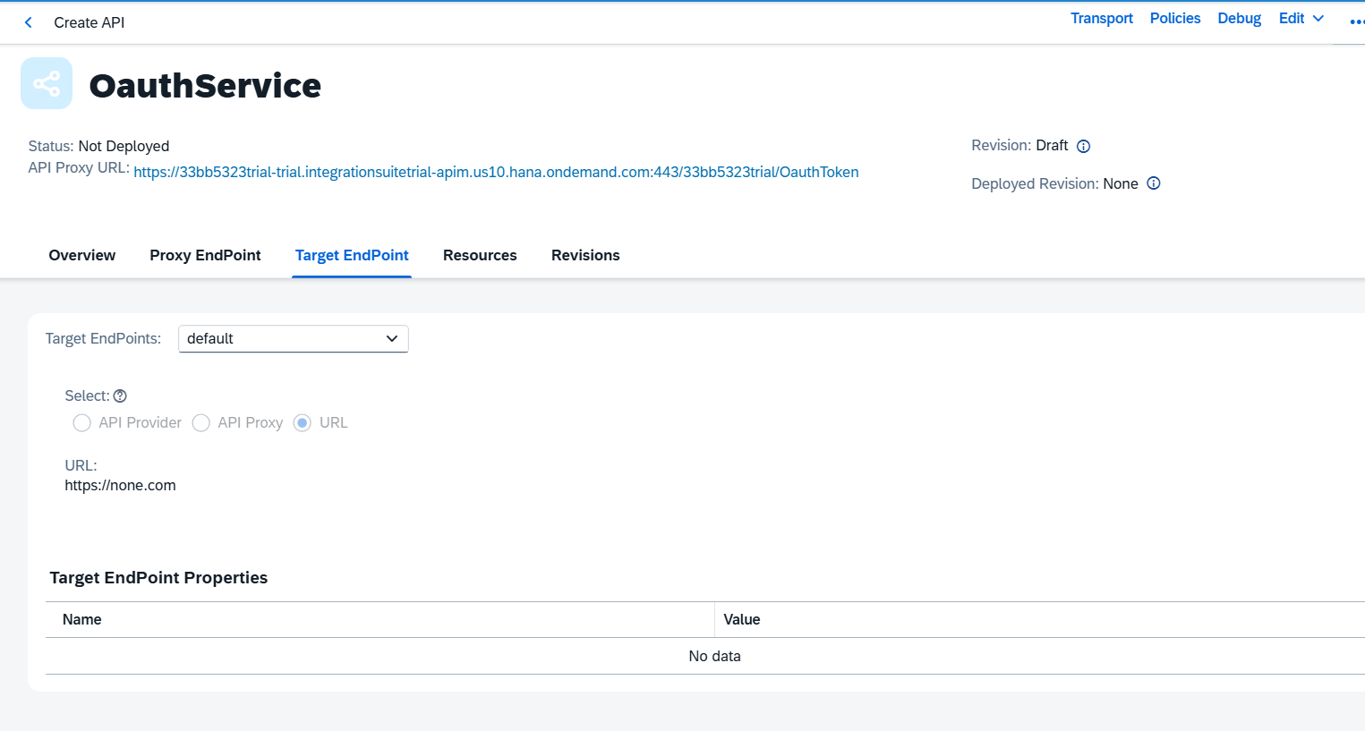
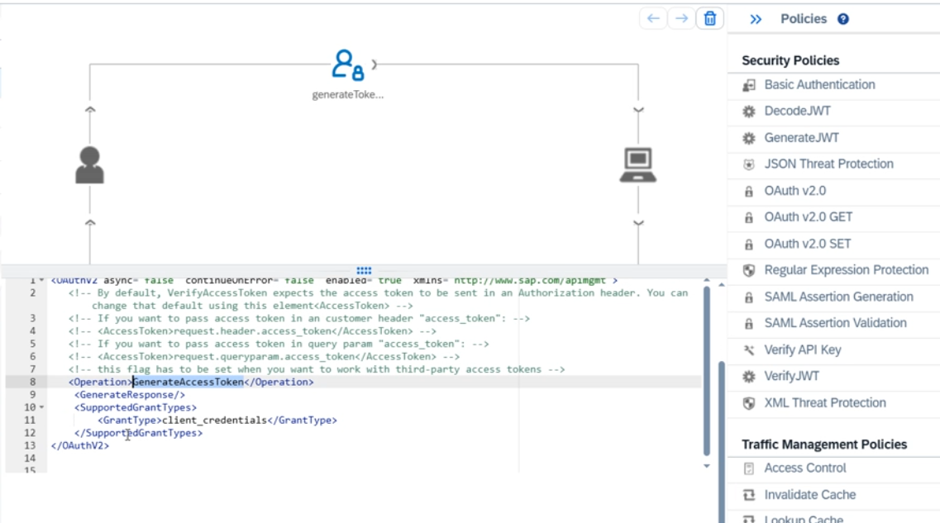
<OAuthV2 async="false" continueOnError="false" enabled="true" xmlns="http://www.sap.com/apimgmt">
<!-- By default, VerifyAccessToken expects the access token to be sent in an Authorization header. You can change that default using this element<AccessToken> -->
<!-- If you want to pass access token in an customer header "access_token": -->
<!-- <AccessToken>request.header.access_token</AccessToken> -->
<!-- If you want to pass access token in query param "access_token": -->
<!-- <AccessToken>request.queryparam.access_token</AccessToken> -->
<!-- this flag has to be set when you want to work with third-party access tokens -->
<!-- valid values are GenerateAccessToken, GenerateAccessTokenImplicitGrant, GenerateAuthorizationCode ,
RefreshAccessToken , VerifyAccessToken , InvalidateToken , ValidateToken -->
<Operation>GenerateAccessToken</Operation>
<GenerateResponse/>
<SupportedGrantTypes>
<GrantType>client_credentials</GrantType>
</SupportedGrantTypes>
</OAuthV2>

IN APIM Need to pass like this in postman
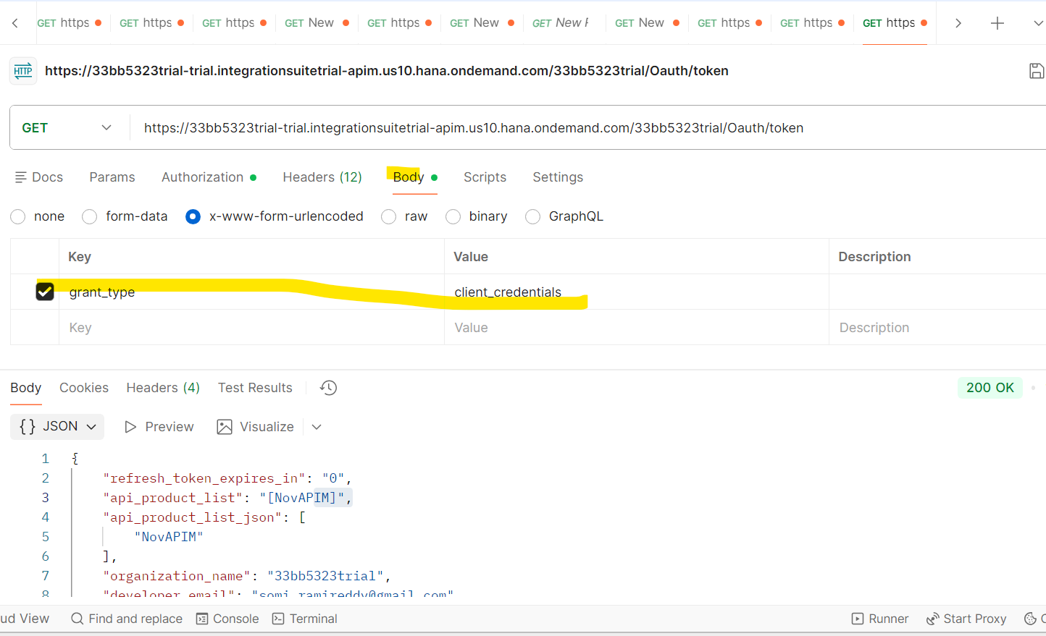
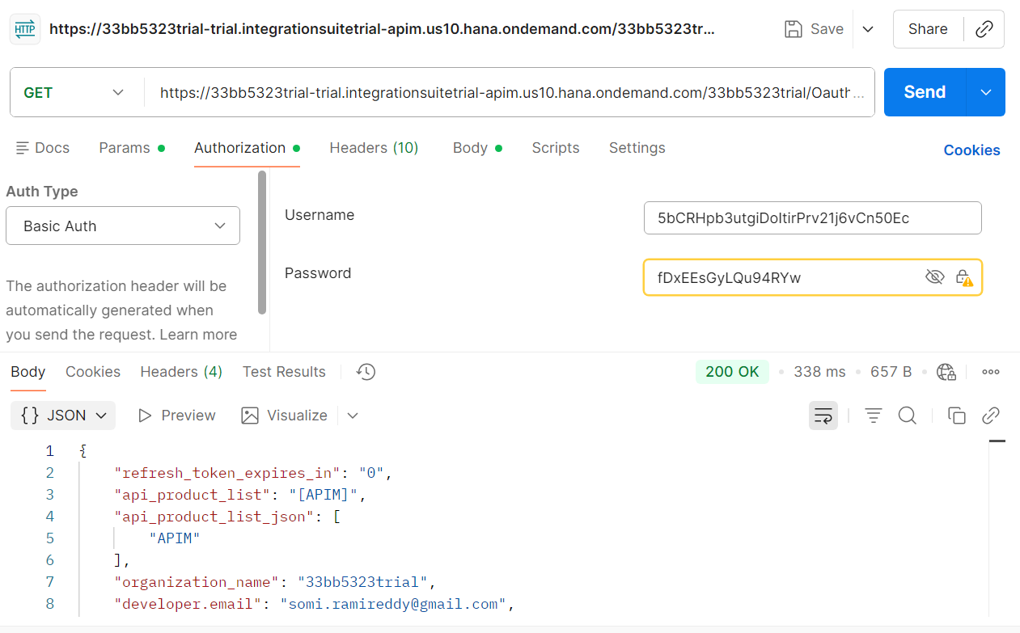
help 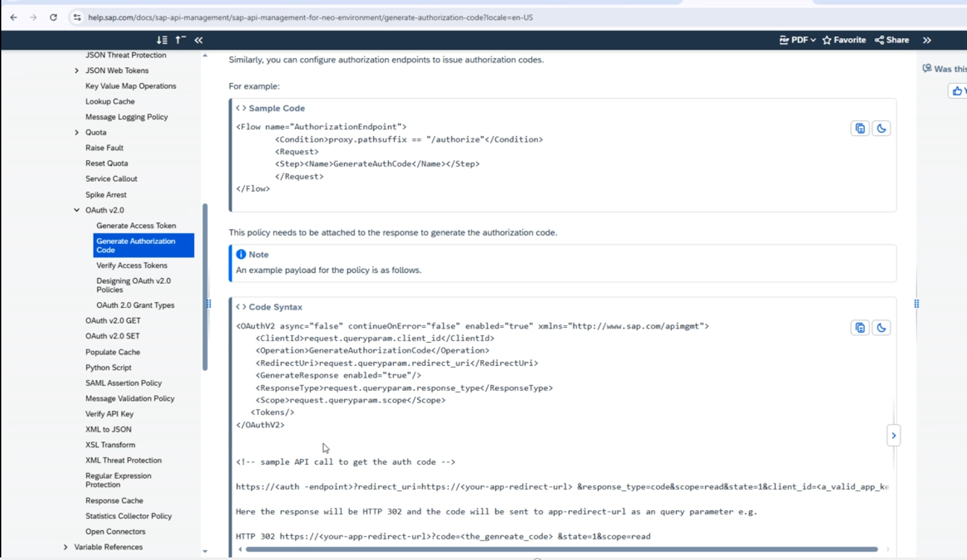
If you want vwerify api token
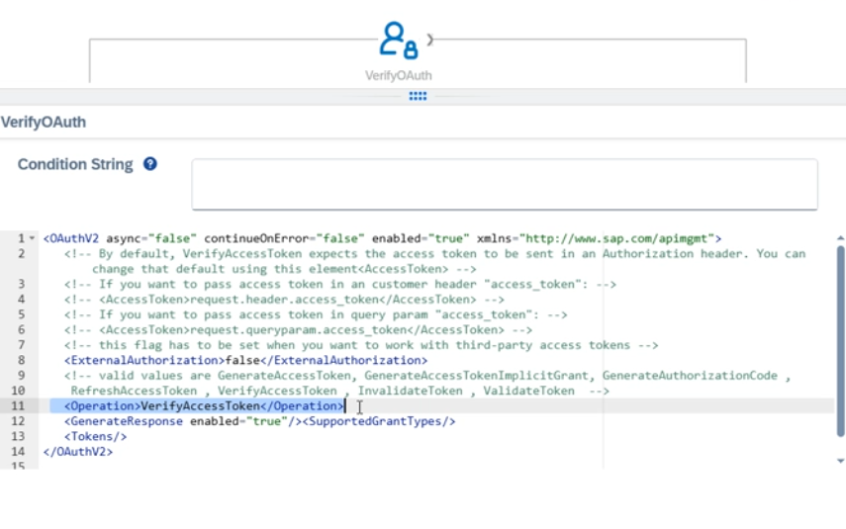
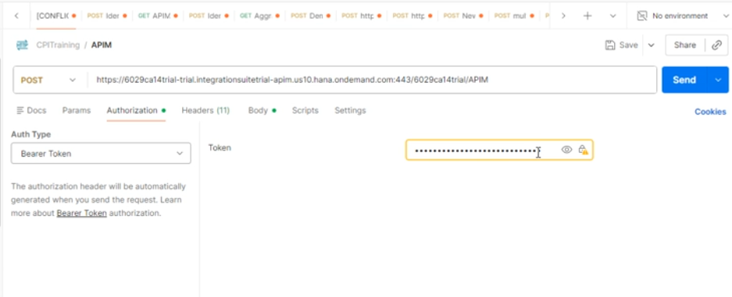
- JWT TOKEN

- Basic Authentication

- XML Threat protection

- Json Threat protection

Mediation polices:
- https://help.sap.com/docs/sap-api-management/sap-api-management/assign-message
- Example 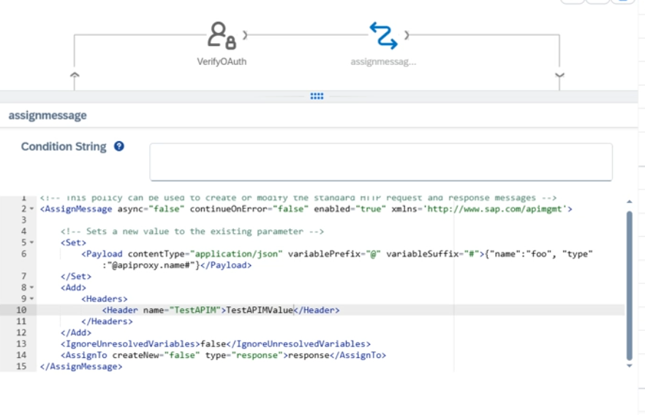
- Xml to json
- Json to xml
- Xsl transform

- Hh
- Fdf
Looping call:
https://services.odata.org/V3/Northwind/Northwind.svc/Orders
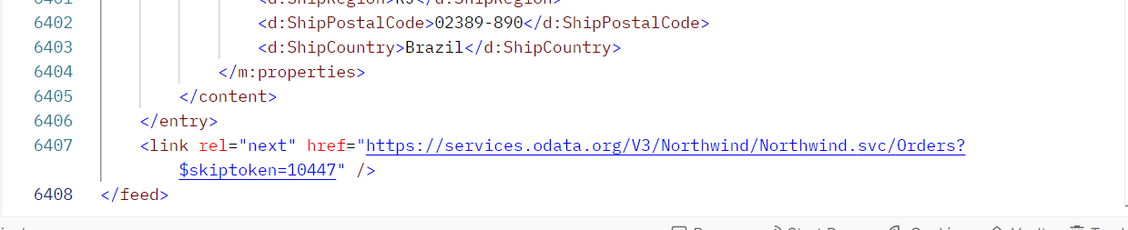
Xpath : //*[local-name()='link' and @rel='next']/@href

Types of Methods in http:

1. Common HTTP Methods
Method | Purpose | Idempotent | Safe | Typical Use
GET | Retrieve data from the server | Yes | Yes | Fetch a webpage, API data, or resource
POST | Send data to the server (create resource) | No | No | Create a new record, submit a form
PUT | Update a resource entirely (replace) | Yes | No | Update an existing record completely
PATCH | Update a resource partially | No | No | Modify specific fields in a record
DELETE | Delete a resource | Yes | No | Remove a record
HEAD | Retrieve headers only | Yes | Yes | Check if a resource exists, metadata check
OPTIONS | Get allowed HTTP methods for a resource | Yes | Yes | CORS preflight, discover available actions
TRACE | Echo the request back | Yes | Yes | Diagnostic/debugging (rarely used)
CONNECT | Establish a tunnel (often for SSL) | No | No | Used for proxies and HTTPS tunneling

